Overview
The rural industries and fisheries in the Northern Territory include cattle (interstate and live export), other livestock (buffalo, crocodiles and horses), horticulture (fruit, vegetables, nursery and cut flowers) and mixed farming (field crops, hay and seeds, and forestry). The fisheries industry comprises harvesting of wild catch (including the Northern Prawn Fleet) and aquaculture. A substantial recreational fishing sector generates tourism activity and provides lifestyle amenity. The percentage contribution of each industry to the rural and fisheries total is illustrated in Figure 1, with the cattle, fisheries and horticulture industries being the major players.
Figure 1: Contribution of Industry to Sector Production Value, 2014-15
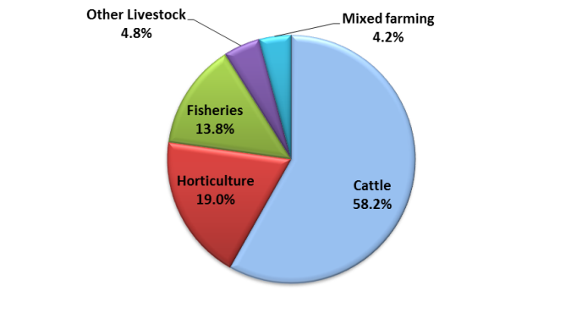
Source: Department of Primary Industry and Fisheries data collections

The rural industries and fisheries have significant links to other sectors of the Territory economy such as manufacturing, transport and storage, retail and wholesale trade. These industries are vital in regional areas, providing economic stimulus and employment for approximately 1,400 persons in 2014-15 (ABS). This labour force estimate is subject to high sampling variability. The sectors also account for a significant proportion of the Territory's non-mineral export revenue. Territory rural industries and fisheries accounted for 1.8% of Gross State Product (GSP) in 2014-15, below the national proportion of 2.3% (Table 1). Exports of Territory rural and fisheries produce are dominated by live cattle exports (mainly to Indonesia), aquaculture, fishing, forestry and to a lesser extent agriculture services.
In 2014-15, the total estimated value of rural industries and fisheries production was $572.8 million, an increase of 15.0% over the previous year, a result reflective of the improving conditions for NT primary industries and fisheries (see Figure 2). The increase is primarily due to a 14.8% increase in the value of cattle production to $333.5 million (driven by live exports and abattoir demand), a 15.3% increase in fisheries production to $79.2 million (driven by the wild stock catch and aquaculture output), a 51.8% rise in other livestock production (mainly crocodile production) to $27.3 million, a 81.1% increase in the value of field crops to $24.0 million (driven by hay-fodder for cattle production), and a 1.0% increase in the value of horticultural production to $108.7 million.
Table 1: Agriculture, Forestry and Fisheries Contribution to GSP by State
2014-15 | % Contribution to GSP
Tasmania | 9.0%
South Australia | 4.9%
Victoria | 2.8%
Queensland | 2.4%
Western Australia | 1.8%
Northern Territory | 1.8%
New South Wales | 1.3%
Australian Capital Territory | 0.04%
Australia (% of GDP) | 2.3%
Source: ABS 5220.0

Figure 2: Northern Territory Rural Industries and Fisheries Production Value
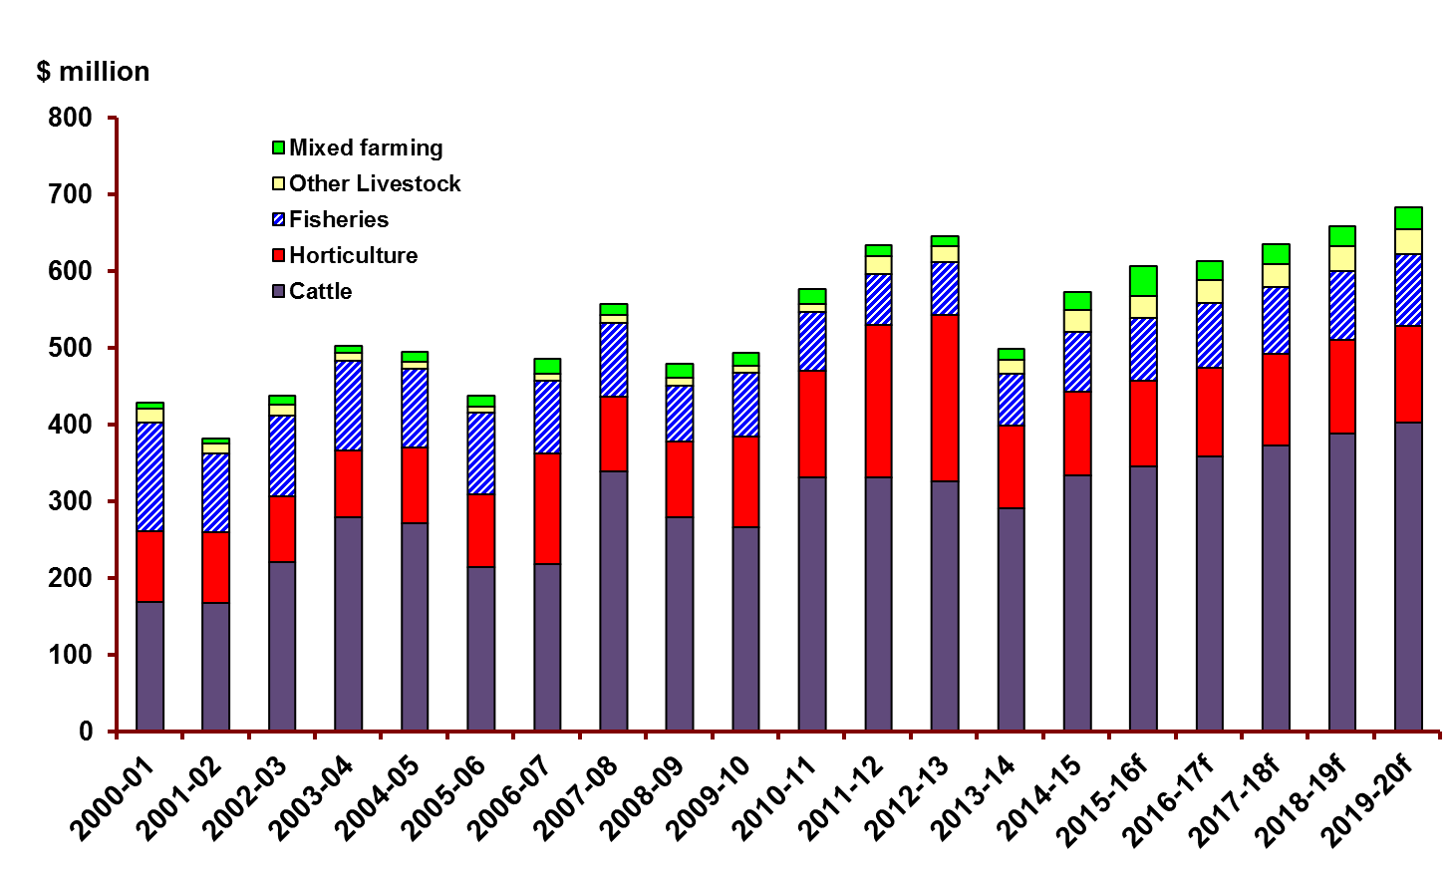
Source: Department of Primary Industry and Fisheries data collections

Table 2: Gross Value of Territory Rural Industries and Fisheries Production ($ million)
Value of horticultural production ($ million)
 | 2012-13 | 2013-14 | 2014-15 | 2015-16f | 2016-17f | 2017-18f
Mangoes | 69.4 | 35.0 | 36.1 | 37.2 | 38.3 | 39.4
Table Grapes | 1.7 | 0.0 | 0.0 | 0.0 | 0.0 | 0.0
Bananas | 5.4 | 0.0 | 0.0 | 0.0 | 0.0 | 0.0
Melons | 63.7 | 34.0 | 35.1 | 36.1 | 37.2 | 38.3
Other fruits | 0.6 | 3.6 | 0.6 | 0.6 | 0.6 | 0.6
Vegetables | 59.9 | 16.1 | 16.6 | 17.1 | 17.6 | 18.1
Turf | 0.0 | 1.5 | 2.5 | 2.6 | 2.7 | 2.7
Nursery & Cut Flowers | 16.2 | 17.4 | 17.9 | 18.5 | 19.0 | 19.6
Total | 216.8 | 107.7 | 108.7 | 112.0 | 115.3 | 118.8
Value of fisheries production ($ million)
 | 2012-13 | 2013-14 | 2014-15 | 2015-16f | 2016-17f | 2017-18f
Fish | 27.7 | 26.0 | 26.2 | 27.0 | 27.8 | 28.7
Crustaceans | 6.4 | 4.2 | 4.6 | 4.7 | 4.9 | 5.0
Aquaculture | 25.3 | 15.2 | 24.1 | 24.8 | 25.5 | 26.3
Molluscs & Echinoderms | 0.01 | 0.2 | 0.2 | 0.0 | 0.0 | 0.0
Total NT Fisheries | 59.4 | 45.6 | 55.1 | 56.5 | 58.2 | 60.0
Crustaceans-NPF | 9.5 | 23.1 | 24.0 | 25.0 | 26.0 | 27.1
Total Fisheries | 68.9 | 68.7 | 79.2 | 81.5 | 84.2 | 87.0
Value of cattle, other livestock and mixed farming ($ million)
 | 2012-13 | 2013-14 | 2014-15 | 2015-16f | 2016-17f | 2017-18f
Cattle | 326.0 | 290.5 | 333.5 | 345.0 | 358.9 | 372.9
Other Livestock | 20.8 | 18.0 | 27.3 | 28.5 | 29.5 | 30.5
Field crops | 13.0 | 13.3 | 24.0 | 24.8 | 25.5 | 26.3
Poppy | 0.0 | 0.0 | 0.0 | 2.4 | 0.0 | 0.0
Forestry | 0.0 | 0.0 | 0.0 | 12.2 | 0.0 | 0.0
Total | 359.8 | 321.8 | 384.9 | 412.9 | 413.8 | 429.6
Total Northern Territory Rural Industries and Fisheries Production Value ($ million)
 | 2012-13 | 2013-14 | 2014-15 | 2015-16f | 2016-17f | 2017-18f
Horticulture | 216.8 | 107.7 | 108.7 | 112.0 | 115.3 | 118.8
Fisheries | 68.9 | 68.7 | 79.2 | 81.5 | 84.2 | 87.0
Cattle | 326.0 | 290.5 | 333.5 | 345.0 | 358.9 | 372.9
Other Livestock | 20.8 | 18.0 | 27.3 | 28.5 | 29.5 | 30.5
Field crops | 13.0 | 13.3 | 24.0 | 24.8 | 25.5 | 26.3
Poppy | 0.0 | 0.0 | 0.0 | 2.4 | 0.0 | 0.0
Forestry | 0.0 | 0.0 | 0.0 | 12.2 | 0.0 | 0.0
Grand Total | 645.4 | 498.1 | 572.8 | 606.4 | 613.4 | 635.4

Source: Department of Primary Industry and Fisheries data collections, f = forecast
Please note all figures here have been rounded respectively and may not tally to totals.
NPF = Northern Prawn Fleet (Commonwealth-managed fishery)
Forecasting Notes
No data was collected for Bananas and Table grapes for 2014-15 therefore no forecasts were generated.
No forecasts were generated for Poppy as the $2.4m (2015-16) represents a trial crop not full production
No forecasts were generated for Forestry as the $12.2m (2015-16) represents only the first two shipments of woodchips and a forecast is not available at this time.

Please use this data from 1 May 2016 to 31 May 2017 only.
Table 3: Gross Value of Territory Rural Industries and Fisheries Production (Percentage changes)
 | 11-12 to 12-13 | 12-13 to 13-14 | 13-14 to 14-15
 | % | % | %
Mangoes | -13.2% | -49.5% | 3.0%
Table Grapes | -74.1% | -100.0% | 0.0%
Bananas | -52.4% | -100.0% | 0.0%
Melons | 6.8% | -46.6% | 3.0%
Other fruits | -84.0% | 550.5% | -84.2%
Vegetables | 188.9% | -73.1% | 3.0%
Turf | 0.0% | 0.0% | 66.7%
Nursery & Cut Flowers | -3.1% | 7.7% | 3.0%
Total | 9.3% | -50.3% | 1.0%
 | 11-12 to 12-13 | 12-13 to 13-14 | 13-14 to 14-15
 | % | % | %
Fish | 7.8% | -6.3% | 1.0%
Crustaceans | -22.5% | -33.6% | 8.5%
Aquaculture | 46.9% | -39.9% | 58.4%
Molluscs & Echinoderms | 0.0% | 0.0% | 0.0%
Total NT Fisheries | 15.7% | -23.3% | 21.1%
Crustaceans - NPF | -37.7% | 143.6% | 4.0%
Total Fisheries | 3.5% | -0.3% | 15.3%
 | 11-12 to 12-13 | 12-13 to 13-14 | 13-14 to 14-15
 | % | % | %
Cattle | -1.7% | -10.9% | 14.8%
Other Livestock | -7.4% | -13.6% | 51.8%
Field crops | -11.3% | 2.3% | 81.1%
Poppy | 0.0% | 0.0% | 0.0%
Forestry | 0.0% | 0.0% | 0.0%
 | 11-12 to 12-13 | 12-13 to 13-14 | 13-14 to 14-15
 | % | % | %
Horticulture | 9.3% | -50.3% | 1.0%
Fisheries | 3.5% | -0.3% | 15.3%
Cattle | -1.7% | -10.9% | 14.8%
Other Livestock | -7.4% | -13.6% | 51.8%
Field crops | -11.3% | 2.3% | 81.1%
Poppy | 0.0% | 0.0% | 0.0%
Forestry | 0.0% | 0.0% | 0.0%
Total | 1.8% | -22.8% | 15.0%

Source: Department of Primary Industry and Fisheries data collections
NPF = Northern Prawn Fleet (Commonwealth-managed fishery)

Please use this data from 1 May 2016 to 1 May 2017 only.

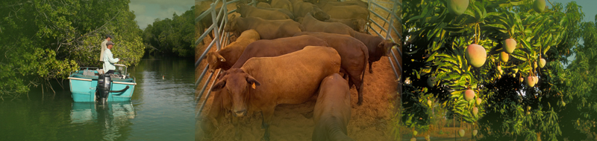

Acknowledgements
The important contributions made by staff of the Department of Primary Industry and Fisheries are gratefully acknowledged.
The author would like to thank the following staff:
Biosecurity and Product Integrity: Adele Kluth
Pastoral Production: Arthur Cameron, Casey Collier, Ben Beumer
Fisheries Group: Glenn Schipp, Murray Barton, Thor Saunders, Hock Seng Lee

Prepared by: Michael Jean

Contact Details
Michael Jean
Senior Economist
Department of Primary Industry and Fisheries
Department of Mines and Energy
GPO Box 3000, DARWIN NT 0801 Australia

Telephone: +61 8 8999 2242
Email: michael.jean@nt.gov.au

Disclaimer
While all care has been taken to ensure that information contained in this document is true and correct at the time of publication, changes in circumstances after the time of publication may impact on the accuracy of its information.
The Northern Territory of Australia gives no warranty or assurance, and makes no representation as to the accuracy of any information or advice contained in this publication, or that it is suitable for your intended use.
You should not rely upon information in this publication for the purpose of making any serious, business or investment decisions without obtaining independent and/or professional advice in relation to your particular situation.
The Northern Territory of Australia disclaims any liability or responsibility or duty of care towards any person for loss or damage caused by any use of or reliance on the information contained in this publication.

