Mineral Titles Act
NOTICE OF LAND CEASING TO BE A MINERAL TITLE
Title Type and Number: | Extractive Mineral Permit 27319
Area ceased on: | 08 March 2018
Area: | 93.00 Hectare
Locality: | MATARANKA
Name of Applicants(s)Holder(s): | 50% DNR ENTERPRISES (NT) PTY LTD [ACN. 099 942 373], 50% FLORO PTY LTD [ACN. 059 752 493]
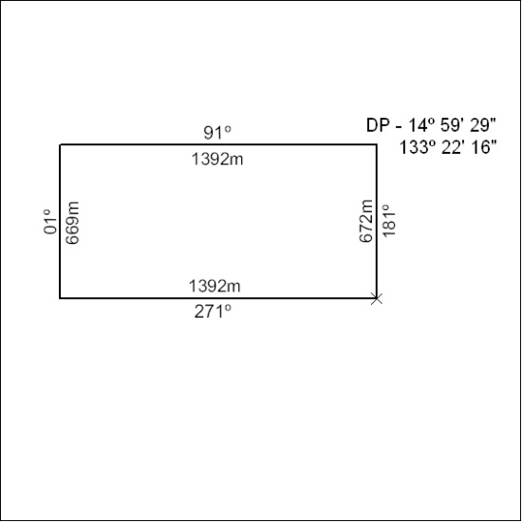

106/18

Mineral Titles Act
NOTICE OF LAND CEASING TO BE A MINERAL TITLE
Title Type and Number: | Extractive Mineral Permit 27320
Area ceased on: | 08 March 2018
Area: | 93.00 Hectare
Locality: | GORRIE
Name of Applicants(s)Holder(s): | 50% DNR ENTERPRISES (NT) PTY LTD [ACN. 099 942 373], 50% FLORO PTY LTD [ACN. 059 752 493]
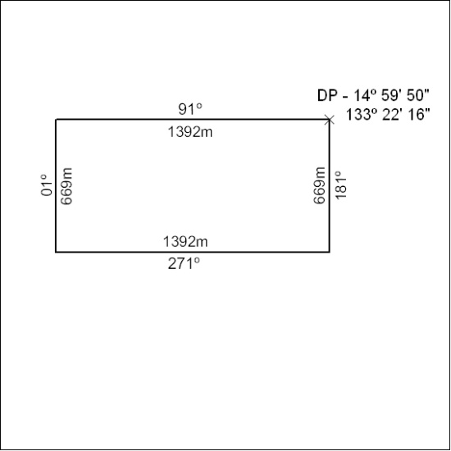

107/18

Mineral Titles Act
NOTICE OF LAND CEASING TO BE A MINERAL TITLE AREA
Title Type and Number: | Exploration Licence 26848
Area Ceased on: | 07 March 2018
Area: | 22 Blocks, 70.26 km²
Locality: | MOUNT PEAKE
Name of Applicant(s)/Holder(s): | 100% TODD RIVER METALS PTY LTD [ACN. 600 314 038]
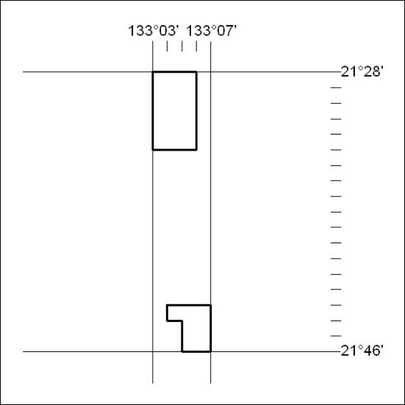

108/18

Mineral Titles Act
NOTICE OF LAND CEASING TO BE A MINERAL TITLE AREA
Title Type and Number: | Exploration Licence 30422
Area Ceased on: | 08 March 2018
Area: | 117 Blocks, 326.85 km²
Locality: | CONICAL HILL
Name of Applicant(s)/Holder(s): | 100% ABM RESOURCES NL [ACN. 009 127 020]
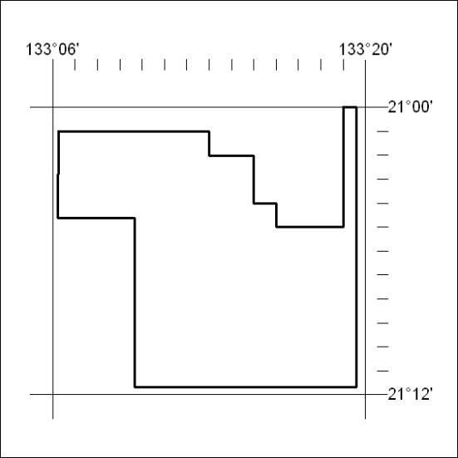

109/18

