Mineral Titles Act
NOTICE OF LAND CEASING TO BE A MINERAL TITLE
Title Type and Number: | Mineral Authority 22962
Area ceased on: | 15 May 2018
Area: | 18.00 Hectare
Locality: | BYNOE
Name of Applicants(s)Holder(s): | 100% A AND SF MADDALOZZO PTY. LIMITED [ACN. 009 624 015]
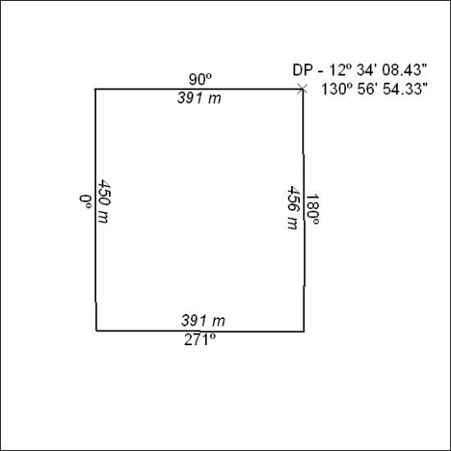

185/18

Mineral Titles Act
NOTICE OF GRANT OF A MINERAL TITLE
Title Type and Number: | Exploration Licence 31664
Granted: | 14 May 2018, for a period of 6 Years
Area: | 248 Blocks, 824.93 km²
Locality: | THROSBY
Name of Holder/s: | 100% MOROAK RESOURCES PTY LTD [ACN. 616 553 014]
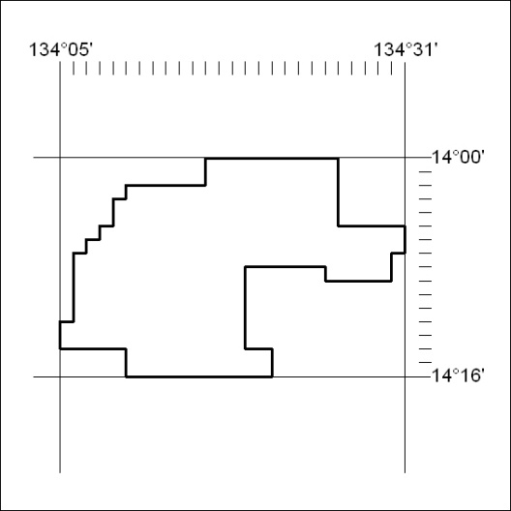
Area granted is indicated above. The titleholder is not permitted to exercise occupational rights on any land that is subject to a development title, or an application for a development title. Any land the subject of a Reserved Land gazettal under the Mineral Titles Act and all land vested in the Commonwealth of Australia is also excluded by description but not excised from the grant area.

186/18

