Mineral Titles Act
NOTICE OF LAND CEASING TO BE A MINERAL TITLE AREA
Title Type and Number: | Exploration Licence 31386
Area Ceased on: | 17 September 2018
Area: | 36 Blocks, 110.42 km²
Locality: | DALY RIVER
Name of Applicant(s)/Holder(s): | 100% CYAN STONE PTY LTD [ACN. 606 864 840]
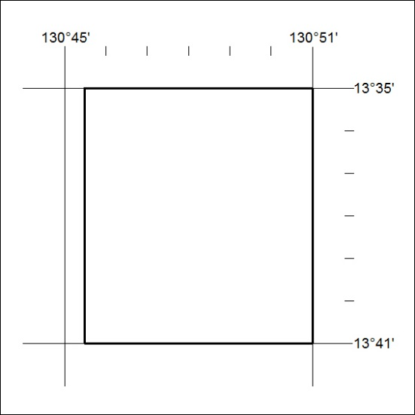

406/18

Mineral Titles Act
NOTICE OF LAND CEASING TO BE A MINERAL TITLE AREA
Title Type and Number: | Exploration Licence 31433
Area Ceased on: | 17 September 2018
Area: | 45 Blocks, 139.89 km²
Locality: | TODD
Name of Applicant(s)/Holder(s): | 100% CYAN STONE PTY LTD [ACN. 606 864 840]
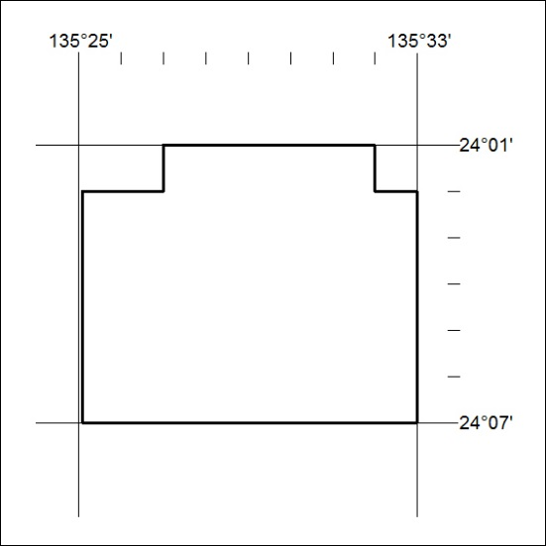

407/18

