Presented by: Dr Geoff Dickinson, DAF, Mareeba Geoff.Dickinson@daf.qld.gov.au |
Funding: CRCNA – Developing Northern Australia and Project Partners
Timeline: January 2018 – December 2020
Project Partners: Manbulloo Ltd, BJM Enterprises, Department of Agriculture and Fisheries, Queensland (DAF) and Australian Mango Industry Association (AMIA)
New intensive mango management systems including high-density and trellis designs have shown great promise to significantly increase the quantity and reliability of fruit yields. Added benefits include adaptation to mechanisation/robotics, greater input efficiency and greater cyclone resilience.
Two large mango growers; Manbulloo Ltd and BJM Enterprises, wish to grow their businesses through greater production of high-quality fruit, suitable for domestic and Asian export markets. These growers have now formed an industry-led venture with DAF and AMIA to commercially trial new mango intensification techniques.
A variety of ‘best-bet’, high-density mango orchard technologies will be established as commercial-scale research trials on 3 properties in Queensland (Mareeba and Bowen) and the Northern Territory (Katherine) using KP, R2E2 and new NMBP varieties to facilitate the transition to next-generation, high-productivity orchard systems. This research joint venture will concurrently investigate industry transition issues from conventional to next generation systems and answer key orchard management questions arising from the change process.
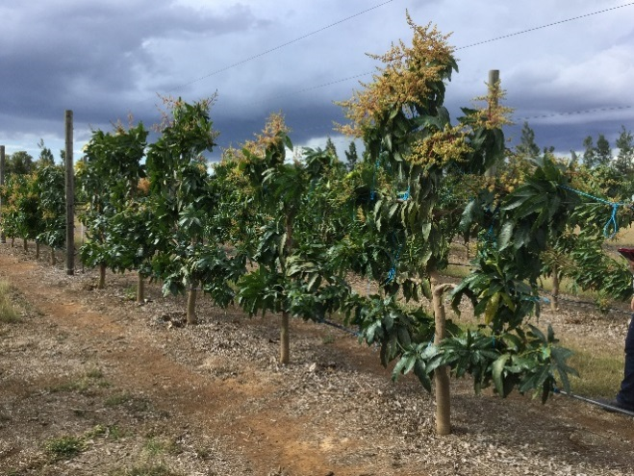
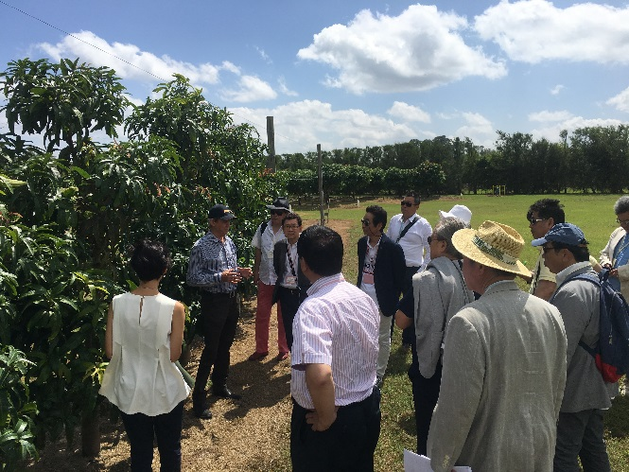
Communication activities co-ordinated by DAF and AMIA will be delivered through well-developed industry networks, to extend the knowledge gained to the national mango industry. New training packages will identify scaling-up and transition issues, backed by an economic analysis to aid orchard transition. This project will create impact for national industry growth through more productive, resilient and reliable orchards, able to service and grow export markets.

