Introduction
Cucumber green mottle mosaic virus (CGMMV) is a tobamovirus that can infect cucurbit plants and is responsible for significant economic losses worldwide. There are several strains of CGMMV worldwide and the primary avenue for spread is through contaminated seed. This provides an infection route between countries and new uninfected cucurbit growing areas.
CGMMV is a highly stable particle that can persist on plant debris, soil, water and seed. Transmission in the ground occurs when seedlings come into contact with contaminated plant debris, soil, machinery, water, seedlings and packing material. See the graphic below for details on methods for movement and spread.
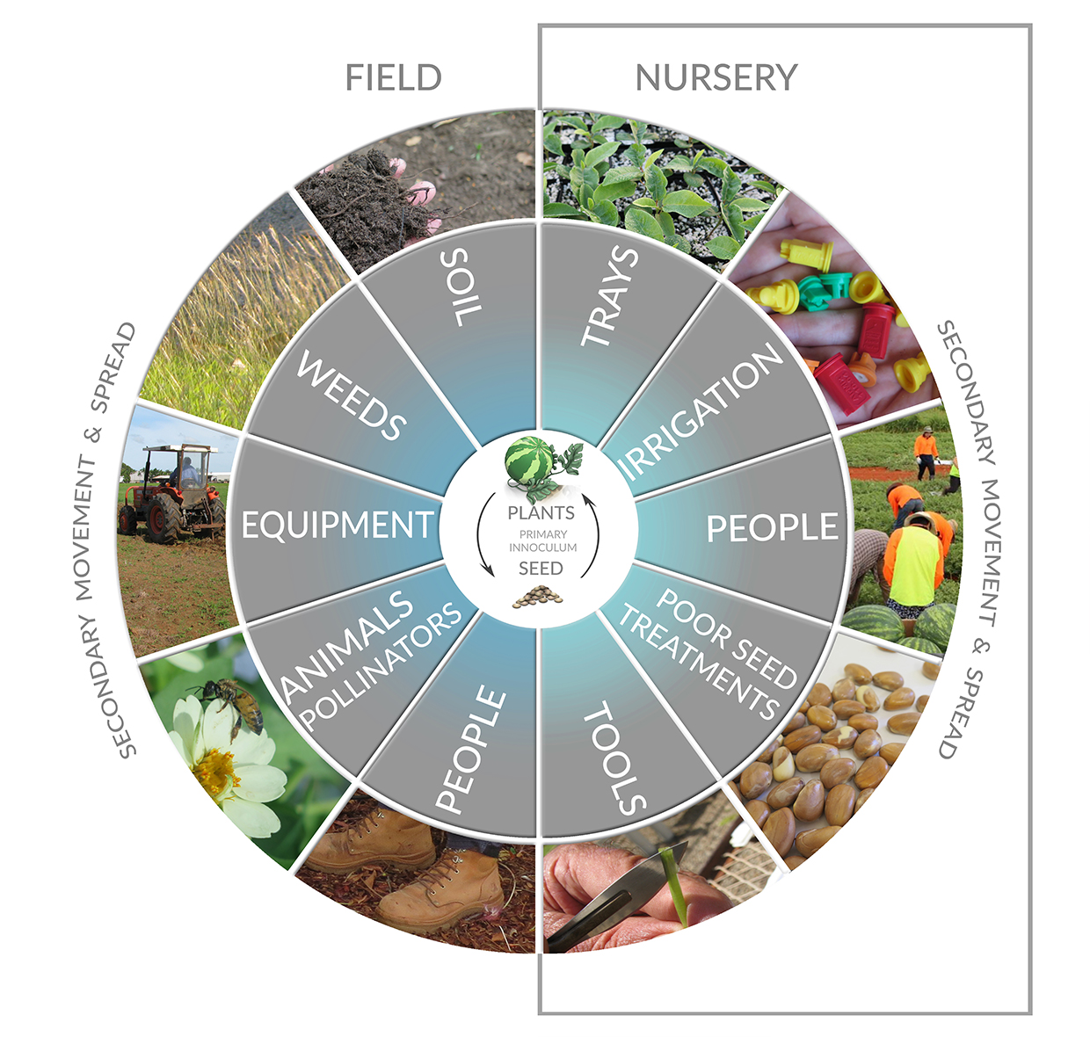

Signs and symptoms
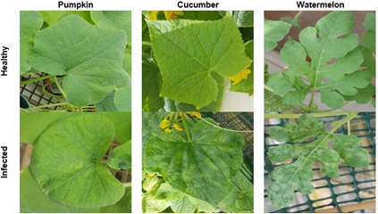
Identifying CGMMV within crops can be difficult early on as visual symptoms may not be observed or distinguishable from other viruses until two-six weeks following infection. This is also dependent upon factors including, initial titre of the virus, temperature during infection, cultivar and species of host which can influence level/load of symptomology.
Melons rarely show symptoms on the outside, however browning and lesions on the peduncle may indicate infection.
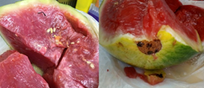
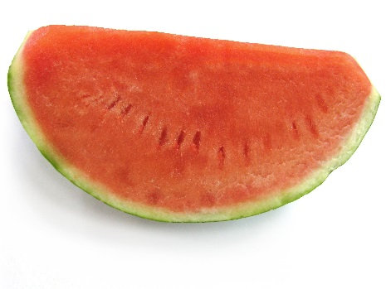
When an infected fruit is cut open, the internal structure is sponge like with a meat texture. In this case, fruit is not suitable for sale.

Above: Healthy (left) and infected (right) watermelon fruit.

Weeds and grasses identified as potential hosts of CGMMV
In glasshouse trials and field surveys, a number of weeds and grasses have been identified as potential hosts of CGMMV. These plants do not show any physical symptoms, making it more difficult to determine if CGMMV is present. See the following table for more information and links to weed descriptions.

Scientific name | Common name
Solanum nigrum | Black nightshade
Amaranthus viridis | Amaranth
Portulaca oleracea | Pigweed
Urochloa mosambicensis | Sabi Grass
Physalis angulata | Wild Gooseberry
Eleusine indica | Crowfoot Grass
Tribulus terrestris | Caltrop

Non-hosts of CGMMV
A range of vegetable and cover crop species were selected for testing to identify whether they are hosts of CGMMV. Dry and wet season crops were tested including:
- sweetcorn
- snake bean
- okra
- capsicum
- peanuts
- sorghum.
Research has identified that these crops are not hosts of the virus, nor do they harbour it for further spread. Sorghum is the most widely used wet season cover crop in the Northern Territory, it is not a host nor will it enable persistence of the virus in the environment

Role of bees and the persistence of CGMMV in honey bee hives
Viable CGMMV found in hives from pollen, honey and adult bees. There is strong evidence that honey bees can introduce CGMMV into clean cucurbit plants. Trials in Israel have shown that bees are able to transfer CGMMV from infected cucurbit plants to clean cucurbit plants in a shade house under specific conditions.¹
Two field trials were conducted in the Northern Territory to assess the role of bees in transmitting the virus. On each occasion, CGMMV was found on the flowers but not the leaves, suggesting that pollinators can introduce the virus into uninfected areas.
All hive products (adult bees and brood, honey, pollen, empty cells, propolis) from the Northern Territory and Queensland trials have been shown to contain CGMMV. The pollen, honey and adult bees have the highest prevalence of the virus. The viability of CGMMV in hive products has been tested. So far, viable virus (capable of causing infection in plants) has been isolated from pollen, honey and adult bees. It is not currently known how long CGMMV remains viable inside bee hives.
CGMMV is typically found on the flower indicating transmission by bees/pollinators.

Good apiary management
Honey bees come into contact with CGMMV when collecting pollen and nectar through their regular foraging activities. Although live CGMMV has been identified in bee hives there is no evidence that CGMMV affects their health. There is some evidence that bees are able to move the virus from CGMMV positive plants to healthy plants and thus transmit the virus but it is unclear whether transmission is also due to mechanical means.
Apiary management requires vigilance of the health of hives. Good biosecurity practices to ensure hive health include:
- regularly checking brood production and appearance
- honey production and worker bee behaviour and appearance.
Other practices that maintain hive hygiene include:
- quarantining and isolating new entrants to the apiary. For bee diseases this is typically four-six weeks
- clean all equipment between hives or loads of hives. If possible, have separate equipment between loads
- store equipment and consumables on the apiary in such a fashion that bees cannot access it
- hive components should only be interchangeable within a load
- honey supers should be separated at the extraction plant and not interchangeable between loads
- the extraction plant and hive equipment should be cleaned between loads to ensure all wax and honey debris is removed. Typically this is done using hot water or steam cleaning.

Understanding CGMMV biology in contaminated soil
CGMMV can persist in the soil for at least 12 months and longer if infected plant debris is present. It is recommended infesed areas are kept weed free of potential hosts (cucurbits and weeds) to ensure the lifecycle of the virus articles ends. This process can take more than 12 months. In the USA, it is recommended that infested soils are left to fallow for three years.
Planting in contaminated soil increases the risk of an infection in the seedlings which can then subsequently infect nearby plants by mechanical means.

Improving diagnostics for plant and seed material
Research efforts have improved the speed and accuracy of CGMMV diagnostics. The project validated a new dipstick test kit which is now commercially available. This test has some cross sensitivity with papaya ringspot virus (PRSV) but provides a fast and accurate in field solution.

Biosecurity considerations
Farm biosecurity plans should identify risks of transmission of CGMMV onto and off the property and measures growers have implemented to address those risks. Such measures may include:
- restricting farm visitor access
- minimising entry and exit of vehicles
- using footbaths upon entry and exit to the property
- cleaning and disinfecting tools and machinery.
- only plant seeds that have been treated using the 9400 seed standard. Visit the Pest risk analysis for CGMMV webpage for more information on this treatment.
- do not share seeds
- practice good hygiene; Come Clean, Go Clean .
Other biosecurity practices that will help limit the spread of CGMMV include:
- sterilisation of vehicles, equipment, plant trays, tools and footwear with potassium peroxymonosulfate or freshly prepared 1% sodium hypochlorite (NaOCl) bleach or 2% Virkon™ S.
- disposal on site of suspect plants and crop residues by burning or deep burial.
- removal of weeds that may harbour viruses in and around cucurbit crops.
- developing a biosecurity plan for your farm. A template for a CGMMV Farm Biosecurity Plan can be found at the melons Australia website .

Contact us
Dr Lucy Tran-Nguyen
Department of Primary Industry and Resources
Phone: +61 8 8999 2235
Email: Lucy.Tran-Nguyen@nt.gov.au
Website: dpir.nt.gov.au
YouTube: dpir.nt.gov.au/youtube

https://keyserver.lucidcentral.org/weeds/data/media/Html/solanum_nigrum.htm
https://www.cabi.org/isc/datasheet/4654
https://www.cabi.org/ISC/datasheet/43609
https://keyserver.lucidcentral.org/weeds/data/media/Html/urochloa_mosambicensis.htm
https://www.cabi.org/isc/datasheet/40711
https://keyserver.lucidcentral.org/weeds/data/media/Html/eleusine_indica.htm
https://www.cabi.org/ISC/datasheet/54447
http://www.agriculture.gov.au/biosecurity/risk-analysis/plant/cucumber-green-mottle-mosaic-virus
https://dpir.nt.gov.au/__data/assets/pdf_file/0008/547163/come-clean-go-clean.pdf
http://www.melonsaustralia.org.au/industry/documents-and-reports/Melon Industry Biosecurity Plan 2014.pdf

