Mineral Titles Act 2010
NOTICE OF LAND CEASING TO BE A MINERAL TITLE AREA
Title Type and Number: | Exploration Licence 24524
Area Ceased on: | 23 April 2019
Area: | 15 Blocks, 42.04 km²
Locality: | GOVE
Name of Applicant(s)/Holder(s): | 100% GROOTE EYLANDT MINING COMPANY PROPRIETARY LIMITED [ACN. 004 618 491]
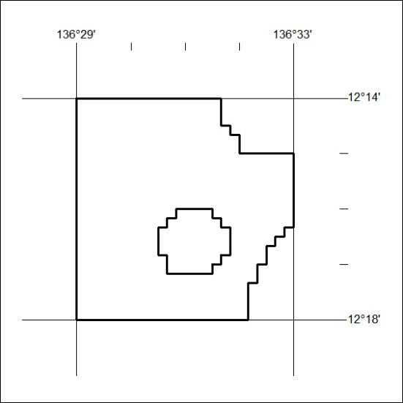

135/19

