Mineral Titles Act 2010
NOTICE OF LAND CEASING TO BE A MINERAL TITLE AREA
Title Type and Number: | Exploration Licence 23506
Area Ceased on: | 07 May 2019
Area: | 25 Blocks, 83.49 km²
Locality: | McKINLAY RIVER
Name of Applicant(s)/Holder(s): | 100% TRL FRANCES CREEK PTY LTD* [ACN. 125 984 401]
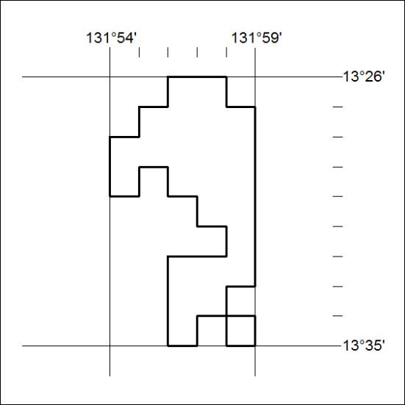

162/19

Mineral Titles Act
NOTICE OF GRANT OF A MINERAL TITLE
Title Type and Number: | Exploration Licence 31980
Granted: | 07 May 2019, for a period of 6 Years
Area: | 68 Blocks, 217.96 km²
Locality: | ARNOLD RIVER
Name of Holder/s: | 100% PENNANT RESOURCES PTY LTD [ACN. 150 501 492]
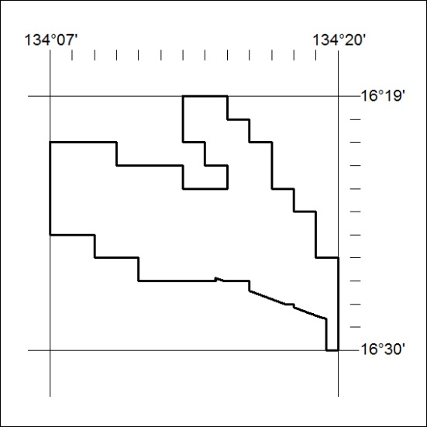
Area granted is indicated above. The titleholder is not permitted to exercise occupational rights on any land that is subject to a development title, or an application for a development title. Any land the subject of a Reserved Land gazettal under the Mineral Titles Act and all land vested in the Commonwealth of Australia is also excluded by description but not excised from the grant area.

163/19

Mineral Titles Act
NOTICE OF GRANT OF A MINERAL TITLE
Title Type and Number: | Exploration Licence 31981
Granted: | 07 May 2019, for a period of 6 Years
Area: | 129 Blocks, 421.45 km²
Locality: | OCTOBER
Name of Holder/s: | 100% PENNANT RESOURCES PTY LTD [ACN. 150 501 492]
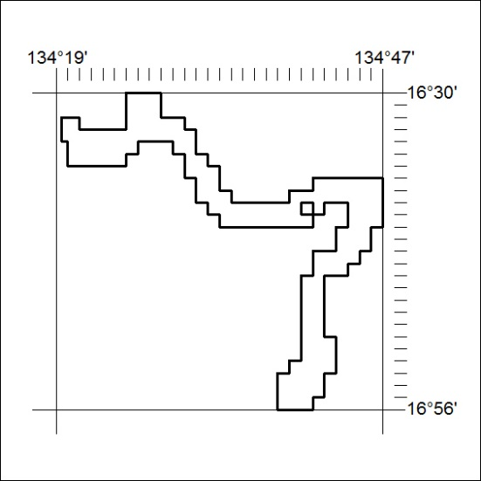
Area granted is indicated above. The titleholder is not permitted to exercise occupational rights on any land that is subject to a development title, or an application for a development title. Any land the subject of a Reserved Land gazettal under the Mineral Titles Act and all land vested in the Commonwealth of Australia is also excluded by description but not excised from the grant area.
164/19

Mineral Titles Act
NOTICE OF GRANT OF A MINERAL TITLE
Title Type and Number: | Exploration Licence 32002
Granted: | 07 May 2019, for a period of 6 Years
Area: | 202 Blocks, 665.03 km²
Locality: | OCTOBER
Name of Holder/s: | 100% PENNANT RESOURCES PTY LTD [ACN. 150 501 492]
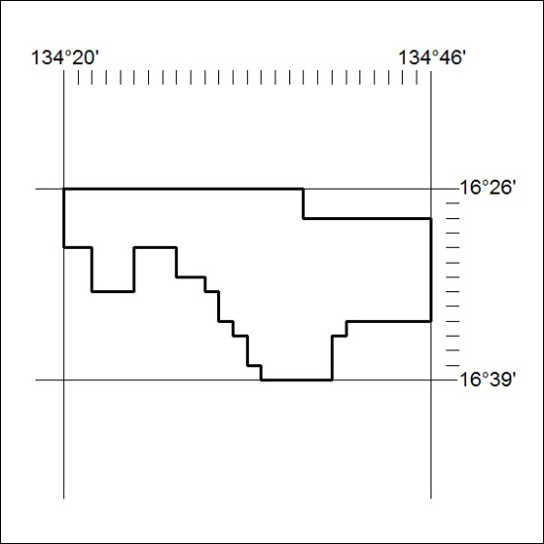
Area granted is indicated above. The titleholder is not permitted to exercise occupational rights on any land that is subject to a development title, or an application for a development title. Any land the subject of a Reserved Land gazettal under the Mineral Titles Act and all land vested in the Commonwealth of Australia is also excluded by description but not excised from the grant area.
165/19

Mineral Titles Act
NOTICE OF GRANT OF A MINERAL TITLE
Title Type and Number: | Exploration Licence 32006
Granted: | 07 May 2019, for a period of 6 Years
Area: | 104 Blocks, 342.56 km²
Locality: | VICTORIA RIVER DOWNS
Name of Holder/s: | 100% PENNANT RESOURCES PTY LTD [ACN. 150 501 492]
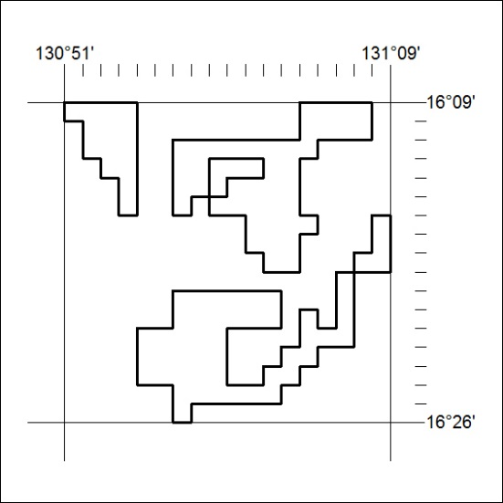
Area granted is indicated above. The titleholder is not permitted to exercise occupational rights on any land that is subject to a development title, or an application for a development title. Any land the subject of a Reserved Land gazettal under the Mineral Titles Act and all land vested in the Commonwealth of Australia is also excluded by description but not excised from the grant area.
166/19

Mineral Titles Act
NOTICE OF GRANT OF A MINERAL TITLE
Title Type and Number: | Exploration Licence 32008
Granted: | 07 May 2019, for a period of 6 Years
Area: | 200 Blocks, 658.77 km²
Locality: | ARNOLD RIVER
Name of Holder/s: | 100% PENNANT RESOURCES PTY LTD [ACN. 150 501 492]
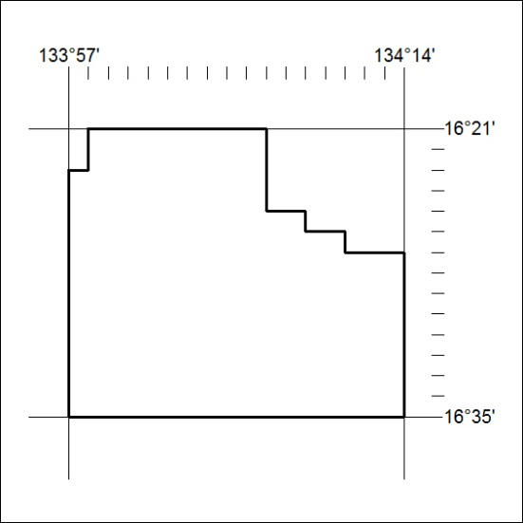
Area granted is indicated above. The titleholder is not permitted to exercise occupational rights on any land that is subject to a development title, or an application for a development title. Any land the subject of a Reserved Land gazettal under the Mineral Titles Act and all land vested in the Commonwealth of Australia is also excluded by description but not excised from the grant area.
167/19

Mineral Titles Act
NOTICE OF GRANT OF A MINERAL TITLE
Title Type and Number: | Exploration Licence 32009
Granted: | 07 May 2019, for a period of 6 Years
Area: | 200 Blocks, 659.40 km²
Locality: | ARNOLD RIVER
Name of Holder/s: | 100% PENNANT RESOURCES PTY LTD [ACN. 150 501 492]
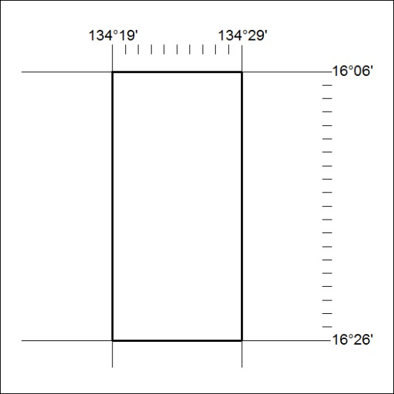
Area granted is indicated above. The titleholder is not permitted to exercise occupational rights on any land that is subject to a development title, or an application for a development title. Any land the subject of a Reserved Land gazettal under the Mineral Titles Act and all land vested in the Commonwealth of Australia is also excluded by description but not excised from the grant area.
168/19

Mineral Titles Act
NOTICE OF GRANT OF A MINERAL TITLE
Title Type and Number: | Exploration Licence 32010
Granted: | 07 May 2019, for a period of 6 Years
Area: | 200 Blocks, 659.41 km²
Locality: | TANUMBIRINI
Name of Holder/s: | 100% PENNANT RESOURCES PTY LTD [ACN. 150 501 492]
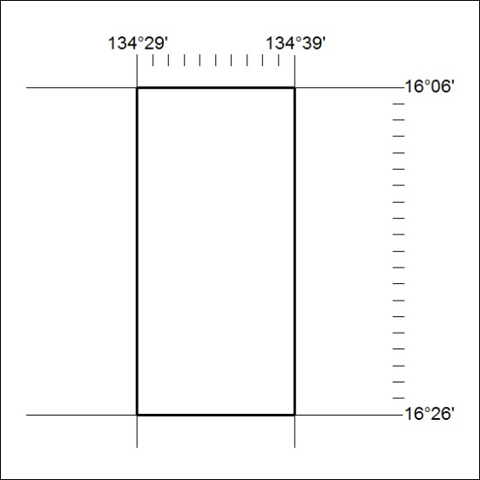
Area granted is indicated above. The titleholder is not permitted to exercise occupational rights on any land that is subject to a development title, or an application for a development title. Any land the subject of a Reserved Land gazettal under the Mineral Titles Act and all land vested in the Commonwealth of Australia is also excluded by description but not excised from the grant area.
169/19

Mineral Titles Act
NOTICE OF GRANT OF A MINERAL TITLE
Title Type and Number: | Exploration Licence 32011
Granted: | 07 May 2019, for a period of 6 Years
Area: | 203 Blocks, 669.12 km²
Locality: | TANUMBIRINI
Name of Holder/s: | 100% PENNANT RESOURCES PTY LTD [ACN. 150 501 492]
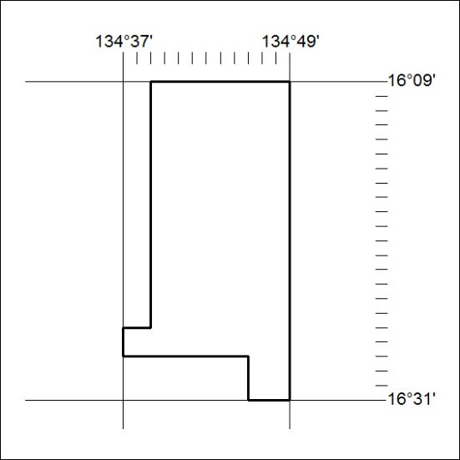
Area granted is indicated above. The titleholder is not permitted to exercise occupational rights on any land that is subject to a development title, or an application for a development title. Any land the subject of a Reserved Land gazettal under the Mineral Titles Act and all land vested in the Commonwealth of Australia is also excluded by description but not excised from the grant area.
170/19

Mineral Titles Act
NOTICE OF GRANT OF A MINERAL TITLE
Title Type and Number: | Exploration Licence 32012
Granted: | 07 May 2019, for a period of 6 Years
Area: | 170 Blocks, 560.05 km²
Locality: | TANUMBIRINI
Name of Holder/s: | 100% PENNANT RESOURCES PTY LTD [ACN. 150 501 492]
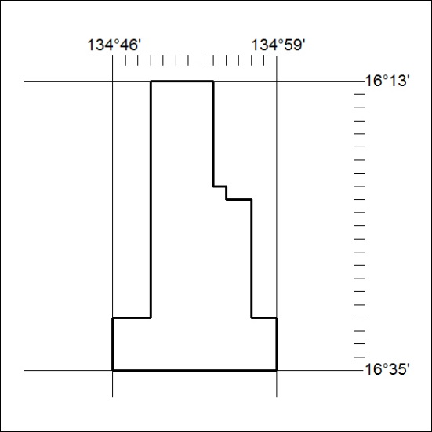
Area granted is indicated above. The titleholder is not permitted to exercise occupational rights on any land that is subject to a development title, or an application for a development title. Any land the subject of a Reserved Land gazettal under the Mineral Titles Act and all land vested in the Commonwealth of Australia is also excluded by description but not excised from the grant area.
171/19

Mineral Titles Act
NOTICE OF GRANT OF A MINERAL TITLE
Title Type and Number: | Exploration Licence 32013
Granted: | 07 May 2019, for a period of 6 Years
Area: | 198 Blocks, 651.37 km²
Locality: | OCTOBER
Name of Holder/s: | 100% PENNANT RESOURCES PTY LTD [ACN. 150 501 492]
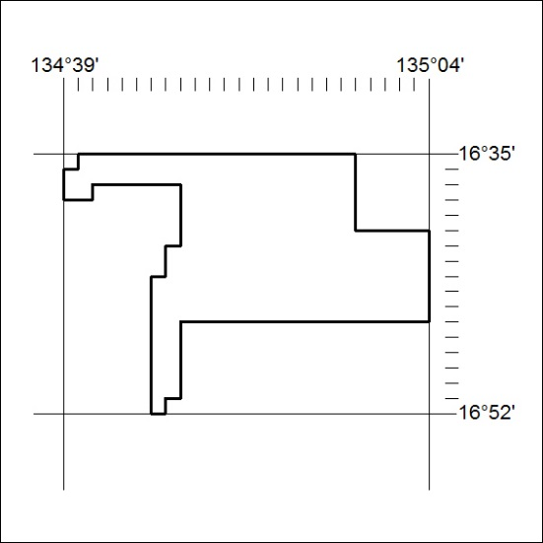
Area granted is indicated above. The titleholder is not permitted to exercise occupational rights on any land that is subject to a development title, or an application for a development title. Any land the subject of a Reserved Land gazettal under the Mineral Titles Act and all land vested in the Commonwealth of Australia is also excluded by description but not excised from the grant area.
172/19

Mineral Titles Act
NOTICE OF GRANT OF A MINERAL TITLE
Title Type and Number: | Exploration Licence 32014
Granted: | 07 May 2019, for a period of 6 Years
Area: | 209 Blocks, 687.29 km²
Locality: | OCTOBER
Name of Holder/s: | 100% PENNANT RESOURCES PTY LTD [ACN. 150 501 492]
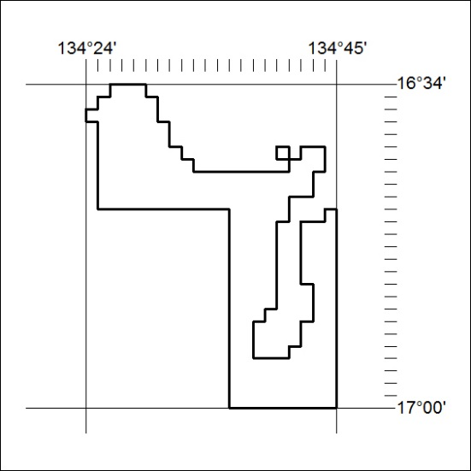
Area granted is indicated above. The titleholder is not permitted to exercise occupational rights on any land that is subject to a development title, or an application for a development title. Any land the subject of a Reserved Land gazettal under the Mineral Titles Act and all land vested in the Commonwealth of Australia is also excluded by description but not excised from the grant area.
173/19

