Mineral Titles Act 2010
NOTICE OF LAND CEASING TO BE A MINERAL TITLE AREA
Title Type and Number: | Exploration Licence 23971
Area Ceased on: | 25 July 2019
Area: | 4 Blocks, 10.46 km²
Locality: | WELLINGTON RANGE
Name of Applicant(s)/Holder(s): | 100% RIO TINTO EXPLORATION PTY LIMITED [ACN. 000 057 125]
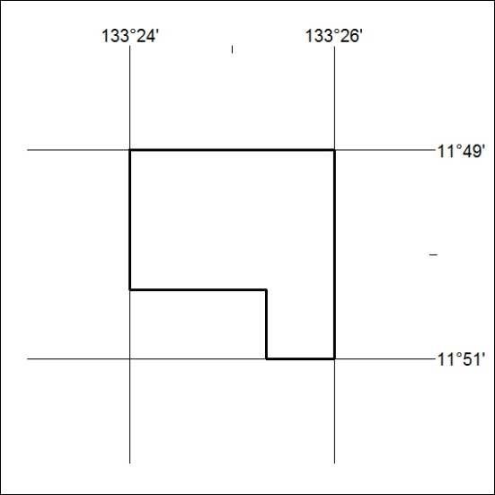

317/19

Mineral Titles Act 2010
NOTICE OF LAND CEASING TO BE A MINERAL TITLE AREA
Title Type and Number: | Exploration Licence 27912
Area Ceased on: | 25 July 2019
Area: | 41 Blocks, 126.84 km²
Locality: | COCKBURN
Name of Applicant(s)/Holder(s): | 100% GEMPART (NT) PTY LTD* [ACN. 081 859 896]
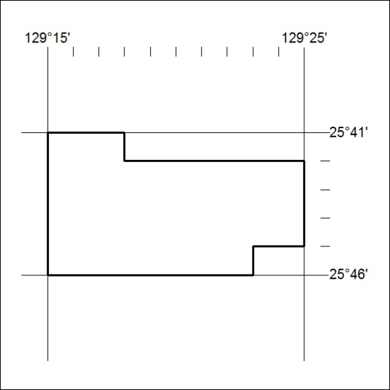

318/19
Mineral Titles Act 2010
NOTICE OF LAND CEASING TO BE A MINERAL TITLE AREA
Title Type and Number: | Exploration Licence 27913
Area Ceased on: | 25 July 2019
Area: | 64 Blocks, 198.19 km²
Locality: | DUFFIELD
Name of Applicant(s)/Holder(s): | 100% GEMPART (NT) PTY LTD* [ACN. 081 859 896]
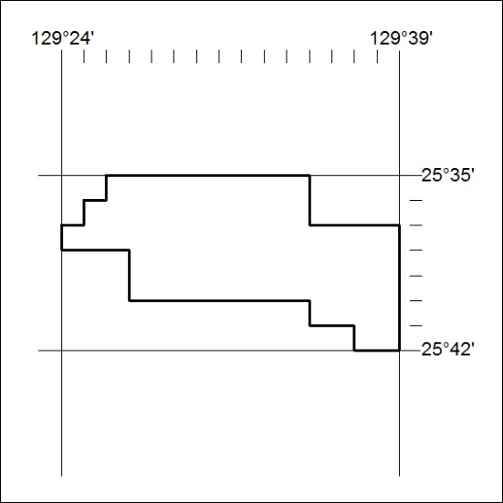

319/19

Mineral Titles Act 2010
NOTICE OF LAND CEASING TO BE A MINERAL TITLE AREA
Title Type and Number: | Exploration Licence 29789
Area Ceased on: | 25 July 2019
Area: | 2 Blocks, 6.30 km²
Locality: | NARWIETOOMA
Name of Applicant(s)/Holder(s): | 56.28% CROSSLAND NICKEL PTY LTD* [ACN. 099 477 915], 43.72% ESSENTIAL MINING RESOURCES PTY LTD [ACN. 601 655 725]
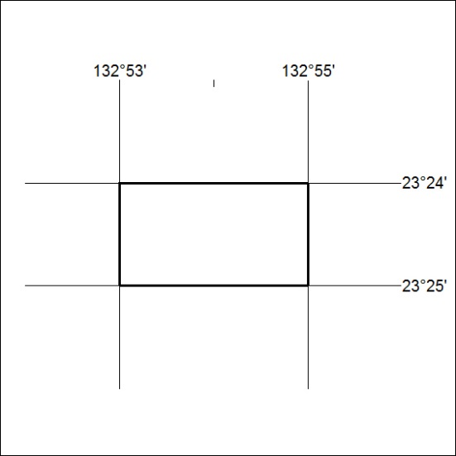

320/19
Mineral Titles Act 2010
NOTICE OF LAND CEASING TO BE A MINERAL TITLE APPLICATION AREA
Title Type and Number: | Exploration Licence 30949
Area Ceased on: | 24 July 2019
Area: | 126 Blocks, 400.39 km²
Locality: | OT DOWNS
Name of Applicant(s)/Holder(s): | 100% MMG EXPLORATION PTY LTD* [ACN. 119 136 659]
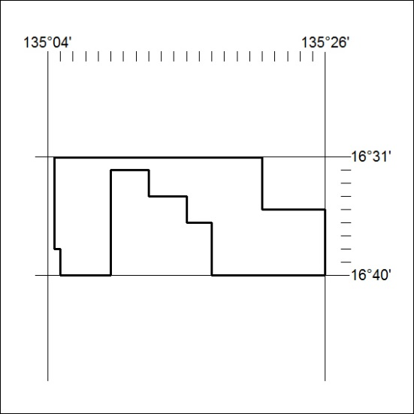

321/19

Mineral Titles Act
NOTICE OF GRANT OF A MINERAL TITLE
Title Type and Number: | Exploration Licence 32027
Granted: | 25 July 2019, for a period of 6 Years
Area: | 25 Blocks, 79.24 km²
Locality: | TAYLOR
Name of Holder/s: | 100% BOWGAN MINERALS LTD [ACN. 137 527 336]
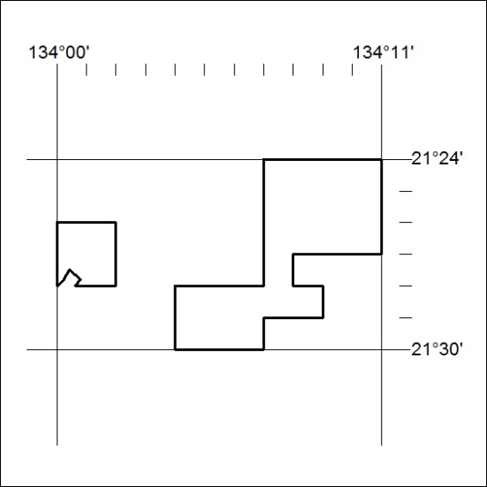
Area granted is indicated above. The titleholder is not permitted to exercise occupational rights on any land that is subject to a development title, or an application for a development title. Any land the subject of a Reserved Land gazettal under the Mineral Titles Act and all land vested in the Commonwealth of Australia is also excluded by description but not excised from the grant area.

322/19

