Mineral Titles Act 2010
NOTICE OF LAND CEASING TO BE A MINERAL TITLE AREA
Title Type and Number: | Extractive Mineral Permit 22217
Area ceased on: | 04 November 2019
Area: | 15.00 Hectare
Locality: | KOOLPINYAH
Name of Applicants(s)Holder(s): | 100% INTEGRITY PTY. LTD. [ACN. 009 635 714]
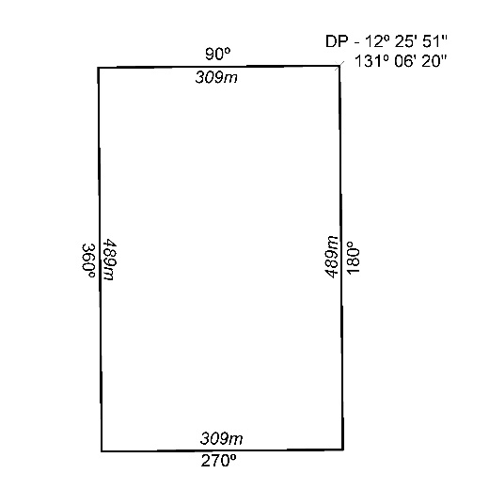

473/19

Mineral Titles Act 2010
NOTICE OF LAND CEASING TO BE A MINERAL TITLE AREA
Title Type and Number: | Extractive Mineral Permit 27239
Area ceased on: | 04 November 2019
Area: | 40.00 Hectare
Locality: | NOONAMAH
Name of Applicants(s)Holder(s): | 100% AH TOY Laurence Cheong
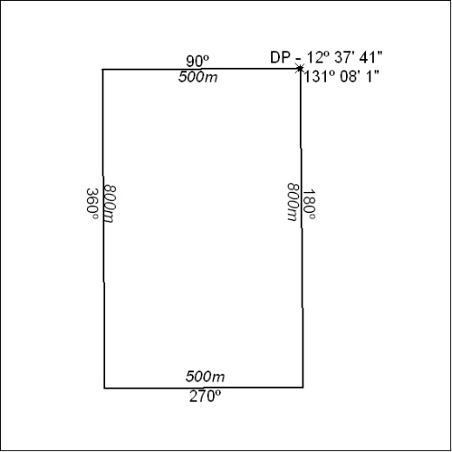

474/19

Mineral Titles Act 2010
NOTICE OF LAND CEASING TO BE A MINERAL TITLE AREA
Title Type and Number: | Mineral Lease 30414
Area ceased on: | 04 November 2019
Area: | 140.00 Hectares
Locality: | ILLOGWA
Name of Applicants(s)Holder(s): | 100% IN MINERALS PTY LTD [ACN. 092 036 603]
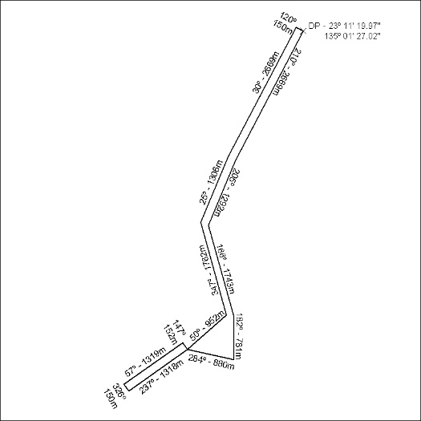

475/19

Mineral Titles Act 2010
NOTICE OF LAND CEASING TO BE A MINERAL TITLE APPLICATION AREA
Title Type and Number: | Exploration Licence 31467
Area Ceased on: | 04 November 2019
Area: | 2 Blocks, 6.46 km²
Locality: | GOSSE RIVER
Name of Applicant(s)/Holder(s): | 100% RED METAL LIMITED [ACN. 103 367 684]
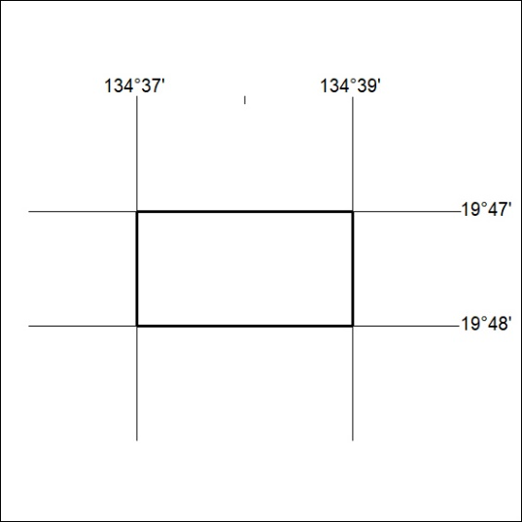

476/19

