Mineral Titles Act 2010
NOTICE OF LAND CEASING TO BE A MINERAL TITLE AREA
Title Type and Number: | Exploration Licence 30797
Area Ceased on: | 24 December 2019
Area: | 22 Blocks, 66.89 km²
Locality: | HOME OF BULLION
Name of Applicant(s)/Holder(s): | 100% BOWGAN MINERALS LTD [ACN. 137 527 336]
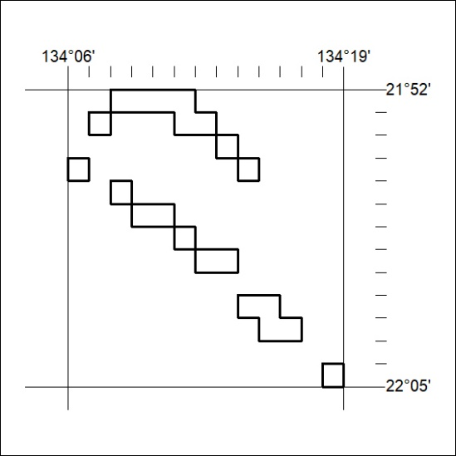
01/20

Mineral Titles Act 2010
NOTICE OF LAND CEASING TO BE A MINERAL TITLE AREA
Title Type and Number: | Mineral Lease (Northern) 90
Area ceased on: | 31 December 2019
Area: | 16.00 Hectare
Locality: | MUNDOGIE
Name of Applicants(s)Holder(s): | 100% NEWCREST OPERATIONS LIMITED [ACN. 009 221 505]
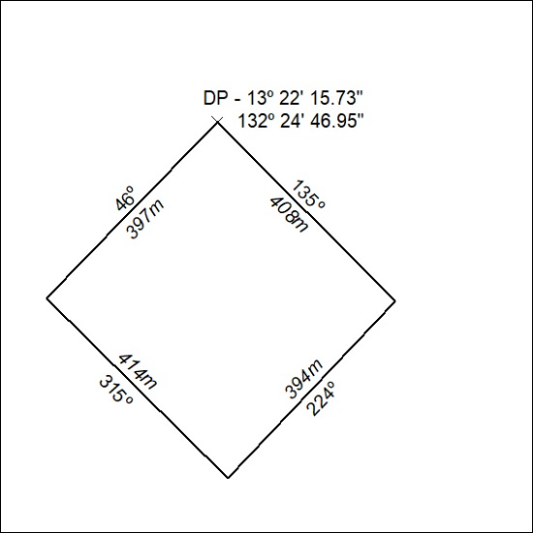
02/20

Mineral Titles Act 2010
NOTICE OF LAND CEASING TO BE A MINERAL TITLE AREA
Title Type and Number: | Mineral Lease (Northern) 91
Area ceased on: | 31 December 2019
Area: | 16.00 Hectare
Locality: | MUNDOGIE
Name of Applicants(s)Holder(s): | 100% NEWCREST OPERATIONS LIMITED [ACN. 009 221 505]
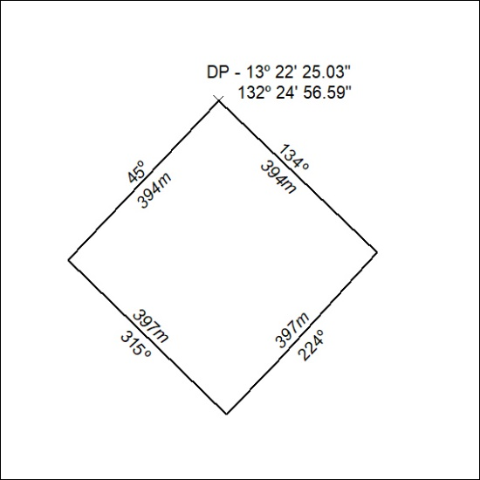
03/20

Mineral Titles Act 2010
NOTICE OF LAND CEASING TO BE A MINERAL TITLE AREA
Title Type and Number: | Mineral Lease (Northern) 92
Area ceased on: | 31 December 2019
Area: | 16.00 Hectare
Locality: | MUNDOGIE
Name of Applicants(s)Holder(s): | 100% NEWCREST OPERATIONS LIMITED [ACN. 009 221 505]
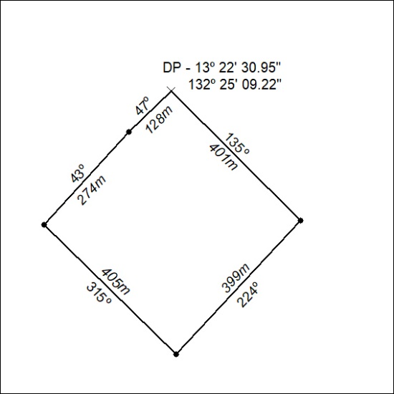
04/20

Mineral Titles Act 2010
NOTICE OF LAND CEASING TO BE A MINERAL TITLE AREA
Title Type and Number: | Mineral Lease (Northern) 93
Area ceased on: | 31 December 2019
Area: | 16.00 Hectare
Locality: | MUNDOGIE
Name of Applicants(s)Holder(s): | 100% NEWCREST OPERATIONS LIMITED [ACN. 009 221 505]
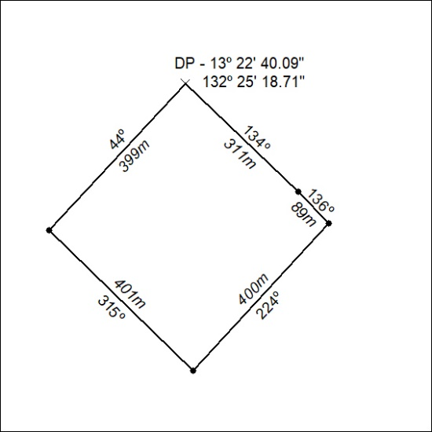
05/20

Mineral Titles Act 2010
NOTICE OF LAND CEASING TO BE A MINERAL TITLE AREA
Title Type and Number: | Mineral Lease (Northern) 94
Area ceased on: | 31 December 2019
Area: | 16.00 Hectare
Locality: | MUNDOGIE
Name of Applicants(s)Holder(s): | 100% NEWCREST OPERATIONS LIMITED [ACN. 009 221 505]
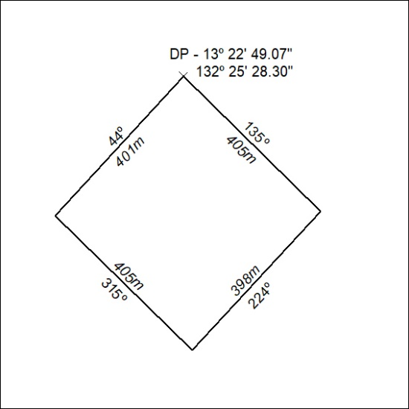
06/20

Mineral Titles Act
NOTICE OF GRANT OF A MINERAL TITLE
Title Type and Number: | Exploration Licence 32122
Granted: | 06 January 2020, for a period of 6 Years
Area: | 143 Blocks, 442.11 km²
Locality: | QUARTZ
Name of Holder/s: | 100% COPPEROZ PTY LTD [ACN. 603 957 124]
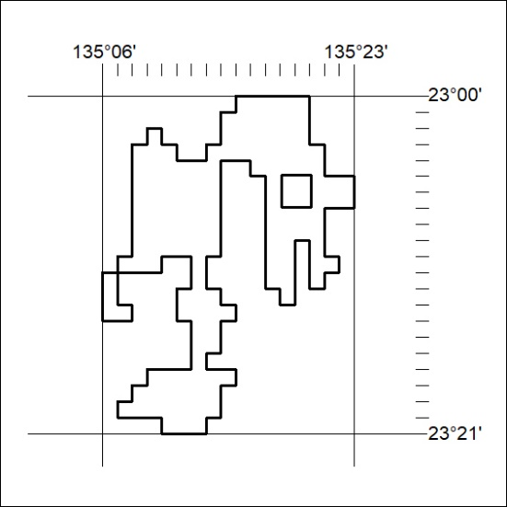
Area granted is indicated above. The titleholder is not permitted to exercise occupational rights on any land that is subject to a development title, or an application for a development title. Any land the subject of a Reserved Land gazettal under the Mineral Titles Act and all land vested in the Commonwealth of Australia is also excluded by description but not excised from the grant area.
07/20

Mineral Titles Act
NOTICE OF GRANT OF A MINERAL TITLE
Title Type and Number: | Extractive Mineral Permit 30340
Granted: | 07 January 2020, for a period of 5 Years
Area: | 12.32 Hectares
Locality: | TAWALLAH RANGE
Name of Holder/s: | 100% NRR MINING PTY LTD* [ACN. 619 218 665]
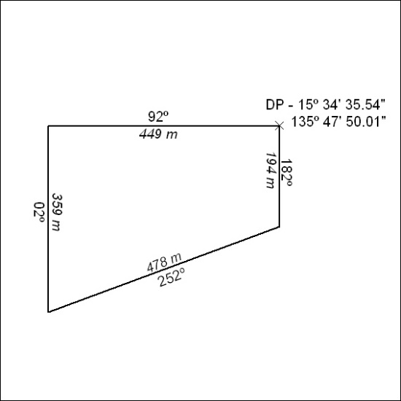
08/20

Mineral Titles Act
NOTICE OF GRANT OF A MINERAL TITLE
Title Type and Number: | Extractive Mineral Permit 30341
Granted: | 07 January 2020, for a period of 5 Years
Area: | 3.00 Hectares
Locality: | TOWNS
Name of Holder/s: | 100% NRR MINING PTY LTD* [ACN. 619 218 665]
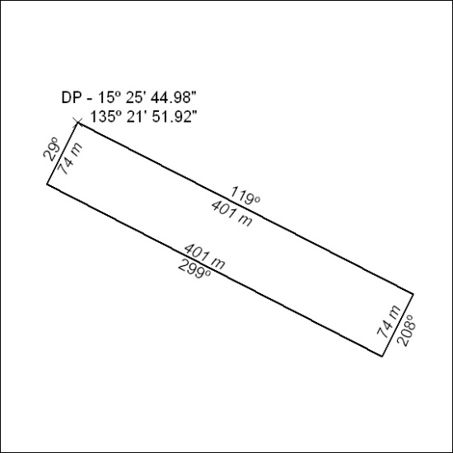
09/20

Mineral Titles Act
NOTICE OF GRANT OF A MINERAL TITLE
Title Type and Number: | Extractive Mineral Permit 30342
Granted: | 07 January 2020, for a period of 5 Years
Area: | 3.00 Hectares
Locality: | TOWNS
Name of Holder/s: | 100% NRR MINING PTY LTD* [ACN. 619 218 665]
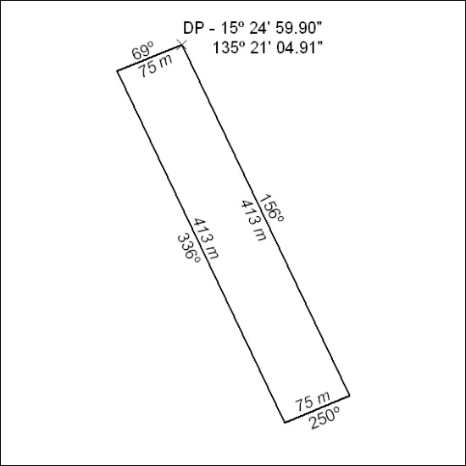
10/20

Mineral Titles Act
NOTICE OF GRANT OF A MINERAL TITLE
Title Type and Number: | Extractive Mineral Permit 30343
Granted: | 07 January 2020, for a period of 5 Years
Area: | 3.00 Hectares
Locality: | TOWNS
Name of Holder/s: | 100% NRR MINING PTY LTD* [ACN. 619 218 665]
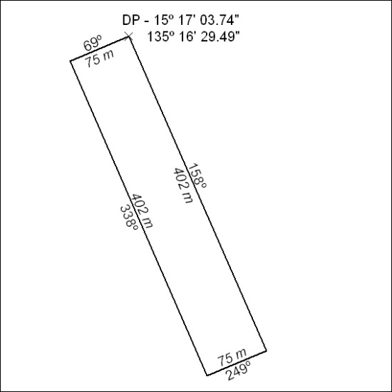
11/20

Mineral Titles Act
NOTICE OF GRANT OF A MINERAL TITLE
Title Type and Number: | Extractive Mineral Permit 30344
Granted: | 07 January 2020, for a period of 5 Years
Area: | 3.00 Hectares
Locality: | TOWNS
Name of Holder/s: | 100% NRR MINING PTY LTD* [ACN. 619 218 665]
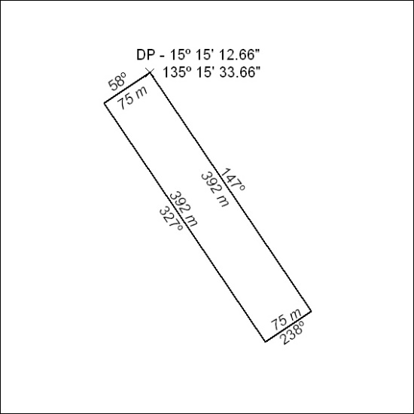
12/20

Mineral Titles Act
NOTICE OF GRANT OF A MINERAL TITLE
Title Type and Number: | Extractive Mineral Permit 30345
Granted: | 07 January 2020, for a period of 5 Years
Area: | 3.00 Hectares
Locality: | TOWNS
Name of Holder/s: | 100% NRR MINING PTY LTD* [ACN. 619 218 665]
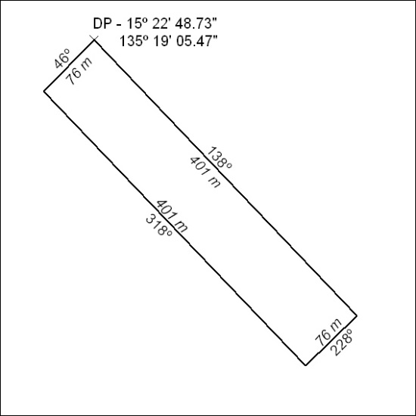
13/20

Mineral Titles Act
NOTICE OF GRANT OF A MINERAL TITLE
Title Type and Number: | Extractive Mineral Permit 30346
Granted: | 07 January 2020, for a period of 5 Years
Area: | 3.00 Hectares
Locality: | TOWNS
Name of Holder/s: | 100% NRR MINING PTY LTD* [ACN. 619 218 665]
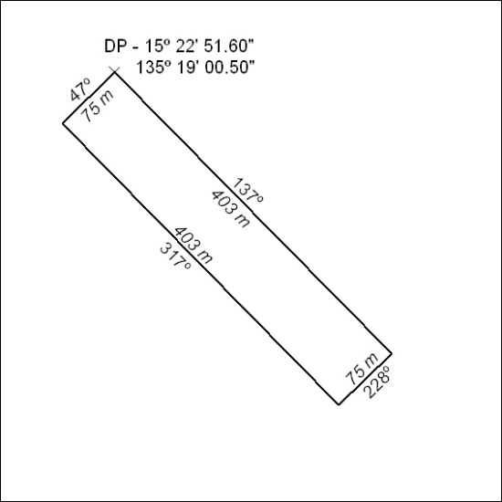
14/20

