Mineral Titles Act
NOTICE OF GRANT OF A MINERAL TITLE
Title Type and Number: | Mineral Lease 32125
Granted: | 11 August 2020, for a period of 25 Years
Area: | 191.10 Hectares
Locality: | NOONAMAH
Name of Holder/s: | 100% DARWIN RIVER QUARRIES PTY LTD [ACN. 167 335 882]
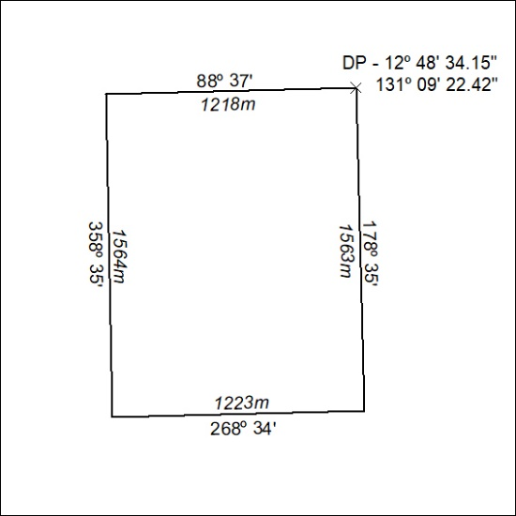

258/20

