Mineral Titles Act 2010
NOTICE OF LAND CEASING TO BE A MINERAL TITLE APPLICATION AREA
Title Type and Number: | Exploration Licence 32442
Area Ceased on: | 12 August 2020
Area: | 6 Blocks, 20.06 km²
Locality: | McKINLAY RIVER
Name of Applicant(s)/Holder(s): | 100% GMG MINING (NT) PTY LTD [ACN. 634 618 410]
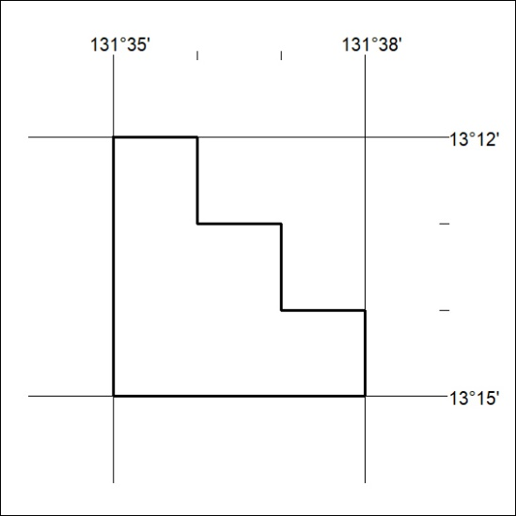

259/20

