Mineral Titles Act 2010
NOTICE OF LAND CEASING TO BE A MINERAL TITLE AREA
Title Type and Number: | Extractive Mineral Lease (Northern) 52
Area ceased on: | 13 August 2020
Area: | 16.00 Hectare
Locality: | KOOLPINYAH
Name of Applicants(s)Holder(s): | 100% ELITE INTERIORS NT PTY LTD [ACN. 153 658 514]
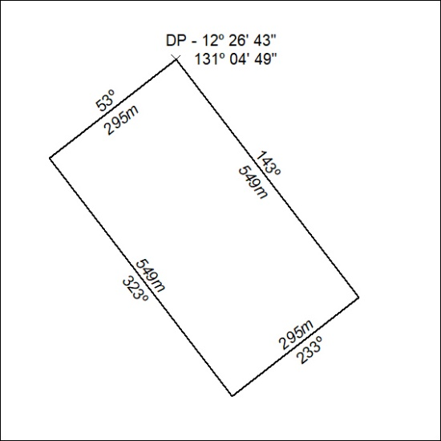

260/20

Mineral Titles Act 2010
NOTICE OF LAND CEASING TO BE A MINERAL TITLE AREA
Title Type and Number: | Extractive Mineral Lease (Northern) 53
Area ceased on: | 13 August 2020
Area: | 15.00 Hectare
Locality: | KOOLPINYAH
Name of Applicants(s)Holder(s): | 100% ELITE INTERIORS NT PTY LTD [ACN. 153 658 514]
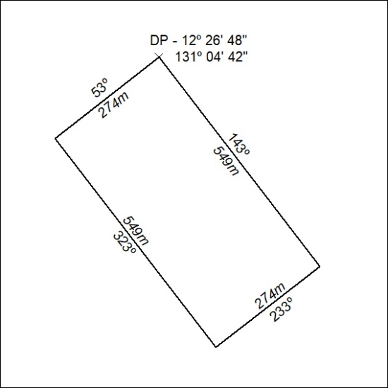

261/20

Mineral Titles Act 2010
NOTICE OF LAND CEASING TO BE A MINERAL TITLE AREA
Title Type and Number: | Extractive Mineral Lease 24626
Area ceased on: | 13 August 2020
Area: | 8.00 Hectare
Locality: | KOOLPINYAH
Name of Applicants(s)Holder(s): | 100% ELITE INTERIORS NT PTY LTD [ACN. 153 658 514]
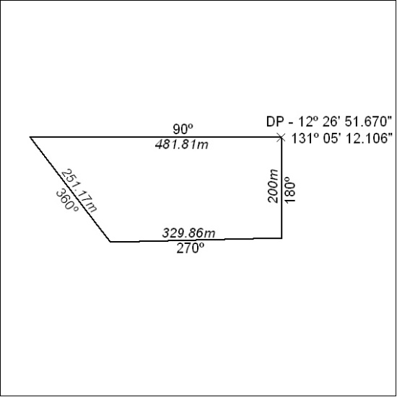

262/20

Mineral Titles Act 2010
NOTICE OF LAND CEASING TO BE A MINERAL TITLE AREA
Title Type and Number: | Extractive Mineral Lease 29506
Area ceased on: | 13 August 2020
Area: | 15.00 Hectare
Locality: | KOOLPINYAH
Name of Applicants(s)Holder(s): | 100% ELITE INTERIORS NT PTY LTD [ACN. 153 658 514]
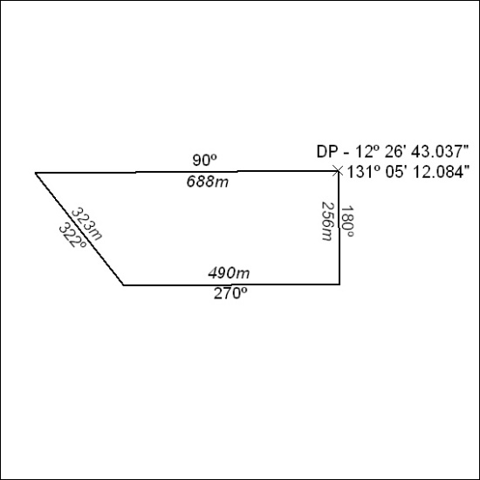

263/20

Mineral Titles Act 2010
NOTICE OF LAND CEASING TO BE A MINERAL TITLE AREA
Title Type and Number: | Extractive Mineral Lease 30140
Area ceased on: | 13 August 2020
Area: | 5.00 Hectare
Locality: | KOOLPINYAH
Name of Applicants(s)Holder(s): | 100% ELITE INTERIORS NT PTY LTD [ACN. 153 658 514]
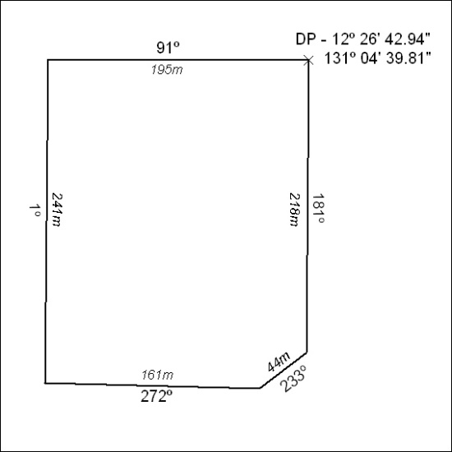

264/20

Mineral Titles Act 2010
NOTICE OF LAND CEASING TO BE A MINERAL TITLE AREA
Title Type and Number: | Extractive Mineral Lease 30141
Area ceased on: | 13 August 2020
Area: | 32.00 Hectare
Locality: | KOOLPINYAH
Name of Applicants(s)Holder(s): | 100% ELITE INTERIORS NT PTY LTD [ACN. 153 658 514]
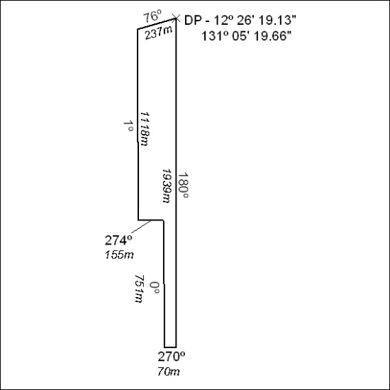

265/20

Mineral Titles Act 2010
NOTICE OF LAND CEASING TO BE A MINERAL TITLE AREA
Title Type and Number: | Extractive Mineral Lease 30142
Area ceased on: | 13 August 2020
Area: | 57.00 Hectare
Locality: | KOOLPINYAH
Name of Applicants(s)Holder(s): | 100% ELITE INTERIORS NT PTY LTD [ACN. 153 658 514]
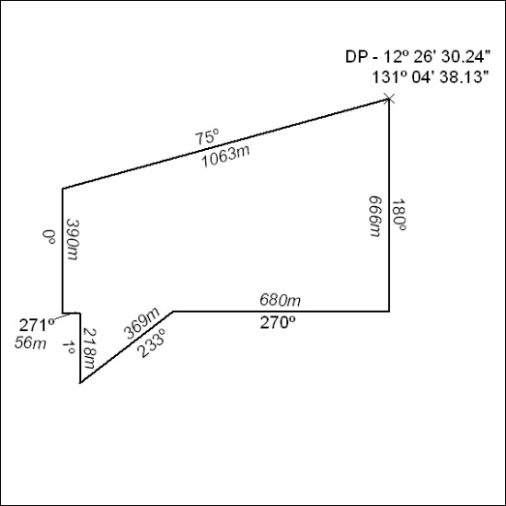

266/20

Mineral Titles Act 2010
NOTICE OF LAND CEASING TO BE A MINERAL TITLE AREA
Title Type and Number: | Extractive Mineral Lease 30143
Area ceased on: | 13 August 2020
Area: | 14.00 Hectare
Locality: | KOOLPINYAH
Name of Applicants(s)Holder(s): | 100% ELITE INTERIORS NT PTY LTD [ACN. 153 658 514]
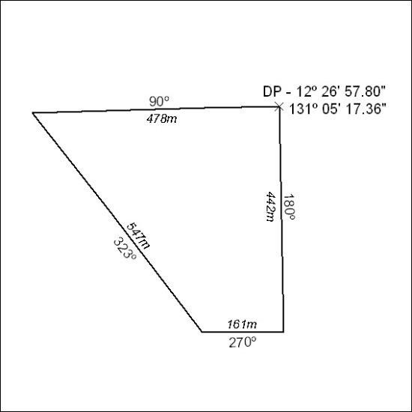

267/20

Mineral Titles Act 2010
NOTICE OF LAND CEASING TO BE A MINERAL TITLE AREA
Title Type and Number: | Extractive Mineral Permit (Northern) 1166
Area ceased on: | 13 August 2020
Area: | 5.00 Hectare
Locality: | KOOLPINYAH
Name of Applicants(s)Holder(s): | 100% ELITE INTERIORS NT PTY LTD [ACN. 153 658 514]
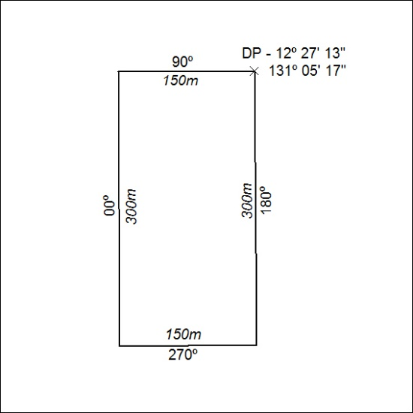

268/20

Mineral Titles Act 2010
NOTICE OF LAND CEASING TO BE A MINERAL TITLE AREA
Title Type and Number: | Extractive Mineral Permit (Northern) 1283
Area ceased on: | 13 August 2020
Area: | 40.00 Hectare
Locality: | KOOLPINYAH
Name of Applicants(s)Holder(s): | 100% ELITE INTERIORS NT PTY LTD [ACN. 153 658 514]
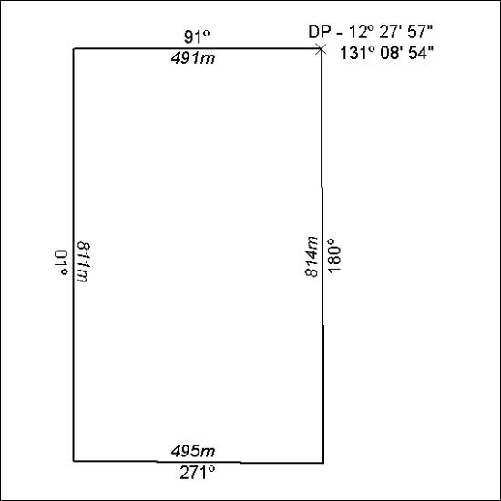

269/20

Mineral Titles Act 2010
NOTICE OF LAND CEASING TO BE A MINERAL TITLE AREA
Title Type and Number: | Extractive Mineral Permit (Northern) 1329
Area ceased on: | 13 August 2020
Area: | 10.00 Hectare
Locality: | KOOLPINYAH
Name of Applicants(s)Holder(s): | 100% ELITE INTERIORS NT PTY LTD [ACN. 153 658 514]
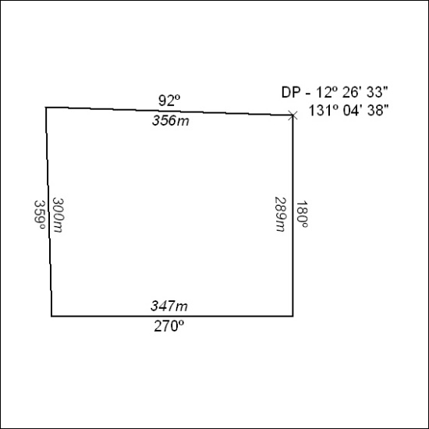

270/20

Mineral Titles Act 2010
NOTICE OF LAND CEASING TO BE A MINERAL TITLE AREA
Title Type and Number: | Extractive Mineral Permit 23051
Area ceased on: | 13 August 2020
Area: | 12.00 Hectare
Locality: | KOOLPINYAH
Name of Applicants(s)Holder(s): | 100% ELITE INTERIORS NT PTY LTD [ACN. 153 658 514]
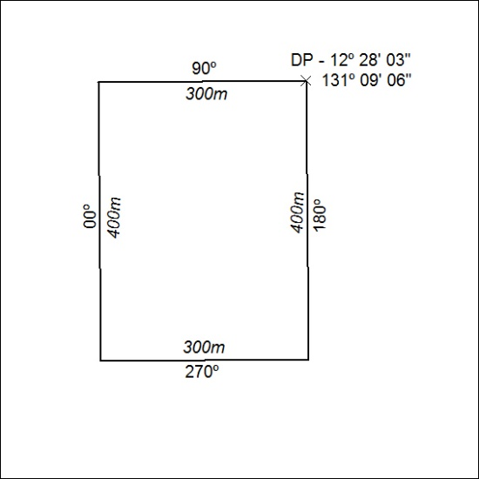

271/20

Mineral Titles Act 2010
NOTICE OF LAND CEASING TO BE A MINERAL TITLE AREA
Title Type and Number: | Extractive Mineral Permit 23600
Area ceased on: | 13 August 2020
Area: | 36.00 Hectare
Locality: | KOOLPINYAH
Name of Applicants(s)Holder(s): | 100% ELITE INTERIORS NT PTY LTD [ACN. 153 658 514]
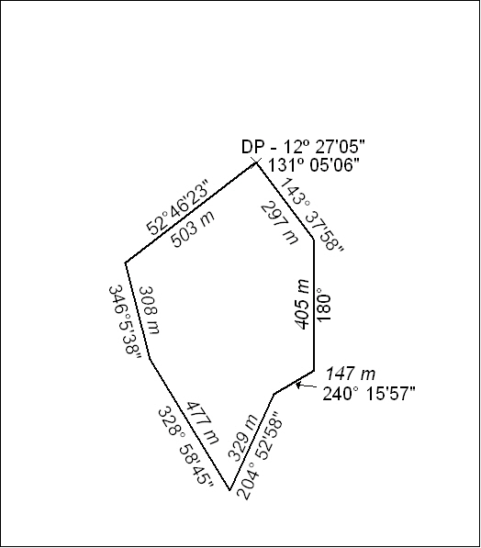

272/20

Mineral Titles Act 2010
NOTICE OF LAND CEASING TO BE A MINERAL TITLE AREA
Title Type and Number: | Extractive Mineral Permit 28571
Area ceased on: | 13 August 2020
Area: | 15.00 Hectare
Locality: | KOOLPINYAH
Name of Applicants(s)Holder(s): | 100% ELITE INTERIORS NT PTY LTD [ACN. 153 658 514]
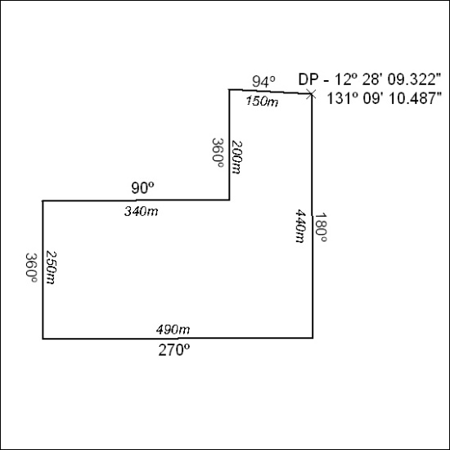

273/20

