Mineral Titles Act 2010
NOTICE OF LAND CEASING TO BE A MINERAL TITLE APPLICATION AREA
Title Type and Number: | Exploration Licence 25272
Area Ceased on: | 29 September 2020
Area: | 171 Blocks, 537.10 km²
Locality: | BAUHINIA DOWNS
Name of Applicant(s)/Holder(s): | 100% ALTA ZINC LIMITED* [ACN. 078 510 988]
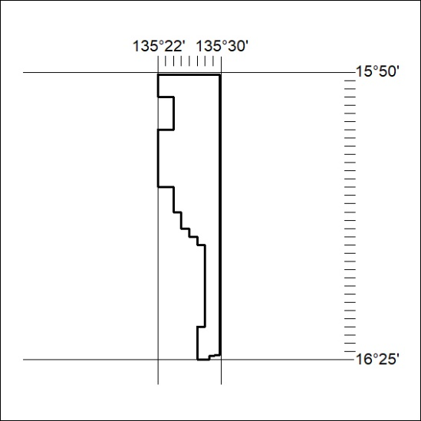
327/20

Mineral Titles Act 2010
NOTICE OF LAND CEASING TO BE A MINERAL TITLE AREA
Title Type and Number: | Exploration Licence 28604
Area Ceased on: | 27 September 2020
Area: | 10 Blocks, 30.35 km²
Locality: | HELEN
Name of Applicant(s)/Holder(s): | 100% OM (MANGANESE) LTD [ACN. 097 091 506]
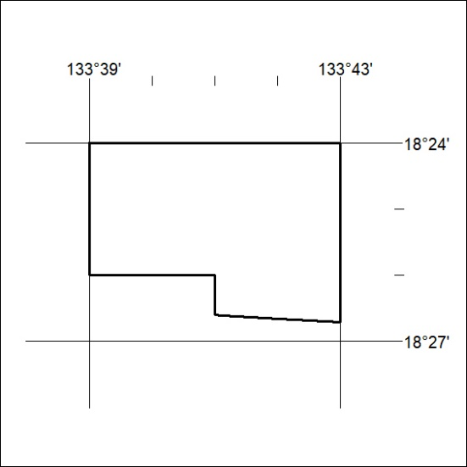
328/20

Mineral Titles Act 2010
NOTICE OF LAND CEASING TO BE A MINERAL TITLE APPLICATION AREA
Title Type and Number: | Exploration Licence 31046
Area Ceased on: | 29 September 2020
Area: | 83 Blocks, 266.30 km²
Locality: | BAUHINIA DOWNS
Name of Applicant(s)/Holder(s): | 100% ALTA ZINC LIMITED* [ACN. 078 510 988]
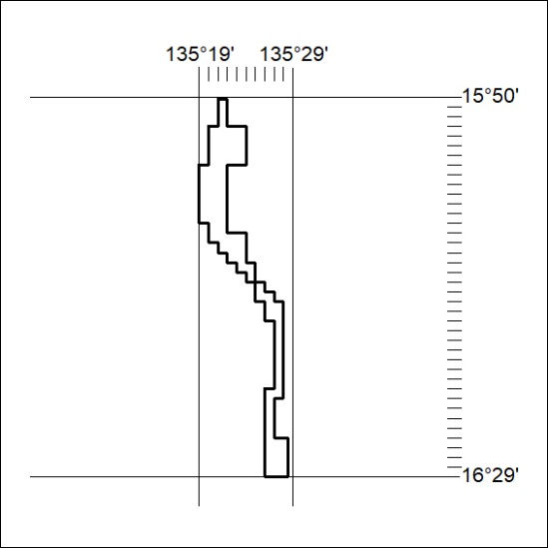
329/20

