Agnote

No: E68
October 2013

Making Round Baled Silage
C. Regan* and A. G. Cameron, Agriculture Development, Darwin
* Formerly DPIF

This Agnote should be read in conjunction with Agnote No. J53: Silage in the Top End, by Barry Lemcke and Arthur Cameron.

INTRODUCTION
Silage is a preserved feed resource for ruminants, such as cattle, buffalo, and goats, and can be stored in many ways including pits, bunkers, and stacks. Baled silage can be made using balers, which produce round bales of hay. The material is baled at a lower dry matter (DM) content and higher moisture than hay, wrapped in plastic film and allowed to ferment into silage.
Almost any pasture can be made into silage. In the Top End of the Northern Territory, silage has been successfully made from a variety of herbage, including Cavalcade, Wynn Cassia, pangola grass, Jarra, Tully, rice straw, maize, grain sorghum and pearl millet. Although the best silage is made from the best quality herbage, a reasonable feed can be made from ensiling a poorer quality material at an early stage of growth, such as spear grass. Weedy pasture can be made into silage, but care must be taken to ensure that any present weeds do not contain substances that are poisonous to stock.

THE PROCESS
Cut the forage when there is a large bulk of plant matter, but before flowers emerge. In the Top End, this will be between late January and mid-February. Cutting at this time will ensure that a good amount of DM is harvested at peak nutrient value, whilst allowing for a second harvest later of the regrowth from late wet season rain.
The cut material should be windrowed and wilted to more than 35% DM. The best silage is made from plant matter of between 40% and 55% DM. Silage made from higher DM material is also very good (it is termed “haylage”), but this is difficult to produce under wet season conditions. Silage made from material with less than 30% DM is not recommended because the high moisture content in each bale will more than likely lead to poor preservation of the plant matter.
After the plant material wilts, it can be baled as normal hay. Silage in round bales is usually made from whole plant matter; however, chopping the material can improve both compaction and the fermentation quality of the silage. If available, use a mower/conditioner because this process releases cell contents to rapid access by fermentation bacteria.
The bales are machine-wrapped in plastic film and stored on their ends (long axis vertical). Bales that are stored on their sides are more easily deformed and there is a greater risk of tearing the plastic film.

MACHINERY REQUIRED
Any round baler can be used. Variable chamber balers are preferred over fixed chamber balers because they compress the material better and produce a bale with a compact and even density from the core to the bale's outer edge (see Figures 1(a) and 1(b)). The higher compression helps improve the fermentation process and reduce spoilage by excluding air and ensures operational efficiency by conserving as much DM per cubic meter as possible.
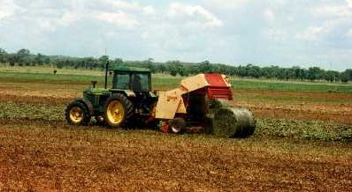
Figure 1(a). Cavalcade being baled using a variable chamber baler

The cut material is approximately 45% DM. The bales are approximately 1200 mm x 1000 mm in size and weigh about 400 kg.
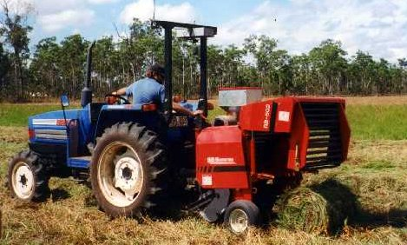
Figure 1(b). A variable chamber baler forming small round bales

Smaller balers are also available (see Figure 1(b)). These are appropriate for the farmer who has only small amounts of pasture to bale and/or only small numbers of ruminants to feed. The bales are 800 mm x 500 mm and weigh 25 kg to 40 kg, depending on the moisture content of the forage.
Notice that the bales in Figure 1(b) are less compressed compared with those shown in Figure 1(a). These are bales of Tully grass and contain about 40% DM and weigh about 25 kg.

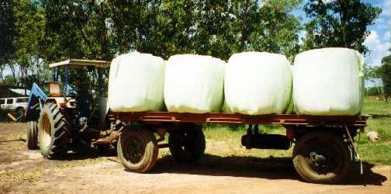
Figure 2. Baled pangola silage

The herbage in Figure 2 was baled at 42% to 45% DM; the mean bale weight was about 440 kg.
The final bale weight depends on the moisture content of the herbage (see Figure 2). The heaviest bales contain the most water (i.e. low DM). The usual size/weight range of herbage bales containing 40% to 55% DM is 1200 mm x 1000 mm, weighing more than 250 kg, to 1900 mm x 1500 mm, weighing up to 800 kg.
The bales are wrapped with a bale wrapper (see Figure 3). This machine puts the bale on a turntable and encloses the herbage in specially developed stretch plastic film. The film comes in 1500-m rolls, which are 750 mm wide x 25 μm thick (for large bales) and 250 mm x 32 μm (for wrapping smallest bales). The film forms a watertight and airtight seal by stretching as it is applied, then shrinking and clinging to other plastic layers using the chemical tackyfier. A “tackyfier” is a chemical which is tacky to the touch. It seals airtight.
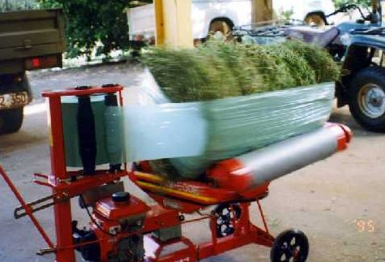
Figure 3. A small bale wrapper in operation

The turntable spins as the plastic film is stretched and applied. The conveyer belt on the turntable makes the bale rotate on its long axis.
Small bales can be manually handled, but large bales need to be moved mechanically. Care needs to be taken that the plastic film is not torn. Hydraulically-operated bale-grabbers are preferred to slings or front-end loader buckets. Tears in the plastic film should be immediately repaired with patching tape to prevent spoilage.

OPERATIONAL CONSIDERATIONS
Having your own equipment is preferred if your enterprise is sufficiently large to justify this capital outlay. In other cases, using a contractor would be preferred. Contractor rates will vary depending on what they are required to do. For example, the most cost-effective process is when you cut and windrow the pasture, and the contractor simply picks up the wilted windrows, forms the bales and then wraps them in plastic film. You then stack the wrapped bales. Due to high transport costs, most contractors would be reluctant to accept small jobs, such as making fewer than one hundred 300-kg bales per day. Costs are much lower for making and wrapping smaller bales.

HOW GOOD IS THE SILAGE
Well-preserved silage is nutritionally similar to the original plant material and better than the same material made into hay later in the dry season. However, even our best preserved tropical pastures will not support high levels of ruminant production when used as the sole feed; feed supplements are still necessary. The reason is that tropical pastures are generally lower in digestibility and provide less energy than temperate pasture species. Nevertheless, the conservation of tropical herbage as either hay or silage is recommended because this significantly reduces the amount of supplement and/or feed that would otherwise need to be purchased during the dry season. A comparison of nutrient values of tropical and temperate forages conserved as silage or hay is presented in Table 1.
Table 1. Representative nutrient values for temperate and tropical forages conserved either as hay or silage
 |  |  | Tropical species |  |  |  |  | Temperate species
 |  | Cavalcade |  |  | Pangola |  | Lucerne |  |  | Maize
 |  | hay |  | silage | hay | silage | hay |  | silage | hay | silage
DM (%) |  | 92 |  | 50 | 90 | 50 | 90 |  | 30 | 88 | 25
Digestibility (% DM) |  | 42 |  | 53 | 48 | 55 | 65 |  | 65 | 70 | 65
Metabolisable energy (ME) (MJ/ kg DM) |  | 6.5 |  | 7.1 | 7.1 | 8.0 | 9.9 |  | 9.6 | 9.1 | 9.0
Crude protein (% DM) |  | 13.0 |  | 16.0 | 9.0 | 11.0 | 20.0 |  | 18.0 | 17.0 | 18.0

HOW CAN SILAGE QUALITY BE IMPROVED?
Silage can be improved by including additives during bale formation and before wrapping. Inoculants, and carbohydrates like molasses, can improve fermentation and enhance the preservation of the ensiled material, but generally do not significantly improve the nutrient value of the preserved material compared with the original source. Adding salt or urea immediately before ensiling can improve the nutrient value of preserved pasture, but this may interfere with the silage fermentation process. In most cases, additives are used to enhance the fermentation process and supplements are added to increase the nutrient value at feeding.
The most important factor in ensuring good silage fermentation and maximising the nutrient content of the preserved material is to wilt the herbage to between 40% and 55% DM before baling.

HOW DO I KNOW HOW GOOD IS THE SILAGE?
A number of commercial laboratories around Australia analyse forages. For about $40 per sample, most laboratories will provide you with pre-paid postage sealable sample bags and analyses are quick with results normally being reported within 10 days. An example is FEEDTEST Analysis of Livestock Feeds for nutritive value: Agriculture Victoria, Pastoral and Veterinary Institute, Private Bag 105, Hamilton Victoria 3300. Such laboratories report on:
DM content, (%)
ME content, (MJ/kg DM)
Digestibility, (% DM)
Crude protein content; (g/kg DM)
It is a good idea to have regular analyses done if you are feeding for definite production targets and need to formulate specific diets for animals.
Without commercial or chemical analysis, a rough indication of silage quality can be estimated as shown in Table 2.
Table 2. Non-technical indicators of silage quality
 | Good quality silage | Poor quality silage
Original pasture | - Good quality pasture  - Plant matter wilted to >40% DM  - Plant growth stage vegetative, before flowering  - Pasture fertilised during growth  - No weeds  - Baled after rapid wilt and in dry sunny conditions  - Bales well compacted | - “Pasture” of uncertain quality  - Plant matter <40% DM  - Plant growth stage either very young or very mature (crop in full flower or later)  - Pasture not fertilised  - Significant weed contamination  - Baled after slow wilt and during overcast or damp conditions  - Bales poorly compacted
Silage at feeding | - Sweet acid smell  - Low incidence of surface mould  - Even khaki / green colour  - Detail of leaf and stem clearly visible  - Silage feels moist but not wet  - pH <4.5 | - Musty, sour, or ammonia smell  - Significant mould growth, extending well below the surface  - Black, burnt patches;  - Decomposed: leaf detail obscure  - Silage feels greasy, can squeeze water from a handful  - pH >6.0

STORAGE
Since rainfall will not affect baled silage, it can be stored in the open. However, if the plastic film is punctured or torn, serious losses can occur. Therefore, baled silage should not be stored under trees (falling branches), or on bare untreated ground (termites), and should be protected from inquisitive local vermin (e.g. rats). Control vermin by placing Bromakil® blocks, or another similar product amongst the stored bales.
The best storage location is any solid, smooth surface which will not allow impact punctures. Bales should be stored with their long axis vertical. It is not recommended to store bales more than two layers high because of the high pressures experienced by bales in the lowest layer.

NUTRIENT LOSSES
Compared with natural pasture, all conserved forages are lower in nutrient value. Some losses are unavoidable, but good management practices can keep the nutrient reduction to a minimum. Losses are caused in three main ways:
Field Losses
These are caused in three ways:
- Mechanical. As the DM content increases and/or the number of turnings of the windrow increase, nutrients can be lost by leaf shatter and consequent leaf fall. Mechanical losses can be minimised by turning the windrows only once or twice and by baling when the DM content is less than 55%.
- Biochemical. These unavoidable losses are due to the continuing chemical activities of the plant after harvest (decomposition). These losses are minimised by the speed of the process, i.e. by wilting rapidly to between 40% and 55% DM, then baling and wrapping as soon as possible.
- Leaching. Rainfall on cut material can quickly leach nutrients. This loss can be minimised or prevented by carefully watching the weather and cutting only enough pasture so that all material can be wilted, baled and wrapped on the same day.
Storage Losses
Two main processes cause these losses:
- Fermentation. Nutrient losses due to fermentation are unavoidable, but can be kept to approximately 3%. The organisms responsible for the fermentation determine the extent of losses. Good fermentations are dominated by lactic acid-producing bacteria. These organisms will only digest some plant sugars. They favour material of high DM content (>40% DM). Clostridial bacteria dominate poor fermentations. These organisms will digest both plant sugars and plant proteins. They can significantly reduce the feed nutrient value. Clostridia favour moist conditions (the more moist the material, that is, the lower the %DM, the greater the likely nutrient loss).
- Spoilage. These losses result from the presence of air in the bale. Poorly compacted bales contain a lot of trapped air. Fungal organisms use the oxygen in the trapped air to digest the stored plant matter. The same thing happens if air gets into the bale during storage (e.g. by poor sealing, or by tearing of the plastic film). These losses are minimised by high bale compaction, ensuring a good seal when the bale is wrapped and by repairing any tears in the plastic as soon as they appear.

Feeding Losses
The extent of these losses depends on the methods chosen to feed the silage. These losses are greater in tropical areas because of the sustained higher air temperatures compared with temperate areas. Feeding from troughs or on concrete floors results in less loss than feeding directly on the ground (see Figure 4). As soon as the bale is opened, oxygen becomes available and the material starts to decompose and the deterioration in feed value accelerates. This can be minimised by ensuring the amount of feed available is appropriate for the number of animals to be fed. For example, a 300-kg bale opened and fed to three cows will result in significant waste. It would be better to use smaller bales (if they are an option), or roll enough silage off the bale for two or three days' feed and reseal the remainder as best you can.
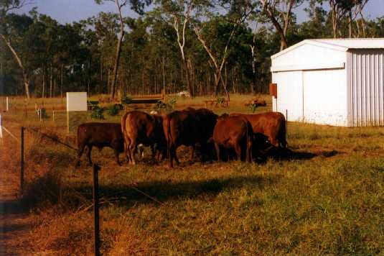
Figure 4. Feeding losses can be very high if the silage is simply tipped onto the ground in the paddock

Warning
Pasture plants have the potential to become weeds in certain situations. To prevent that, ensure that pasture seeds and/or vegetative materials are not inadvertently transferred to adjacent properties or road sides.

Please visit us at our website:
www.nt.gov.au/d

© Northern Territory Government
ISSN 0157-8243
Serial No. 787
Agdex No. 132/52

Disclaimer: While all care has been taken to ensure that information contained in this document is true and correct at the time of publication, the Northern Territory of Australia gives no warranty or assurance, and makes no representation as to the accuracy of any information or advice contained in this publication, or that it is suitable for your intended use. No serious, business or investment decisions should be made in reliance on this information without obtaining independent and/or professional advice in relation to your particular situation.

