Australian Office

Level 7, 151 Macquarie Street Sydney NSW 2000 Australia T: +61 2 9251 1846

F: +61 2 9251 0244

**Imperial Oil & Gas**

**Environment Plan Summary**

**EP184**

**Wells: BCF SC 05, BCF SC 04, BCF SC 03 and BCF SC 02**

**Document title** EP184-BCFSC02-05-XPN-EMP-SUM-001-Rev03

|  |  |  |  |  |  |
| --- | --- | --- | --- | --- | --- |
| **Rev** | **Status** | **Prepared by** | **Checked by** | **Approved by** | **Date** |
| 03 | Issued to NT DME | C. Eickhoff | G. Hokin | G. Hokin | 3/07/2014 |

Signature of approved person:



EP184-BCFSC02-05-XPN-EMP-SUM-001-Rev03

**Contents**

1 Introductions......................................................................................3

2 Description of the activity ..................................................................4

3 Existing environment .........................................................................5

3.1 Socio-economic Environment.......................................................5

3.2 Physical environment ...................................................................5

4 Environmental RISKS, their assessment and management ..............8

5 undertaken and ongoing consultation ..............................................14

Contact details for operator’s nominated liaison personnel

Communication Contacts Directory................................................15

**List of Tables**

Table 1: Proposed location of the core holes. ......................................... 3

Table 2: Data were retrieved from the Australian Government

Bureau of Meteorology site [http://www.bom.gov.au](http://www.bom.gov.au/) at

the 28/05/2014. 6

Table 3: Environmental Management Controls. ...................................... 9

Table 4: Contact Details of personnel. .................................................. 15

**List of Figures**

Figure 1: Locality map of proposed core holes within EP184. ................. 4

Figure 2: Mean monthly rainfall for Ngukurr. Data from Table 2 used. .... 6

Figure 3: EP184 soil types. ..................................................................... 7

**1 INTRODUCTIONS**

Exploration Permit (EP) 184 is located in McArthur Basin of the Northern Territory, with the Roper River forming its northern border. EP184 is centred approximately

350 km southeast of Darwin and 250 km east of Katherine (refer Figure 1).

The nearest sizeable communities to the proposed drilling activity is Ngukurr. No activities will be conducted within 5 km of this community. The proposed drilling activity, which will be conducted on a 12 hour basis, should have minimal aural and visual impact. In limited circumstances the drilling rig may be visible from the highway.

Imperial Oil & Gas (IOG), as Tenement Holder and Operator, proposes to undertake a number of activities during the 2014 dry seasons to review the prospectivity of EP184 for the presence of hydrocarbons within the McArthur Basin.

The objective of the exploration program is to delineate a hydrocarbon resource of conventional and unconventional gas from the dolomites and shales found within the chronostratigraphic equivalent to the Barney Creek Formation in the Urapunga Fault Zone of the McArthur Basin, the Saint Vidgeon Formation.

The core hole drilling and rehabilitation operations activity covered by this Environmental Management Plan (EMP) summary is for the wells BCF SC 02, BCF SC 03, BCF SC 04 and BCF SC 05 in EP184 at the location mentioned in Table 1.

Table 1: Proposed location of the core holes.

|  |  |  |  |
| --- | --- | --- | --- |
| **Well Name** | **Easting** | **Northing** | **GL [m]** |
| **BCF SC 02 (lat/long)\*** | 134°51'11.33"E | 14°49'50.33"S | 25 |
| **BCF SC 02 (decimal)\*** | 484200 m E | 8360400 m S | 25 |
| **BCF SC 03 (lat/long)\*** | 134°45'28.8" | 14°52'44.7" | 25 |
| **BCF SC 03 (decimal)\*** | 473968 m E | 8355033 m S | 25 |
| **BCF SC 04 (lat/long)\*** | 134°45'12.92" | 14°55'38.29" | 38 |
| **BCF SC 04 (decimal)\*** | 473500 m E | 8349700 m S | 38 |
| **BCF SC 05 (lat/long)\*** | 134°45'49.63"E | 14°57'20.20"S | 45 |
| **BCF SC 05 (decimal)\*** | 474600 m E | 8346570 m S | 45 |

*NB: predicted coordinates and elevation subject to actual survey.

**2 DESCRIPTION OF THE ACTIVITY**

Imperial Oil & Gas Ltd, proposes to drill four vertical pilot and partly cored exploration holes in the McArthur Basin of the Northern Territory, approximately 500 km southeast of Darwin and 250 km east of Katherine. These holes are proposed as exploration wells targeting the Barney Creek Formation equivalent, the Saint Vidgeon Formation, within the Umbolooga Sub-group of the McArthur Group in the Urapunga Fault Zone.

In a first stage four shallow wells will be drilled and HQ cored with the objective of collecting fresh rock samples of the target formation for geochemical analysis and source rock potential estimates.

The well sites are located between 17-25 km south southeast of Ngukurr with BCF SC 02 being the closest and BCF SC 05 the furthest away, and can be accessed through existing and new access tracks.

Proposed routes indicating roads, tracks, permit boundaries and other infrastructure are displayed in Figure 1.

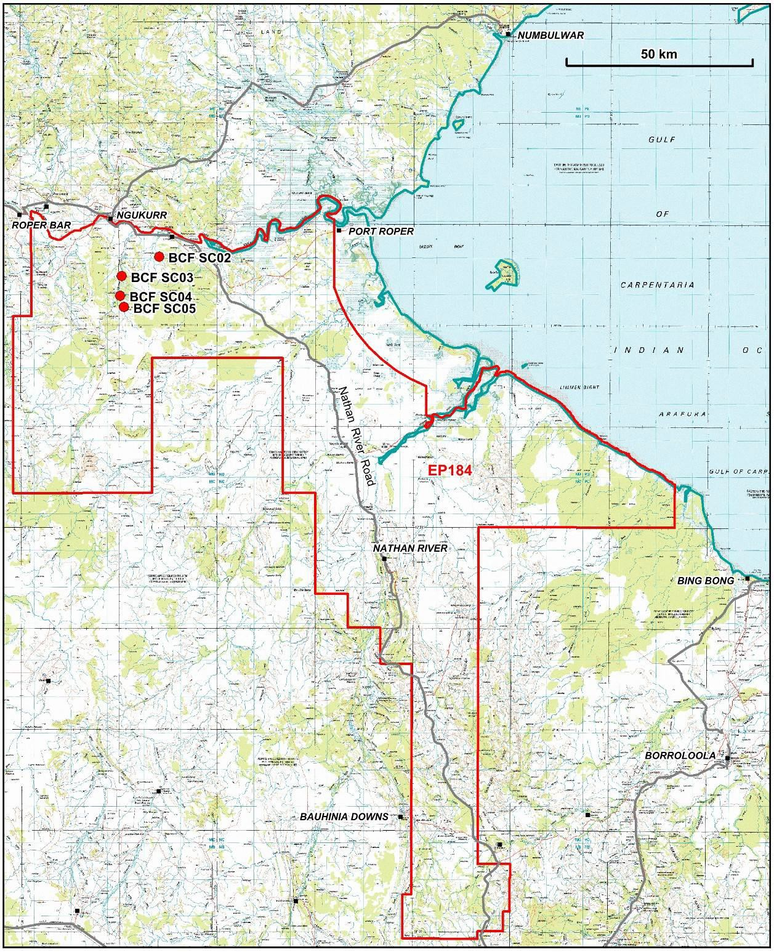

Figure 1: Locality map of proposed core holes within EP184.

**3 EXISTING ENVIRONMENT**

**3.1 Socio-economic Environment**

Much of the region is Aboriginal freehold land and part of the Arnhem Land Aboriginal Land Trust lands. The Australian Government has recognised the nearby townships of Ngukurr and Numbulwar as Remote Service Delivery communities within the bioregion. These towns have been designated Territory Growth Towns.

The area is sparsely populated except for the Aboriginal communities located at Numbulwar to the north of the EP, Ngukurr, Urapunga, Hodgson Downs and Djilkminggan. To the east of the tenement is the township of Borroloola.

**3.2 Physical environment**

Located in the transition zone between tropical and arid zones, the Site sits approximately 350 km southwest of the township of Nhulunbuy on the Gove Peninsular, and 250 km east of Katherine and 500 km southeast of Darwin.

The project area experiences a tropical savannah climate with a distinct wet and dry season. The seasonal contrast between the Wet and the Dry has significant implications for water resources. The monsoon brings Wet season rain and during times of cyclones the project area experiences significant rainfall events. These rainfall events can cause flooding which is determined by the volume, duration and spatial distribution of the rainfall. It is these flooding events that provide the recharge to the aquifers. In contrast, the dry season experiences negligible rain which results in many of the rivers ceasing to flow.

The project area falls within the humid zone which can experience an average rainfall between 600 – 800 mm per year. Weather stations exist at Ngukurr (Station 14609) and Limmen River (Station 14645). Figure 2 displays the mean monthly rainfall for the Ngukurr region at the northern end of the tenement.

Most of the rain falls during the wet season between November and April, while the dry season from May to October brings negligible rainfall**.** Available data shows a mean maximum monthly rainfall ranging between 182 -252 mm (January) and a mean minimum monthly rainfall ranging between 0.1 - 0.7 mm (August) for Ngukurr and Limmen River.

The mean daily minimum temperatures at Ngukurr range from 15.1 to 25.5°C and a maximum mean daily temperature range from 29.6 – 38.9 °C. Average annual evaporation is approximately 2 400 mm for the region which, even in the wettest of years, exceeds the annual rainfall (NT Govt, 2009).

EP184-BCFSC02-05-XPN-EMP-SUM-001-Rev03 5 | P a g e

Table 2: Data were retrieved from the Australian Government Bureau of Meteorology site [http://www.bom.gov.au](http://www.bom.gov.au/) at the 28/05/2014.

|  |  |  |  |  |  |  |  |  |  |  |  |  |  |  |
| --- | --- | --- | --- | --- | --- | --- | --- | --- | --- | --- | --- | --- | --- | --- |
| **Statistics** | **Jan** | **Feb** | **Mar** | **Apr** | **May** | **Jun** | **Jul** | **Aug** | **Sep** | **Oct** | **Nov** | **Dec** | **Annual** | **Years** |
| Mean rainfall  1910 to 2012 | 182.8 | 176.5 | 174.8 | 55.9 | 10.7 | 5.1 | 1.1 | 0.7 | 1.8 | 13.5 | 42.4 | 131.6 | 815.5 | 79 |

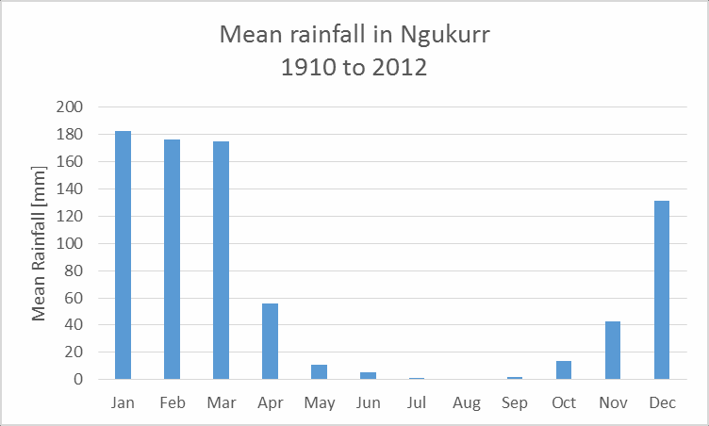

Figure 2: Mean monthly rainfall for Ngukurr. Data from Table 2 used.

EP184-BCFSC02-05-XPN-EMP-SUM-001-Rev03 6 | P a g e

**Soils**

EP184 is composed of gently undulating coastal plains with scattered rugged areas of Proterozoic sandstones and Tertiary sediments. Soils are predominantly sandy red earths and shallow gravelly sands.

The parent rocks of most of the soils (except the volcanics) are on at least their second cycle of erosion or are deeply weathered or both and are generally arenaceous (composed of sand sized particles). This has produced mainly very infertile soils with a near neutral reaction.

Soil erosion is the most significant type of land degradation likely to occur in the area because of marked climatic seasonality, high intensity wet season rainfall, cyclonic winds and the inherent susceptibility of many of the soils, even very low slopes can be susceptible to erosion if disturbed.

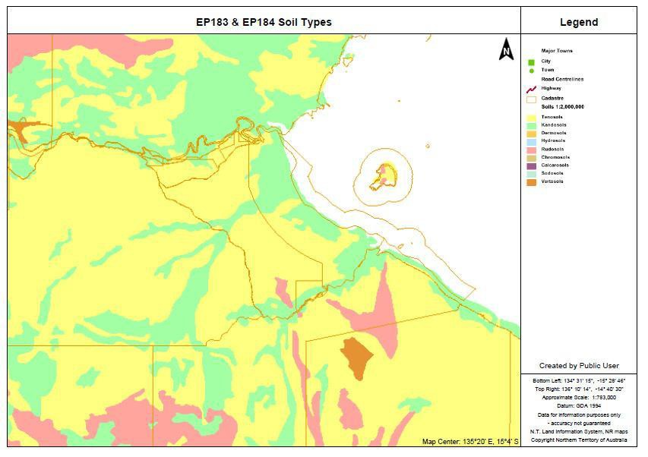

Figure 3: EP184 soil types.

**4 ENVIRONMENTAL RISKS, THEIR ASSESSMENT AND MANAGEMENT**

Activities or associated elements of activities related to drilling of the four exploration wells that have the potential to impact the environment have been identified and assessed.

The environmental hazards are identified as:

• Importation of weeds through moving of equipment and personnel

• Explosion or fire

• Accidental spills or leaks associated with drilling procedures or storage of oil, fuels and chemicals

• Loss of well integrity (aquifer crossflow)

Key areas of attention in the construction and management of the drill site and access are:

• Groundwater,

• Surface water,

• Soils,

• Dust,

• Noise,

• Cultural heritage.

The effect on the environment will be temporary and minimised to as low as reasonably practicable. The clearing of the drill site and upgrading of access tracks, will have the main environmental impact on fauna and flora. However this operation is classed as having a low to neglible impact due to the small size of the affected area.

Formally Risk Assessments systematically identify potential major hazards and accident scenarios and are considered to be the first stage in managing risks.

The external environments considered include ecological, community, social, regulatory, cultural, political, stakeholder and business drivers. Internal environments include culture, stakeholders, structure, and capabilities in terms of systems, people, processes, and strategic goals.

The review process identified hazards that could impact the operation and or the environment. These hazards were identified through a combination of experience with the type of work to be undertaken and an understanding of the conditions to be encountered during the operation through site visit and desk top studies of the environmental conditions.

Consideration has been given to a checklist of hazard types based on the internal and external parameters to guide the team and ensure full consideration of all possibilities.

Include a summary of the management plans. Need to trim this down a bit.

Table 3: Environmental Management Controls.

|  |  |  |
| --- | --- | --- |
| **Area** | **Threats/Consequences** | **Control** |
| **Air quality** | Insufficient / ineffective  dust, particulate and/ or odour control measures resulting in excessive dust generation and impact on sensitive receptors. Community complaints. Health issues with community and or personnel | Implement plant and vehicle speed restrictions (40 km/h on unsealed roads in close proximity (<200 m)  to sensitive receptors). Reduce vegetation clearing to minimum essential. Utilize natural barriers where ever possible. |
| Watering site and access roadways where appropriate |
| Locate and construct new (linking) access tracks as far as practicable from sensitive receptors |
| No burning of cleared vegetation |
| Implement Work Program staging and minimize total area of disturbance at any one time |
| Utilise meteorological information and weather forecast to confirm suitability of conditions for the proposed work program activities |
| Vehicles and equipment will be switched off when not in use |
| Maintain vehicles and equipment in accordance with manufacturer’s specifications |
| Increased greenhouse gas, hydrocarbon or  ozone-depleting emissions | No burning of cleared vegetation. Minimise waste generation. Maximise waste containment and removal to approved disposal sites |
| Implement Work Program staging and minimize total area of disturbance at any one time |
| Vehicles and equipment will be switched off when not in use |
| Maintain vehicles and equipment in accordance with manufacturer’s specifications |
| Minimise haul / travel distances where practicable |
| No free flow of hydrocarbon gas from wells. All gas is to be burnt (flared). |
| **Amenity** | Temporary or permanent loss of access or amenity  (including light overspill, economic and service impacts) | Equipment operators will be made aware of the potential amenity issues relevant to each work area and techniques to minimize impacts. Implement review of locations and utilize physical barriers of hills or  tree lines where ever possible to eliminate light spill. Placement of light towers to eliminate light spill. plan onsite storage and management of waste generated to reduce amount of waste and optimise storage and removal/disposal. |
| Locate sites preferably behind visual barrier such as tree line or hill |
| Vehicles and equipment will be switched off when not in use |

|  |  |  |
| --- | --- | --- |
|  |  |  |
|  | Maintain vehicles and equipment in accordance with manufacturer’s specifications |
| Locate and construct new (linking) access tracks, work areas, compounds and stockpiling areas as far as practicable from sensitive receptors |
| Equipment operators will be made aware of the potential amenity issues relevant to each work area and techniques to minimize potential impacts |
| The community engagement strategy will address the provision of information regarding potential impacts to amenity for sensitive receptors located <2 km from site activities and notification  requirements for local authorities |
| Fence pits, ponds and storage areas (use stockproof fencing where appropriate) |
| Record volumes and types of waste generated on site, the treatment / disposal method adopted for each waste stream and dates of offsite waste transport and disposal |
| interactions between project and the community | The community engagement strategy will address the provision of communications regarding heritage matters including notification obligations for authorities |
| All complaints to be referred to authorised Imperial Oil & Gas personnel |
| **Fertile and productive topsoil** | Loss of valuable topsoil material | Strip and stockpile topsoil for reuse during site reinstatement |
| Install sediment control devices down gradient of stockpiles and disturbed / active areas of the site  (including roadsides, laydown areas and cleared areas) |
| Contamination of soil | Backfill excavations when not required for >7 days |
| Line mud pits and monitor liner condition and integrity |
| Comply with spill management and emergency management procedures |
| Store and maintain spill containment measures |
| Refuelling, vehicle / equipment maintenance and repairs will occur in designated areas where adequate  protection measures are in place |
| Refuelling and chemical fuel storage to be in bunded area only |
| Material lay down and storage areas designated for hazardous materials will comply with relevant standards |
| Hazchem and fuel areas to be bunded to comply with relevant standards |
| **Flora/fauna** | Loss of protected flora species, essential habitat  and biodiversity | Ensure all necessary permits and approvals are in place and compliance obligations communicated to site personnel prior to commencing vegetation clearing |
| Mark the boundary of the work program area with tape and/ or hi-viz fencing designated for ‘No Go |

Use existing roadways and pastoral tracks where ever possible and practicable

|  |  |  |
| --- | --- | --- |
|  | Permanent detrimental  impact to biodiversity or ecological function | Zones’ and monitor integrity |
|  | Minimise clearing of new access tracks to sticks, logs and larger rocks necessary to ensure good safe access where ever possible |
| Minimise the use of grading of new access tracks and lines to sufficient to allow the safe passage of equipment |
| New access tracks will not be constructed unless unavoidable |
| New tracks shall be constructed at the minimum possible width to conduct the travel of the drilling equipment |
| No operations to occur within 200m of a known environmentally or Culturally Sensitive or Sacred Site area without prior approval from the relevant Local Aboriginal Group and other relevant stakeholders |
| No vehicle access permitted in rehabilitated areas |
| Retention of Traditional Aboriginal Owners to monitor and advise on Culturally sensitive locations |
| Site specific fire management plans will be implemented for each proposed area of activity and will  utilize the fire management plan presented in the Emergency Response Plan as the basis of that plan |
| Stockpiles that may be susceptible to erosion must have suitable erosion and sediment controls  measures applied |
| The clearing and disturbance of vegetation will be kept to a minimum with particular care taken in regard  to preserving mature trees and vegetation along watercourses |
| Weed invasion/ infestation and / increased  occurrence or abundance  of feral animals | Upgrade existing tracks where practical to accommodate the heavy vehicle traffic (including widening). |
| Vehicle wash down prior to entering the area |
| Vehicle wash down for the removal of weed seeds for all vehicles moving through known weed infestations |
| No burning of cleared vegetation |
| Implement Work Program staging and minimize total area of disturbance at any one time |
| Loss of riparian vegetation | Mark and maintain a ‘No Go Zone’ from the outer boundary of riparian zones for all areas outside the  proposed / approved clearing footprint. No vegetation clearing on or near a drainage pathway. Minimise earthworks to essential works only. |
| Ensure all necessary permits and approvals are in place and compliance obligations communicated to  site personnel prior to commencing vegetation clearing |
| Mark the boundary of the work program area with tape and/ or hi-viz fencing designated for ‘No Go  Zones’ and monitor integrity |

|  |  |  |
| --- | --- | --- |
|  |  |  |
|  | Minimise the use of grading of new access tracks and lines to sufficient to allow the safe passage of equipment |
| New access tracks will not be constructed unless unavoidable |
| New tracks shall be constructed at the minimum possible width to conduct the travel of the drilling equipment |
| No operations to occur within 200m of a known environmentally or Culturally Sensitive or Sacred Site area without prior approval from the relevant Local Aboriginal Group and other relevant stakeholders |
| No vehicle access permitted in rehabilitated areas |
| Where clearing of riparian vegetation is required, rootstock will be retained insitu where practical |
| **Noise and vibration** | Insufficient / ineffective  noise and/or vibration control measures resulting inexcessive noise / vibration generation and impact on sensitive receptors | Equipment operators will be made aware of the potential issues relevant to each work area and  techniques to minimize noise and vibration emissions |
| Vehicles and equipment will be switched off when not in use |
| Maintain vehicles and equipment in accordance with manufacturer’s specifications |
| Locate and construct new (linking) access tracks, work areas, compounds and stockpiling areas as far  as practicable from sensitive receptors |
| Locate sites preferably behind sound barrier such as tree line or hill |
| Implement a community engagement strategy to address the provision of information regarding potential impacts from noise and vibration generating activities on sensitive receptors located <2 km  from site activities and notification requirements for local authorities |
| Disruption or damage to  public utilities or facilities | Equipment operators will be made aware of the potential noise and/or vibration issues relevant to each  work area and techniques to minimize impacts. Minimise excavation and earthworks to essential works and consider location to sensitive receptors. Time works to occur in non-sensitive periods. No drilling to occur within 100 m of overhead powerlines or 200 m of underground services. No drilling within 1 km of dwellings |
| **Water quality, abundance and** | Reduced surface water quality, quantity and/ or ecological function of  waterways or wetlands. Detrimental impacts to  water resources (surface | Install sediment control devices down gradient of stockpiles and disturbed / active areas of the site  (including roadsides, lay down areas and cleared areas) |
| Install runoff diversion devices up gradient of disturbed and active work areas of the site to divert ‘clean’  storm water runoff away from disturbed / potentially contaminated areas |
| Install runoff velocity reduction devices to dissipate / disrupt concentrated flow and runoff from sloped areas |

Minimise clearing of new access tracks to sticks, logs and larger rocks necessary to ensure good safe access where ever possible

|  |  |  |
| --- | --- | --- |
| **availability** | or groundwater) or waterways / wetlands |  |
| Groundwater encountered during drilling will be recovered for use as water supply where practical, safe  and sustainable to do so |
| Adopt drilling and casing methods that will minimize the impact to shallow aquifer stability |
| Hydrocarbon contamination of waterways | Develop and implement Oil Spill Contingency Plan |
| Implement oil spill containment measures in the event of an oil spill incident |
| Refuelling, fuel decanting and vehicle maintenance will occur in designated areas only that have spill protection/containment measures in place |
| Accelerated erosion resulting from unsuitable or ineffective erosion mitigation measures | Inspection and monitoring of condition and effectiveness of erosion mitigation measures adopted across the site |
| Maintain erosion mitigation measures adopted for the site |
| Conduct direct return of topsoil and vegetation debris where practicable |
| Conduct progressive rehabilitation to minimise the total area open |
| Disturbed areas will be re-contoured, spread with stockpiled topsoil and vegetation debris where necessary |
| Pits and scrapes to be backfilled and compacted to prevent future formation of depressions |
| Sediment movement resulting from unsuitable  or ineffective sediment control measures | Inspection and monitoring of conditions and effectiveness of sediment controls |
| Conduct direct return of topsoil and vegetation debris where practicable |
| Conduct progressive rehabilitation to minimise the total area open |
| Maintain and repair sediment control devices |
| Stabilise stockpiles that will remain >7 days and monitor effectiveness of stabilisation |
| **Stable soils and landforms** | Accelerated physical and chemical erosion and landform instability | Stabilise batters of pits and voids, and exposed slopes with a maximum slope gradient of 1V:2H |
| Inspection and monitoring of condition and effectiveness of erosion mitigation measures adopted across  the site |
| Maintain erosion mitigation measures adopted for the site |
| Conduct progressive rehabilitation to minimise the total area open |
| Disturbed areas will be re-contoured, spread with stockpiled topsoil and vegetation debris where  necessary |
| Inspect and monitor condition / effectiveness of stabilization of disturbed areas of the site |
| Pits and scrapes to be backfilled and compacted to prevent future formation of depressions |

No filling, draining or alteration of any waterway or groundwater aquifer on site will occur unless in compliance with permit / approval conditions

**5 UNDERTAKEN AND ONGOING CONSULTATION**

Approval for the shallow core holes has been received from the Northern Land Council after an ethnographic sacred site clearance survey of the area. No pastoral land lease holders exist in the region of proposed work and as such no communication or consultation is required with these entities. Agreements with Local Aboriginal Groups have been implemented.

It is a condition of work approvals that two Traditional Owners for the country accompany the work team at all times to monitor the cultural environment and to ensure the preservation of sites of cultural sensitivity.

Consultation has been undertaken with the NT Parks and Wildlife and approval obtained for work programs where these may impact on flora and fauna

Approval for the work program has been obtained from the NT Department of Mines and Energy and consultation on the work program has been undertaken with the Northern Territory Geological Survey.

For any further information contact: Geoff Hokin

Imperial Oil & Gas

Principal Advisor Exploration & Operations [ghokin@empiregp.net](mailto:ghokin@empiregp.net)

**CONTACT DETAILS FOR OPERATOR’S NOMINATED LIAISON PERSONNEL COMMUNICATION CONTACTS DIRECTORY**

Table 4: Contact Details of personnel.

|  |  |  |
| --- | --- | --- |
| **Imperial Oil & Gas** | | |
| Dr John Warburton (Director) | Sydney | 0404 807070 |
| Geoff Hokin (Principal Advisor Exploration & Operations) | Brisbane | 0437 440417 |
| Site Personell | Satellite Phone | 0420 369 871 |
| Chief Well Engineer | Brisbane | TBD |
| Site Geologist | Satellite Phone | 0420 369 937 |
| **Drilling Contractor – DRILLSTRALIS** | | |
| Rig Manager | TBD |  |
| Division Manager | Jamie Mazouris | 0147141886 (Satellite phone) |
| HSE | Jamie Mazouris | 0418256355 |
| **Wire line Contractor – ACS Mining Services Pty ltd** | | |
| Luke Woods (Senior Engineer) | Gunnedah NSW | 0421 795591 |
| **Department of Mines and Energy** | | |
| Annette Duncan (Director of Petroleum) | Darwin | 08 8999 5357 |
| Dominic Marozzi (Petroleum operations) | Darwin | 08 8999 6350 |

EP184-BCFSC02-05-XPN-EMP-SUM-001-Rev03 15 | P a g e