Mineral Titles Act
NOTICE OF GRANT OF A MINERAL TITLE
Title Type and Number: | Exploration Licence 27266
Granted: | 23 April 2018, for a period of 6 Years
Area: | 164 Blocks, 516.09 km²
Locality: | LAKE CAROLINE
Name of Holder/s: | 100% RED METAL LIMITED [ACN. 103 367 684]
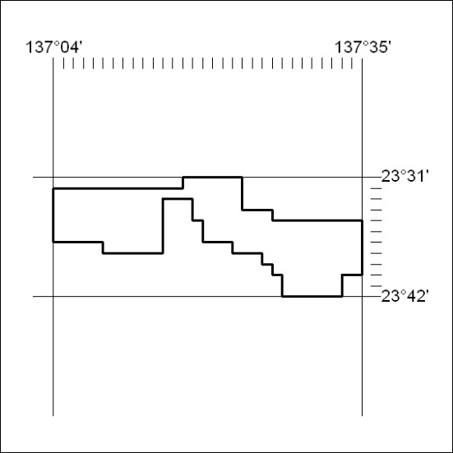
Area granted is indicated above. The titleholder is not permitted to exercise occupational rights on any land that is subject to a development title, or an application for a development title. Any land the subject of a Reserved Land gazettal under the Mineral Titles Act and all land vested in the Commonwealth of Australia is also excluded by description but not excised from the grant area.

142/18

