Mineral Titles Act
NOTICE OF LAND CEASING TO BE A MINERAL TITLE AREA
Title Type and Number: | Exploration Licence 30838
Area Ceased on: | 26 April 2018
Area: | 10 Blocks, 31.57 km²
Locality: | QUARTZ
Name of Applicant(s)/Holder(s): | 100% PINNACLE EXPLORATION PTY LTD [ACN. 605 748 196]
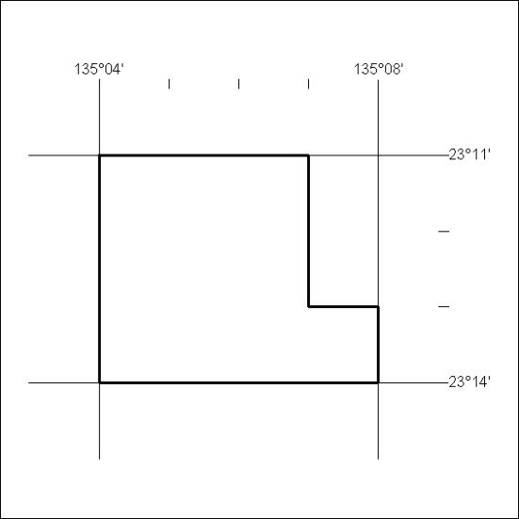

147/18

