Mineral Titles Act
NOTICE OF LAND CEASING TO BE A MINERAL TITLE
Title Type and Number: | Mineral Authority 471
Area ceased on: | 07 May 2018
Area: | 7.00 Hectare
Locality: | BYNOE
Name of Applicants(s)Holder(s): | 100% A AND SF MADDALOZZO PTY. LIMITED [ACN. 009 624 015]
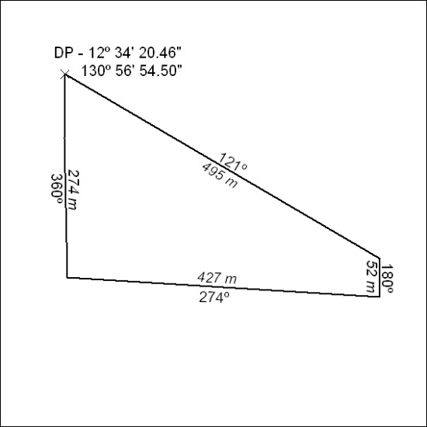

176/18

Mineral Titles Act
NOTICE OF LAND CEASING TO BE A MINERAL TITLE
Title Type and Number: | Mineral Authority 472
Area ceased on: | 07 May 2018
Area: | 7.00 Hectare
Locality: | BYNOE
Name of Applicants(s)Holder(s): | 100% A AND SF MADDALOZZO PTY. LIMITED [ACN. 009 624 015]
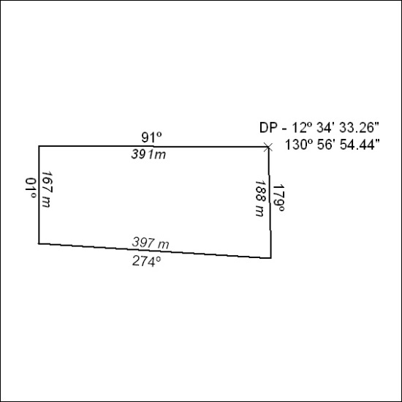

177/18

