Mineral Titles Act
NOTICE OF LAND CEASING TO BE A MINERAL TITLE
Title Type and Number: | Extractive Mineral Permit 27767
Area ceased on: | 17 August 2018
Area: | 100.00 Hectare
Locality: | NOONAMAH
Name of Applicants(s)Holder(s): | 100% A AND SF MADDALOZZO PTY. LIMITED [ACN. 009 624 015]
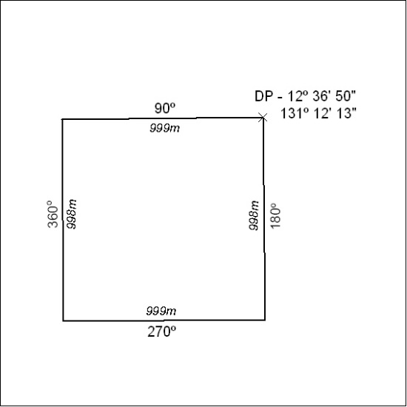

348/18

Mineral Titles Act
NOTICE OF GRANT OF A MINERAL TITLE
Title Type and Number: | Exploration Licence 31789
Granted: | 15 August 2018, for a period of 6 Years
Area: | 238 Blocks, 759.58 km²
Locality: | SANDOVER
Name of Holder/s: | 100% TERRITORY PHOSPHATE PTY LTD [ACN. 130 065 351]
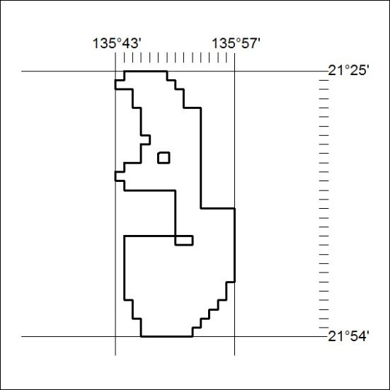
Area granted is indicated above. The titleholder is not permitted to exercise occupational rights on any land that is subject to a development title, or an application for a development title. Any land the subject of a Reserved Land gazettal under the Mineral Titles Act and all land vested in the Commonwealth of Australia is also excluded by description but not excised from the grant area.
349/18

Mineral Titles Act
NOTICE OF GRANT OF A MINERAL TITLE
Title Type and Number: | Exploration Licence 31790
Granted: | 15 August 2018, for a period of 6 Years
Area: | 233 Blocks, 746.27 km²
Locality: | GEORGE CREEK
Name of Holder/s: | 100% TERRITORY PHOSPHATE PTY LTD [ACN. 130 065 351]
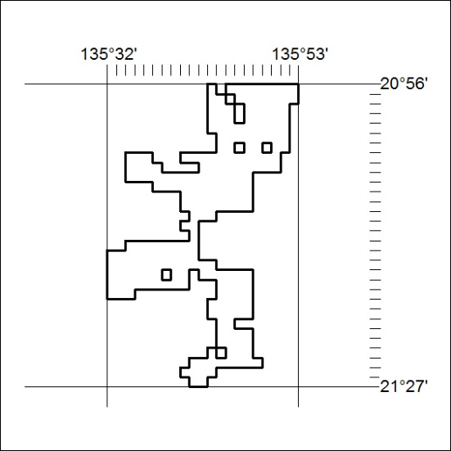
Area granted is indicated above. The titleholder is not permitted to exercise occupational rights on any land that is subject to a development title, or an application for a development title. Any land the subject of a Reserved Land gazettal under the Mineral Titles Act and all land vested in the Commonwealth of Australia is also excluded by description but not excised from the grant area.

350/18

