Mineral Titles Act
NOTICE OF GRANT OF A MINERAL TITLE
Title Type and Number: | Exploration Licence 31629
Granted: | 26 October 2018, for a period of 6 Years
Area: | 232 Blocks, 685.78 km²
Locality: | HATCHES
Name of Holder/s: | 100% TREASURE CREEK PTY LTD [ACN. 619 057 644]
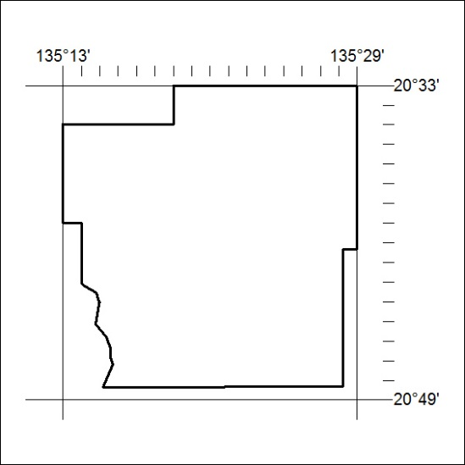
Area granted is indicated above. The titleholder is not permitted to exercise occupational rights on any land that is subject to a development title, or an application for a development title. Any land the subject of a Reserved Land gazettal under the Mineral Titles Act and all land vested in the Commonwealth of Australia is also excluded by description but not excised from the grant area.

500/18

Corrigendum
Notice number 486/18 appearing in MN139/18 on 30 October is hereby cancelled.

