Mineral Titles Act
NOTICE OF LAND CEASING TO BE A MINERAL TITLE AREA
Title Type and Number: | Exploration Licence 26625
Area Ceased on: | 16 November 2018
Area: | 26 Blocks, 83.95 km²
Locality: | BUCK
Name of Applicant(s)/Holder(s): | 85% RAMELIUS RESOURCES LIMITED [ACN. 001 717 540], 15% TYCHEAN TANAMI PTY LTD* [ACN. 137 135 847]
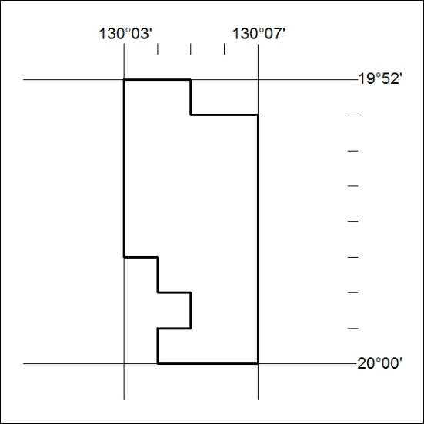

522/18

Mineral Titles Act
NOTICE OF LAND CEASING TO BE A MINERAL TITLE AREA
Title Type and Number: | Exploration Licence 27511
Area Ceased on: | 16 November 2018
Area: | 75 Blocks, 240.27 km²
Locality: | WICKHAM
Name of Applicant(s)/Holder(s): | 85% RAMELIUS RESOURCES LIMITED [ACN. 001 717 540], 15% TYCHEAN TANAMI PTY LTD* [ACN. 137 135 847]
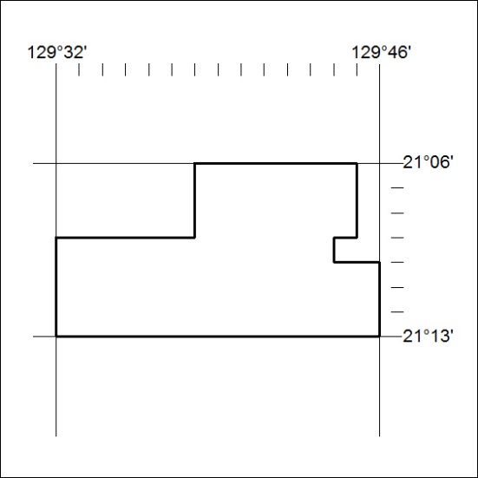

523/18

Mineral Titles Act
NOTICE OF LAND CEASING TO BE A MINERAL TITLE AREA
Title Type and Number: | Exploration Licence 27806
Area Ceased on: | 16 November 2018
Area: | 6 Blocks, 18.88 km²
Locality: | WILSON CREEK
Name of Applicant(s)/Holder(s): | 85% RAMELIUS RESOURCES LIMITED [ACN. 001 717 540], 15% TYCHEAN TANAMI PTY LTD* [ACN. 137 135 847]
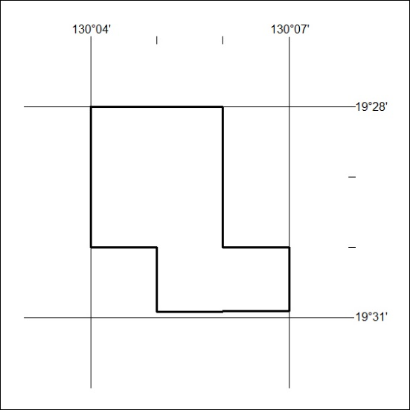

524/18

Mineral Titles Act
NOTICE OF LAND CEASING TO BE A MINERAL TITLE AREA
Title Type and Number: | Exploration Licence 27921
Area Ceased on: | 16 November 2018
Area: | 18 Blocks, 58.16 km²
Locality: | BUCK
Name of Applicant(s)/Holder(s): | 100% TYCHEAN TANAMI PTY LTD* [ACN. 137 135 847]
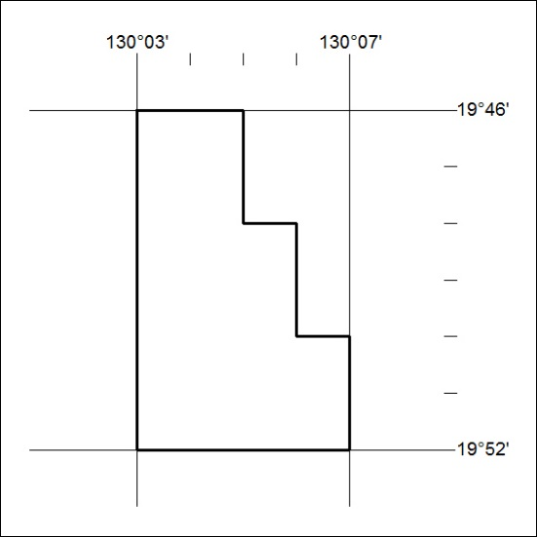

525/18

Mineral Titles Act
NOTICE OF LAND CEASING TO BE A MINERAL TITLE AREA
Title Type and Number: | Exploration Licence 27997
Area Ceased on: | 16 November 2018
Area: | 57 Blocks, 183.71 km²
Locality: | REIFF
Name of Applicant(s)/Holder(s): | 100% TYCHEAN TANAMI PTY LTD* [ACN. 137 135 847]
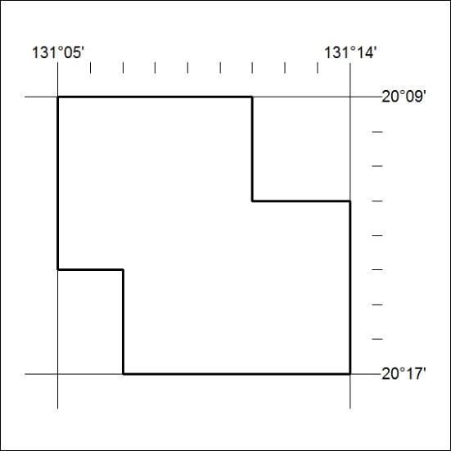

526/18

Mineral Titles Act
NOTICE OF LAND CEASING TO BE A MINERAL TITLE AREA
Title Type and Number: | Exploration Licence 28493
Area Ceased on: | 16 November 2018
Area: | 2 Blocks, 6.46 km²
Locality: | BUCK
Name of Applicant(s)/Holder(s): | 100% TYCHEAN TANAMI PTY LTD* [ACN. 137 135 847]
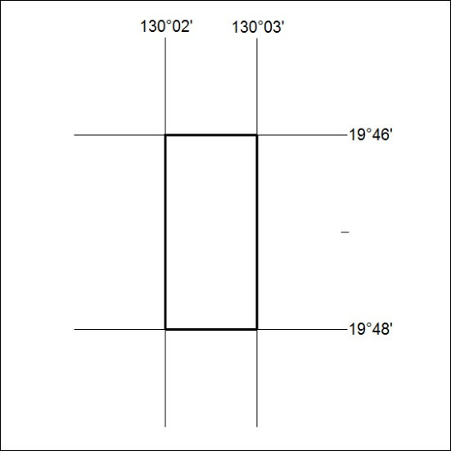

527/18

Mineral Titles Act
NOTICE OF LAND CEASING TO BE A MINERAL TITLE AREA
Title Type and Number: | Exploration Licence 29829
Area Ceased on: | 16 November 2018
Area: | 125 Blocks, 400.48 km²
Locality: | WICKHAM
Name of Applicant(s)/Holder(s): | 85% RAMELIUS RESOURCES LIMITED [ACN. 001 717 540], 15% TYCHEAN TANAMI PTY LTD* [ACN. 137 135 847]
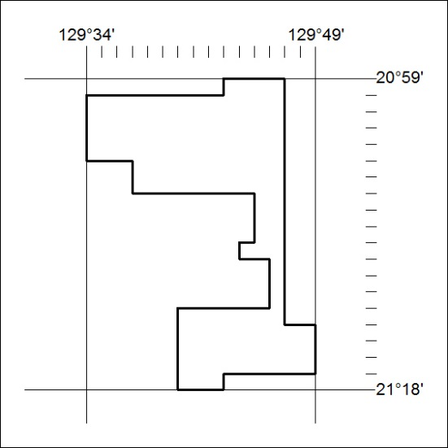

528/18

Mineral Titles Act
NOTICE OF LAND CEASING TO BE A MINERAL TITLE
Title Type and Number: | Extractive Mineral Permit 31657
Area ceased on: | 16 November 2018
Area: | 3.00 Hectare
Locality: | KOOLPINYAH
Name of Applicants(s)Holder(s): | 100% A AND SF MADDALOZZO PTY. LIMITED [ACN. 009 624 015]
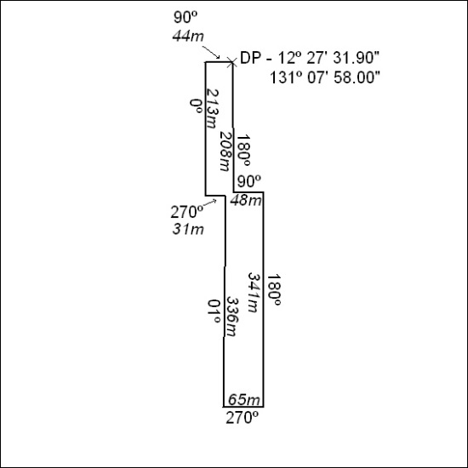

529/18

Mineral Titles Act
NOTICE OF LAND CEASING TO BE A MINERAL TITLE
Title Type and Number: | Extractive Mineral Permit (Northern) 1154
Area ceased on: | 15 November 2018
Area: | 6.00 Hectare
Locality: | MANBULLOO
Name of Applicants(s)Holder(s): | 100% ROWLANDS QUARRIES (KATHERINE) PTY LIMITED [ACN. 051 932 560]
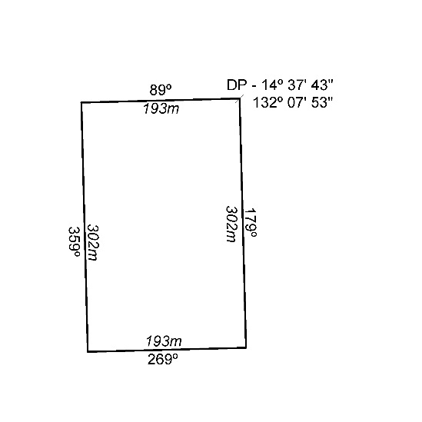

530/18

