Mineral Titles Act
NOTICE OF LAND CEASING TO BE A MINERAL TITLE AREA
Title Type and Number: | Exploration Licence 30613
Area Ceased on: | 27 November 2018
Area: | 3 Blocks, 9.63 km²
Locality: | WAUCHOPE
Name of Applicant(s)/Holder(s): | 100% TERRITORY PHOSPHATE PTY LTD [ACN. 130 065 351]
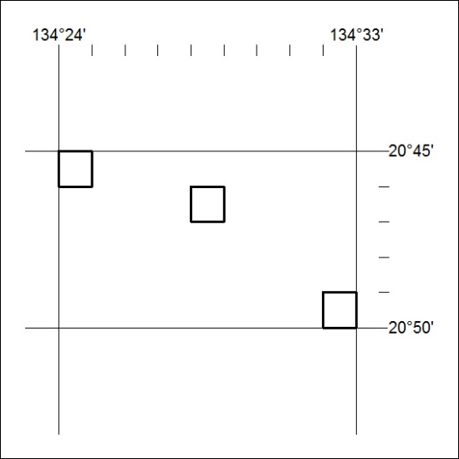

559/18

