Mineral Titles Act
NOTICE OF LAND CEASING TO BE A MINERAL TITLE
Title Type and Number: | Mineral Lease (Northern) 113
Area ceased on: | 31 December 2018
Area: | 3.00 Hectare
Locality: | PINE CREEK
Name of Applicants(s)Holder(s): | 100% YOUNG Warren Albert
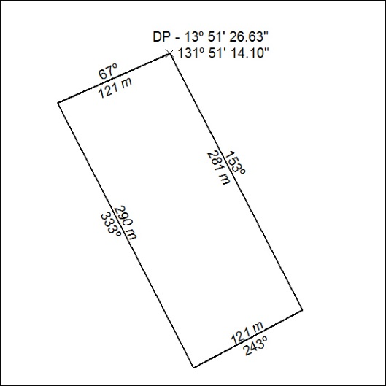

01/19

Mineral Titles Act
NOTICE OF GRANT OF A MINERAL TITLE
Title Type and Number: | Exploration Licence 27521
Granted: | 21 December 2018, for a period of 6 Years
Area: | 11 Blocks, 20.38 km²
Locality: | LANGDON
Name of Holder/s: | 100% WINCHELSEA MINING PTY LTD [ACN. 626 747 037]
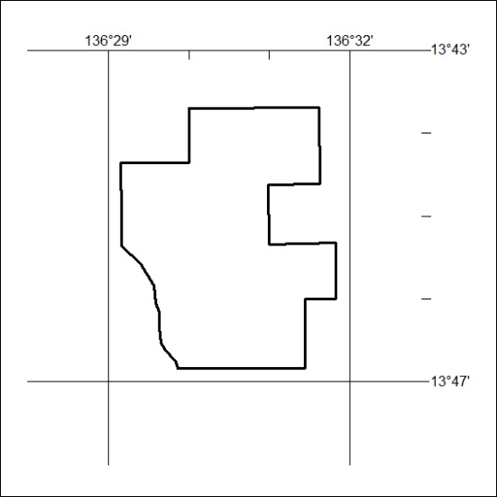
Area granted is indicated above. The titleholder is not permitted to exercise occupational rights on any land that is subject to a development title, or an application for a development title. Any land the subject of a Reserved Land gazettal under the Mineral Titles Act and all land vested in the Commonwealth of Australia is also excluded by description but not excised from the grant area.

02/19

Mineral Titles Act
NOTICE OF GRANT OF A MINERAL TITLE
Title Type and Number: | Exploration Licence 31543
Granted: | 02 January 2019, for a period of 6 Years
Area: | 148 Blocks, 448.91 km²
Locality: | BRAHMA
Name of Holder/s: | 100% TYPHON MINERALS PTY LTD [ACN. 614 887 464]
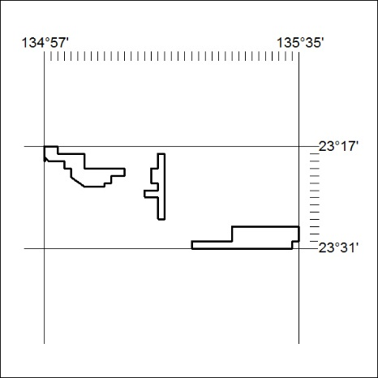
Area granted is indicated above. The titleholder is not permitted to exercise occupational rights on any land that is subject to a development title, or an application for a development title. Any land the subject of a Reserved Land gazettal under the Mineral Titles Act and all land vested in the Commonwealth of Australia is also excluded by description but not excised from the grant area.

03/19

Mineral Titles Act
NOTICE OF GRANT OF A MINERAL TITLE
Title Type and Number: | Exploration Licence 31937
Granted: | 02 January 2019, for a period of 6 Years
Area: | 30 Blocks, 94.65 km²
Locality: | QUARTZ
Name of Holder/s: | 100% TYPHON MINERALS PTY LTD [ACN. 614 887 464]
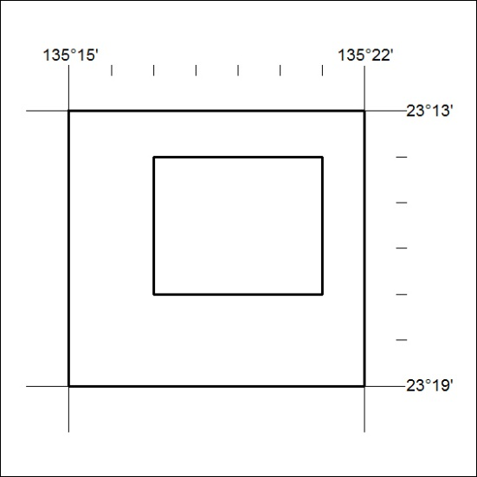
Area granted is indicated above. The titleholder is not permitted to exercise occupational rights on any land that is subject to a development title, or an application for a development title. Any land the subject of a Reserved Land gazettal under the Mineral Titles Act and all land vested in the Commonwealth of Australia is also excluded by description but not excised from the grant area.

04/19

