Mineral Titles Act
NOTICE OF LAND CEASING TO BE A MINERAL TITLE AREA
Title Type and Number: | Exploration Licence 28844
Area Ceased on: | 27 February 2019
Area: | 4 Blocks, 13.19 km²
Locality: | HUMBERT
Name of Applicant(s)/Holder(s): | 100% AUSTRALIA MINING & GEMSTONE CO. PTY LTD [ACN. 114 395 247]
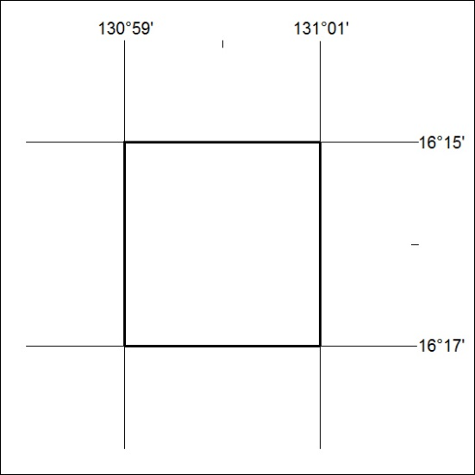

61/19

Mineral Titles Act
NOTICE OF LAND CEASING TO BE A MINERAL TITLE AREA
Title Type and Number: | Exploration Licence 28850
Area Ceased on: | 27 February 2019
Area: | 4 Blocks, 13.17 km²
Locality: | HUMBERT
Name of Applicant(s)/Holder(s): | 100% AUSTRALIA MINING & GEMSTONE CO. PTY LTD [ACN. 114 395 247]
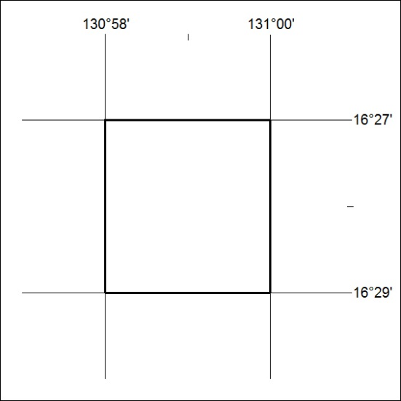

62/19

Mineral Titles Act
NOTICE OF LAND CEASING TO BE A MINERAL TITLE AREA
Title Type and Number: | Exploration Licence 28944
Area Ceased on: | 27 February 2019
Area: | 6 Blocks, 16.40 km²
Locality: | AILERON
Name of Applicant(s)/Holder(s): | 100% AUSTRALIA MINING & GEMSTONE CO. PTY LTD [ACN. 114 395 247]
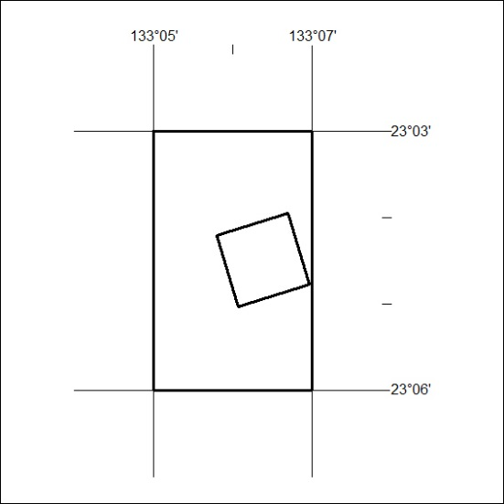

63/19

Mineral Titles Act
NOTICE OF LAND CEASING TO BE A MINERAL TITLE AREA
Title Type and Number: | Exploration Licence 28945
Area Ceased on: | 27 February 2019
Area: | 5 Blocks, 15.84 km²
Locality: | AILERON
Name of Applicant(s)/Holder(s): | 100% AUSTRALIA MINING & GEMSTONE CO. PTY LTD [ACN. 114 395 247]
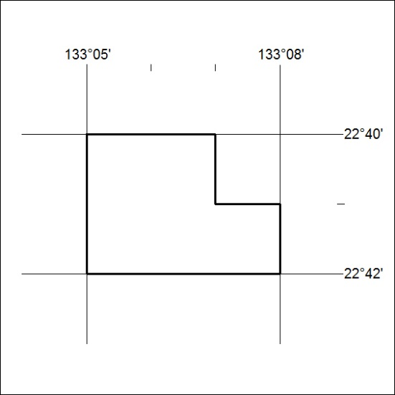

64/19

