Mineral Titles Act
NOTICE OF LAND CEASING TO BE A MINERAL TITLE AREA
Title Type and Number: | Exploration Licence 28870
Area Ceased on: | 19 March 2019
Area: | 22 Blocks, 73.35 km²
Locality: | ADAM
Name of Applicant(s)/Holder(s): | 100% AUSTRALIAN ILMENITE RESOURCES PTY LIMITED* [ACN. 093 419 311]
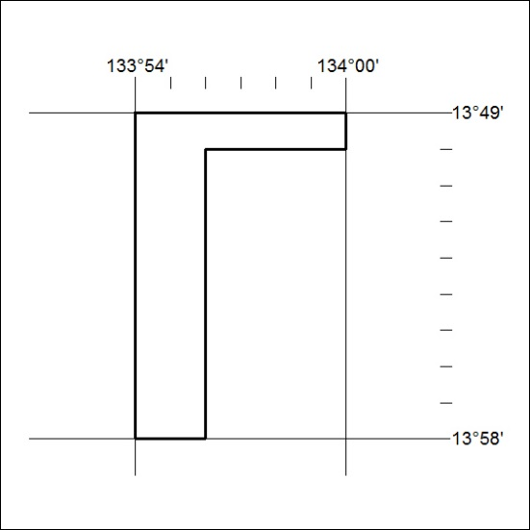

98/19

Mineral Titles Act
NOTICE OF LAND CEASING TO BE A MINERAL TITLE AREA
Title Type and Number: | Exploration Licence 28871
Area Ceased on: | 19 March 2019
Area: | 78 Blocks, 259.79 km²
Locality: | WATERHOUSE
Name of Applicant(s)/Holder(s): | 100% AUSTRALIAN ILMENITE RESOURCES PTY LIMITED* [ACN. 093 419 311]
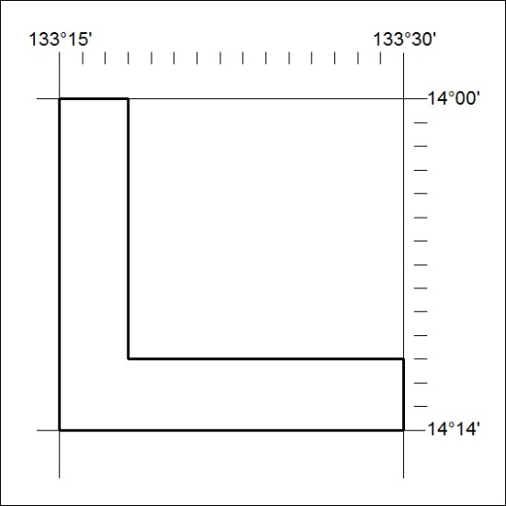

99/19

Mineral Titles Act
NOTICE OF LAND CEASING TO BE A MINERAL TITLE AREA
Title Type and Number: | Exploration Licence 31406
Area Ceased on: | 19 March 2019
Area: | 1 Block, 1.52 km²
Locality: | MARY RIVER
Name of Applicant(s)/Holder(s): | 100% DARWIN CHRISTIAN MINISTRIES INC
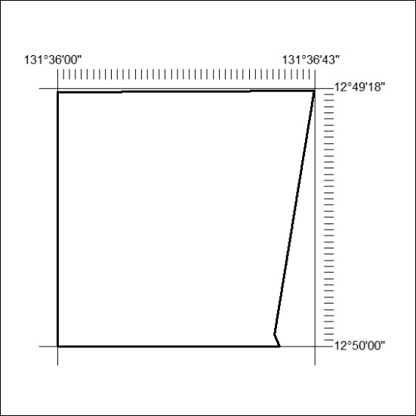

100/19

Mineral Titles Act
NOTICE OF LAND CEASING TO BE A MINERAL TITLE AREA
Title Type and Number: | Extractive Mineral Exploration Licence 31344
Area Ceased on: | 16 March 2019
Area: | 1 Block, 3.34 km²
Locality: | PINE CREEK
Name of Applicant(s)/Holder(s): | 100% TAYLOR-BIRCH Shane Alan
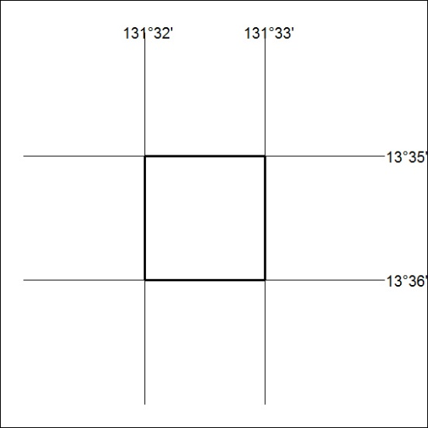

101/19

Mineral Titles Act
NOTICE OF LAND CEASING TO BE A MINERAL TITLE
Title Type and Number: | Extractive Mineral Permit 24719
Area ceased on: | 16 March 2019
Area: | 8.00 Hectare
Locality: | TENNANT CREEK
Name of Applicants(s)Holder(s): | 100% EARTHWORKS NT PTY LTD [ACN. 145 461 169]
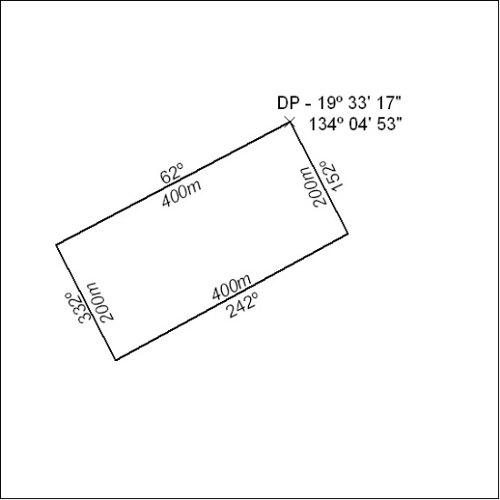

102/19

Mineral Titles Act
NOTICE OF GRANT OF A MINERAL TITLE
Title Type and Number: | Exploration Licence 31951
Granted: | 19 March 2019, for a period of 6 Years
Area: | 216 Blocks, 692.02 km²
Locality: | GEORGE CREEK
Name of Holder/s: | 100% MAGNET EXPLORATION PTY LTD [ACN. 623 568 918]
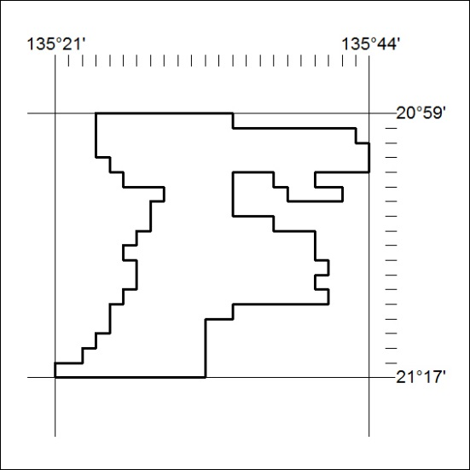
Area granted is indicated above. The titleholder is not permitted to exercise occupational rights on any land that is subject to a development title, or an application for a development title. Any land the subject of a Reserved Land gazettal under the Mineral Titles Act and all land vested in the Commonwealth of Australia is also excluded by description but not excised from the grant area.

103/19

Mineral Titles Act
NOTICE OF GRANT OF A MINERAL TITLE
Title Type and Number: | Exploration Licence 31952
Granted: | 19 March 2019, for a period of 6 Years
Area: | 184 Blocks, 588.55 km²
Locality: | GEORGE CREEK
Name of Holder/s: | 100% MAGNET EXPLORATION PTY LTD [ACN. 623 568 918]
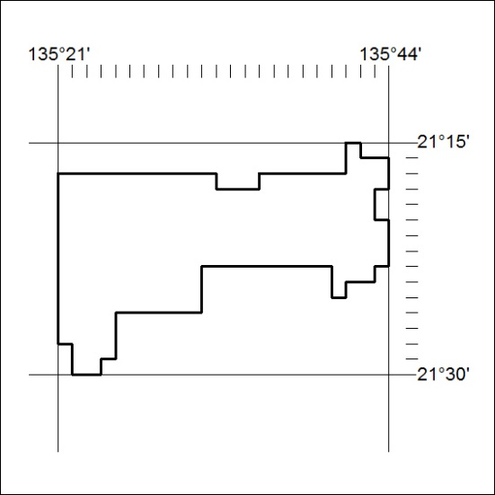
Area granted is indicated above. The titleholder is not permitted to exercise occupational rights on any land that is subject to a development title, or an application for a development title. Any land the subject of a Reserved Land gazettal under the Mineral Titles Act and all land vested in the Commonwealth of Australia is also excluded by description but not excised from the grant area.

104/19

