Mineral Titles Act 2010
NOTICE OF LAND CEASING TO BE A MINERAL TITLE AREA
Title Type and Number: | Exploration Licence 31760
Area Ceased on: | 21 May 2019
Area: | 111 Blocks, 363.66 km²
Locality: | SURPRISE CREEK
Name of Applicant(s)/Holder(s): | 100% EL CARO RESOURCES PTY LTD [ACN. 619 093 819]
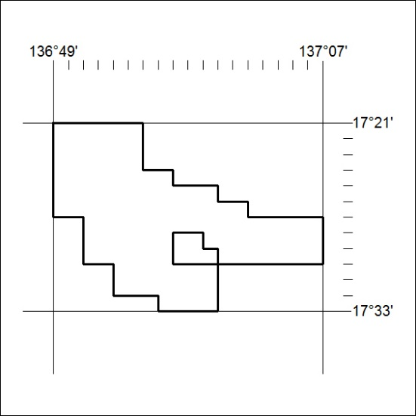

186/19

