Mineral Titles Act 2010
NOTICE OF LAND CEASING TO BE A MINERAL TITLE AREA
Title Type and Number: | Exploration Licence 31340
Area Ceased on: | 19 July 2019
Area: | 50 Blocks, 157.98 km²
Locality: | MURRAY DOWNS
Name of Applicant(s)/Holder(s): | 100% TERRITORY MINING PTY LTD [ACN. 122 356 398]
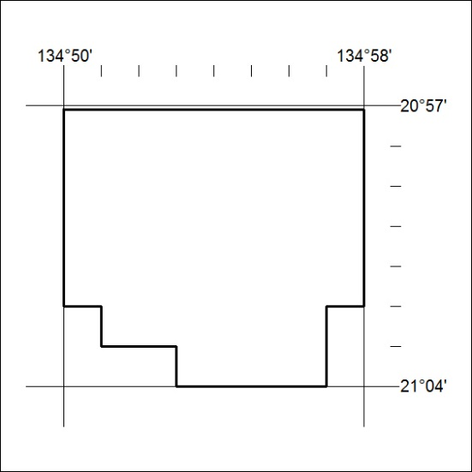

299/19

Mineral Titles Act 2010
NOTICE OF LAND CEASING TO BE A MINERAL TITLE AREA
Title Type and Number: | Exploration Licence 31786
Area Ceased on: | 19 July 2019
Area: | 47 Blocks, 123.29 km²
Locality: | LIMBLA
Name of Applicant(s)/Holder(s): | 100% GEMPART (NT) PTY LTD* [ACN. 081 859 896]
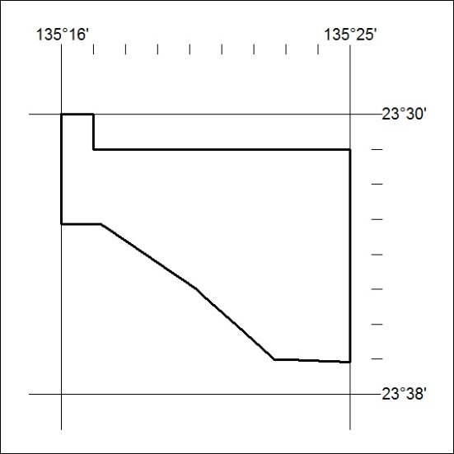

300/19

