Mineral Titles Act 2010
NOTICE OF LAND CEASING TO BE A MINERAL TITLE AREA
Title Type and Number: | Exploration Licence 30603
Area Ceased on: | 05 September 2019
Area: | 33 Blocks, 107.43 km²
Locality: | BOWMAN
Name of Applicant(s)/Holder(s): | 100% TRACKER GEOSERVICES PTY LTD [ACN. 093 390 197]
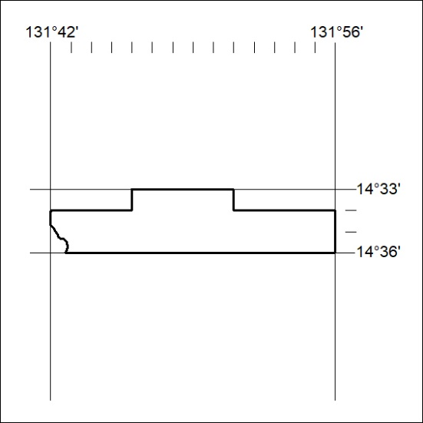

368/19

Mineral Titles Act 2010
NOTICE OF LAND CEASING TO BE A MINERAL TITLE AREA
Title Type and Number: | Exploration Licence 30616
Area Ceased on: | 05 September 2019
Area: | 4 Blocks, 12.07 km²
Locality: | BOWMAN
Name of Applicant(s)/Holder(s): | 100% TRACKER GEOSERVICES PTY LTD [ACN. 093 390 197]
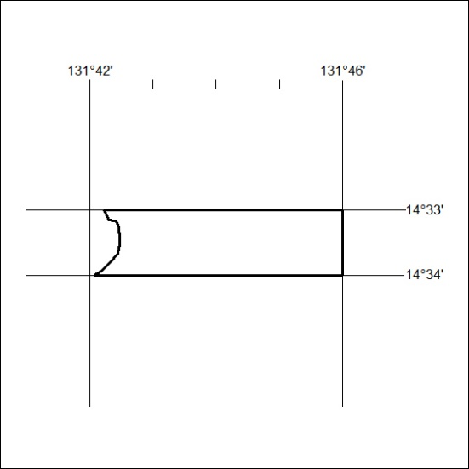

369/19
Mineral Titles Act 2010
NOTICE OF LAND CEASING TO BE A MINERAL TITLE AREA
Title Type and Number: | Exploration Licence 31508
Area Ceased on: | 05 September 2019
Area: | 111 Blocks, 345.04 km²
Locality: | CHARLOTTE
Name of Applicant(s)/Holder(s): | 100% BMEX LIMITED* [ACN. 615 217 680]
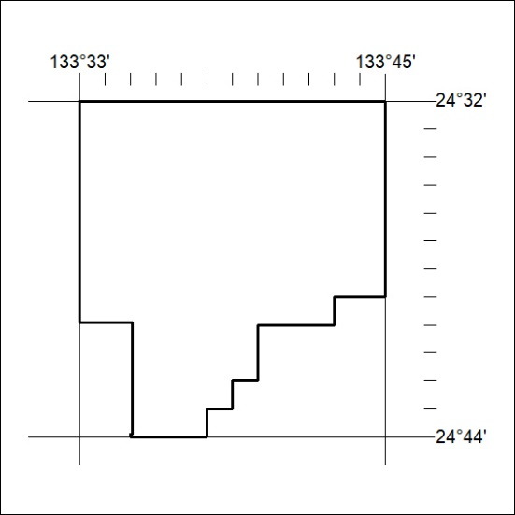

370/19

Mineral Titles Act 2010
NOTICE OF LAND CEASING TO BE A MINERAL TITLE AREA
Title Type and Number: | Exploration Licence 31509
Area Ceased on: | 05 September 2019
Area: | 120 Blocks, 374.26 km²
Locality: | CHARLOTTE
Name of Applicant(s)/Holder(s): | 100% BMEX LIMITED* [ACN. 615 217 680]
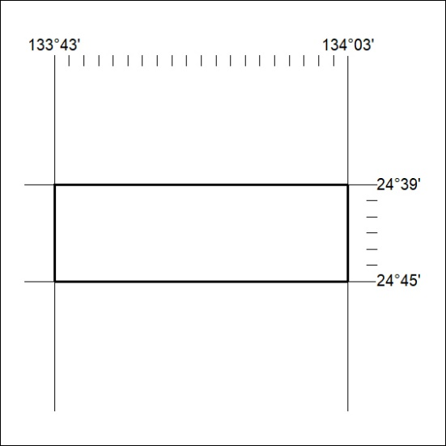

371/19
Mineral Titles Act 2010
NOTICE OF LAND CEASING TO BE A MINERAL TITLE AREA
Title Type and Number: | Exploration Licence 31510
Area Ceased on: | 05 September 2019
Area: | 158 Blocks, 493.92 km²
Locality: | SANTA TERESA
Name of Applicant(s)/Holder(s): | 100% BMEX LIMITED* [ACN. 615 217 680]
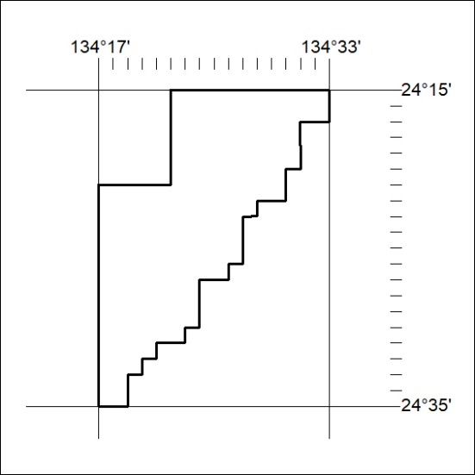

372/19

Mineral Titles Act 2010
NOTICE OF LAND CEASING TO BE A MINERAL TITLE AREA
Title Type and Number: | Exploration Licence 31589
Area Ceased on: | 05 September 2019
Area: | 241 Blocks, 753.12 km²
Locality: | RODINGA
Name of Applicant(s)/Holder(s): | 100% BMEX LIMITED* [ACN. 615 217 680]
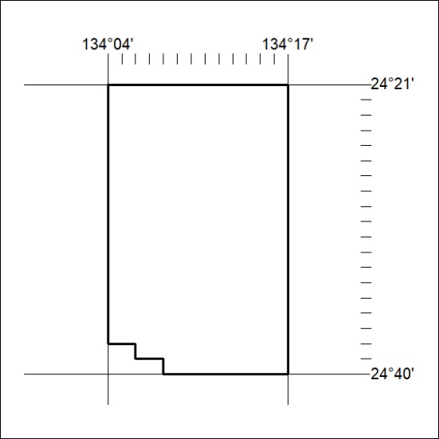

373/19

