Mineral Titles Act 2010
NOTICE OF LAND CEASING TO BE A MINERAL TITLE AREA
Title Type and Number: | Extractive Mineral Permit 25404
Area ceased on: | 14 November 2019
Area: | 64.00 Hectare
Locality: | NOONAMAH
Name of Applicants(s)Holder(s): | 100% OSTOJIC GROUP PTY LTD* [ACN. 009 629 805]
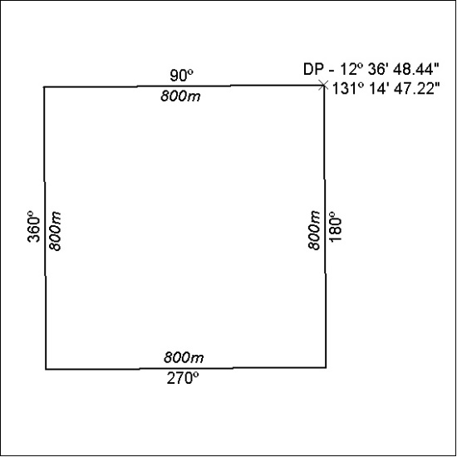

484/19

Mineral Titles Act
NOTICE OF GRANT OF A MINERAL TITLE
Title Type and Number: | Extractive Mineral Permit 31994
Granted: | 14 November 2019, for a period of 5 Years
Area: | 1.30 Hectares
Locality: | ALICE SPRINGS
Name of Holder/s: | 100% P.F. & C.J. BROWN PTY. LTD. [ACN. 009 652 868]
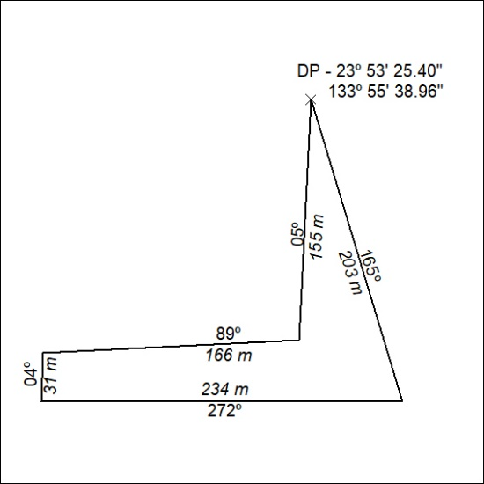

485/19

Mineral Titles Act
NOTICE OF GRANT OF A MINERAL TITLE
Title Type and Number: | Extractive Mineral Permit 32088
Granted: | 14 November 2019, for a period of 5 Years
Area: | 5.60 Hectares
Locality: | UNDOOLYA
Name of Holder/s: | 100% P.F. & C.J. BROWN PTY. LTD. [ACN. 009 652 868]
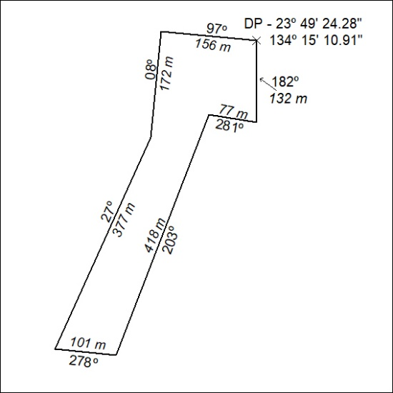

486/19

