Mineral Titles Act
NOTICE OF GRANT OF A MINERAL TITLE
Title Type and Number: | Mineral Lease 32074
Granted: | 12 December 2019, for a period of 20 Years
Area: | 682.10 Hectares
Locality: | BYNOE
Name of Holder/s: | 100% LITHIUM DEVELOPMENTS (GRANTS NT) PTY LTD [ACN. 622 047 232]
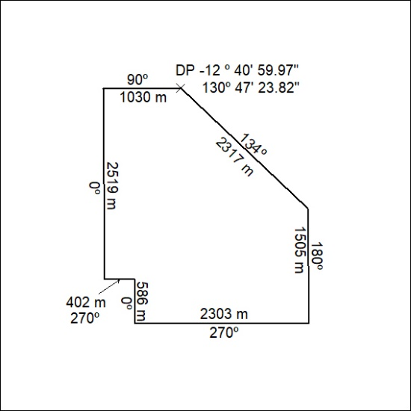

533/19

Mineral Titles Act
NOTICE OF GRANT OF A MINERAL TITLE
Title Type and Number: | Exploration Licence 32124
Granted: | 12 December 2019, for a period of 6 Years
Area: | 24 Blocks, 80.16 km²
Locality: | McKINLAY RIVER
Name of Holder/s: | 100% WILD BULL RESOURCES LIMITED [ACN. 109 681 478]
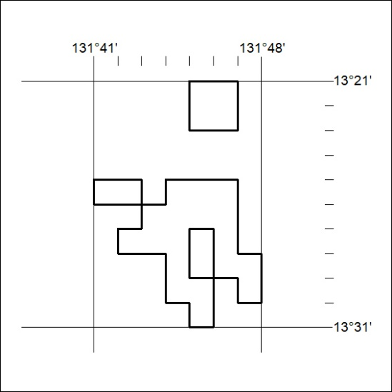
Area granted is indicated above. The titleholder is not permitted to exercise occupational rights on any land that is subject to a development title, or an application for a development title. Any land the subject of a Reserved Land gazettal under the Mineral Titles Act and all land vested in the Commonwealth of Australia is also excluded by description but not excised from the grant area.

534/19

