Mineral Titles Act 2010
NOTICE OF LAND CEASING TO BE A MINERAL TITLE AREA
Title Type and Number: | Exploration Licence 28886
Area Ceased on: | 18 December 2019
Area: | 16 Blocks, 50.80 km²
Locality: | UTOPIA
Name of Applicant(s)/Holder(s): | 100% XAVIER RESOURCES PTY LTD [ACN. 623 262 304]
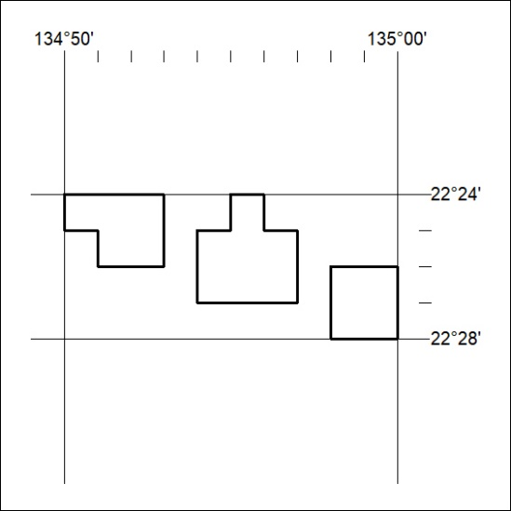

536/19

Mineral Titles Act 2010
NOTICE OF LAND CEASING TO BE A MINERAL TITLE AREA
Title Type and Number: | Exploration Licence 27581
Area Ceased on: | 18 December 2019
Area: | 83 Blocks, 258.78 km²
Locality: | HULL
Name of Applicant(s)/Holder(s): | 100% GEMPART (NT) PTY LTD* [ACN. 081 859 896]
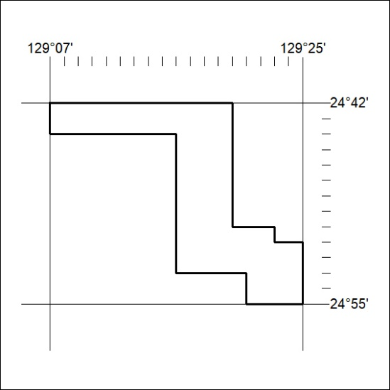

537/19
Mineral Titles Act 2010
NOTICE OF LAND CEASING TO BE A MINERAL TITLE AREA
Title Type and Number: | Exploration Licence 31531
Area Ceased on: | 18 December 2019
Area: | 125 Blocks, 389.74 km²
Locality: | BLOODS RANGE
Name of Applicant(s)/Holder(s): | 100% GEMPART (NT) PTY LTD* [ACN. 081 859 896]
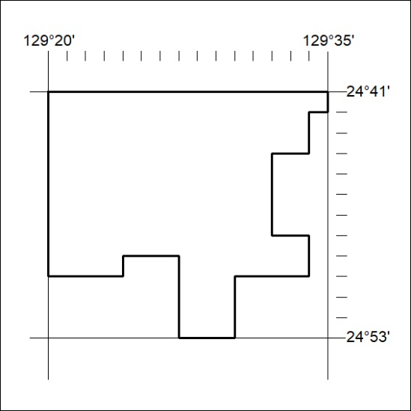

538/19

