Mineral Titles Act 2010
NOTICE OF LAND CEASING TO BE A MINERAL TITLE AREA
Title Type and Number: | Extractive Mineral Permit 24489
Area ceased on: | 28 January 2020
Area: | 18.00 Hectare
Locality: | KOOLPINYAH
Name of Applicants(s)Holder(s): | 100% ALISANTE HOLDINGS PTY LTD [ACN. 067 361 559]
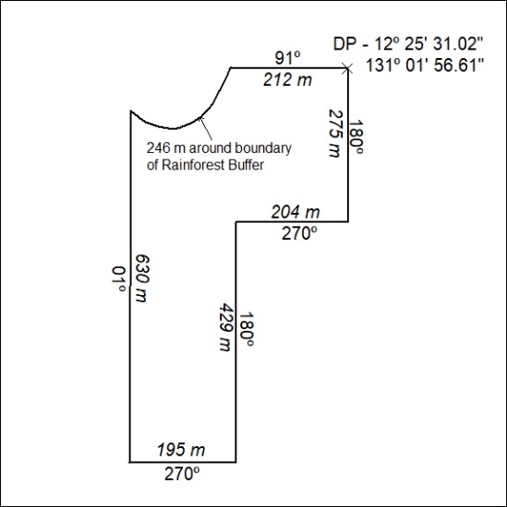

33/20

Mineral Titles Act 2010
NOTICE OF LAND CEASING TO BE A MINERAL TITLE AREA
Title Type and Number: | Extractive Mineral Permit 26128
Area ceased on: | 28 January 2020
Area: | 14.00 Hectare
Locality: | KOOLPINYAH
Name of Applicants(s)Holder(s): | 100% ALISANTE HOLDINGS PTY LTD [ACN. 067 361 559]
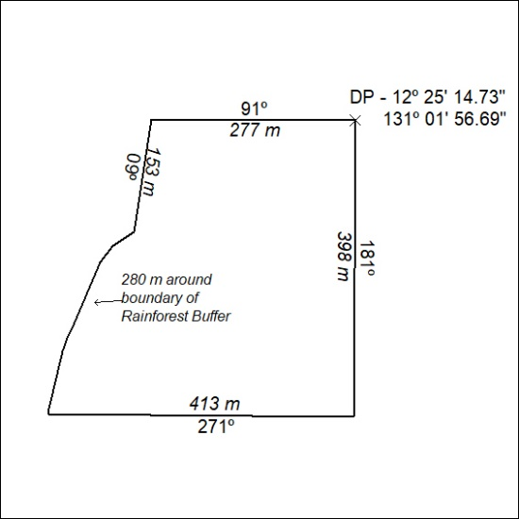

34/20

Mineral Titles Act 2010
NOTICE OF LAND CEASING TO BE A MINERAL TITLE AREA
Title Type and Number: | Extractive Mineral Permit 28195
Area ceased on: | 24 January 2020
Area: | 28.00 Hectare
Locality: | KOOLPINYAH
Name of Applicants(s)Holder(s): | 100% MOUSELLIS & SONS PTY. LTD. [ACN. 009 654 791]
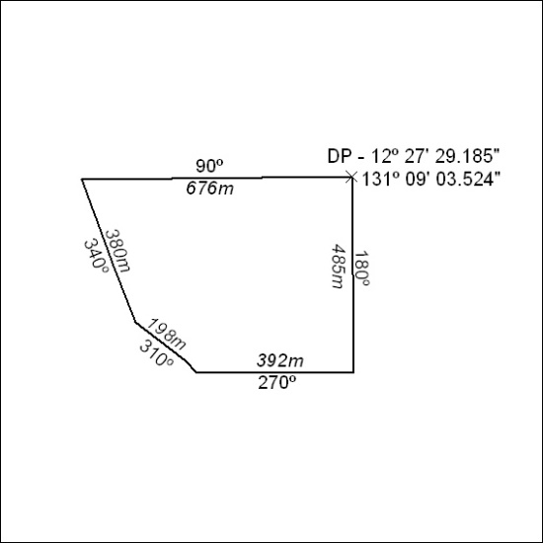

35/20

