Mineral Titles Act 2010
NOTICE OF LAND CEASING TO BE A MINERAL TITLE AREA
Title Type and Number: | Exploration Licence 31548
Area Ceased on: | 31 January 2020
Area: | 67 Blocks, 199.73 km²
Locality: | SELBY
Name of Applicant(s)/Holder(s): | 100% MANGROVE RESOURCES PTY LTD [ACN. 612 043 240]
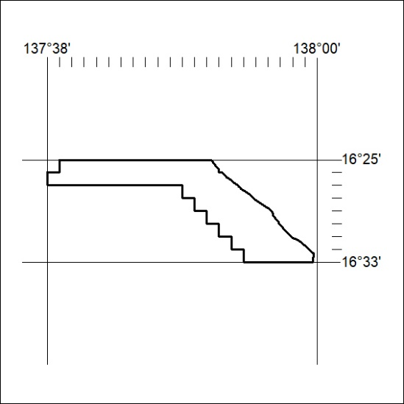

40/20

Mineral Titles Act 2010
NOTICE OF LAND CEASING TO BE A MINERAL TITLE AREA
Title Type and Number: | Exploration Licence 31549
Area Ceased on: | 31 January 2020
Area: | 77 Blocks, 231.66 km²
Locality: | SELBY
Name of Applicant(s)/Holder(s): | 100% MANGROVE RESOURCES PTY LTD [ACN. 612 043 240]
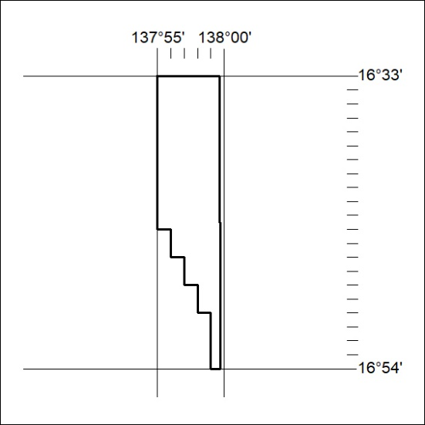

41/20

Mineral Titles Act
NOTICE OF GRANT OF A MINERAL TITLE
Title Type and Number: | Extractive Mineral Permit 31334
Granted: | 30 January 2020, for a period of 5 Years
Area: | 89.00 Hectares
Locality: | KOOLPINYAH
Name of Holder/s: | 100% MOUSELLIS & SONS PTY. LTD. [ACN. 009 654 791]
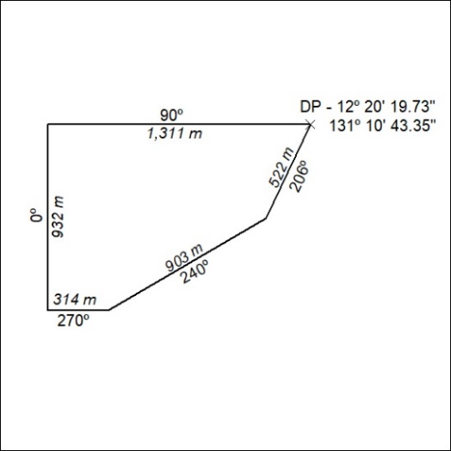

42/20

Mineral Titles Act
NOTICE OF GRANT OF A MINERAL TITLE
Title Type and Number: | Extractive Mineral Permit 31335
Granted: | 30 January 2020, for a period of 5 Years
Area: | 73.00 Hectares
Locality: | KOOLPINYAH
Name of Holder/s: | 100% MOUSELLIS & SONS PTY. LTD. [ACN. 009 654 791]
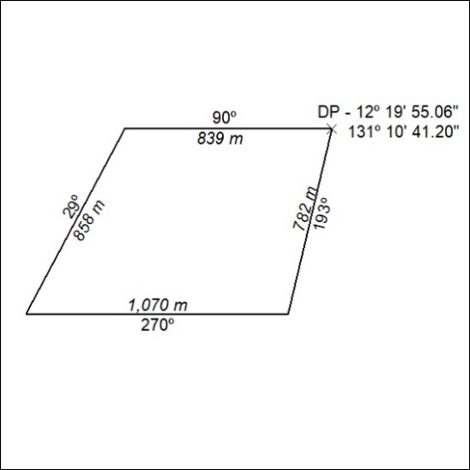

43/20

Mineral Titles Act
NOTICE OF GRANT OF A MINERAL TITLE
Title Type and Number: | Extractive Mineral Permit 31336
Granted: | 30 January 2020, for a period of 5 Years
Area: | 93.00 Hectares
Locality: | KOOLPINYAH
Name of Holder/s: | 100% MOUSELLIS & SONS PTY. LTD. [ACN. 009 654 791]
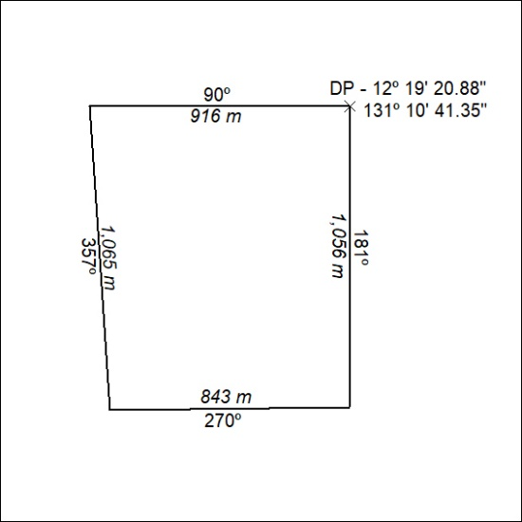

44/20

Mineral Titles Act
NOTICE OF GRANT OF A MINERAL TITLE
Title Type and Number: | Extractive Mineral Permit 31337
Granted: | 30 January 2020, for a period of 5 Years
Area: | 58.00 Hectares
Locality: | KOOLPINYAH
Name of Holder/s: | 100% MOUSELLIS & SONS PTY. LTD. [ACN. 009 654 791]
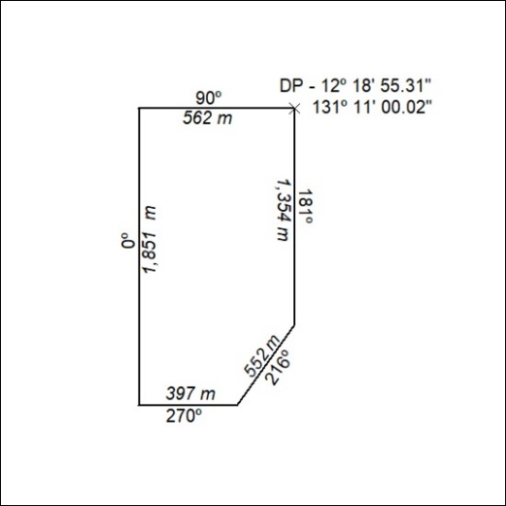

45/20

Mineral Titles Act
NOTICE OF GRANT OF A MINERAL TITLE
Title Type and Number: | Extractive Mineral Permit 31338
Granted: | 30 January 2020, for a period of 5 Years
Area: | 92.00 Hectares
Locality: | KOOLPINYAH
Name of Holder/s: | 100% MOUSELLIS & SONS PTY. LTD. [ACN. 009 654 791]
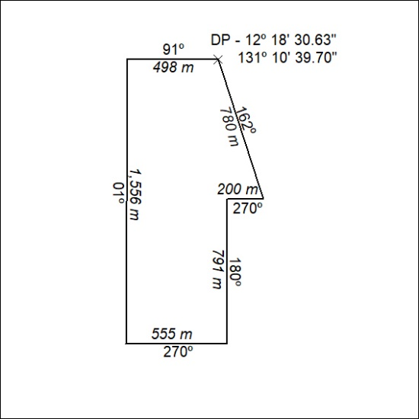

46/20

Mineral Titles Act
NOTICE OF GRANT OF A MINERAL TITLE
Title Type and Number: | Extractive Mineral Permit 31339
Granted: | 30 January 2020, for a period of 5 Years
Area: | 99.00 Hectares
Locality: | KOOLPINYAH
Name of Holder/s: | 100% MOUSELLIS & SONS PTY. LTD. [ACN. 009 654 791]
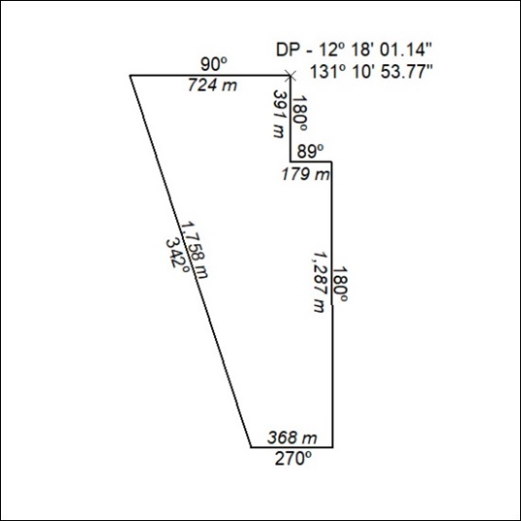

47/20

Mineral Titles Act
NOTICE OF GRANT OF A MINERAL TITLE
Title Type and Number: | Extractive Mineral Permit 31642
Granted: | 30 January 2020, for a period of 5 Years
Area: | 34.00 Hectares
Locality: | KOOLPINYAH
Name of Holder/s: | 100% MOUSELLIS & SONS PTY. LTD. [ACN. 009 654 791]
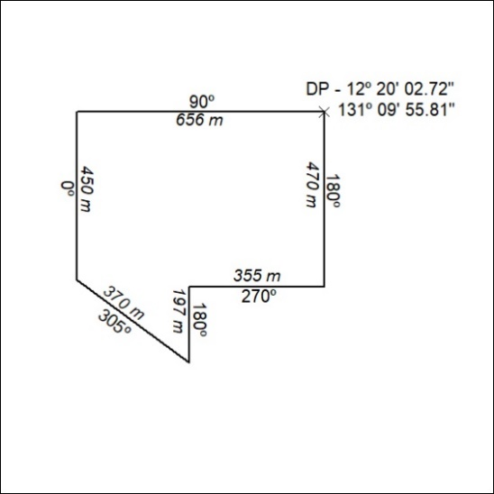

48/20

