Mineral Titles Act 2010
NOTICE OF LAND CEASING TO BE A MINERAL TITLE AREA
Title Type and Number: | Exploration Licence 27266
Area Ceased on: | 18 June 2020
Area: | 8 Blocks, 25.17 km²
Locality: | LAKE CAROLINE
Name of Applicant(s)/Holder(s): | 100% RED METAL LIMITED [ACN. 103 367 684]
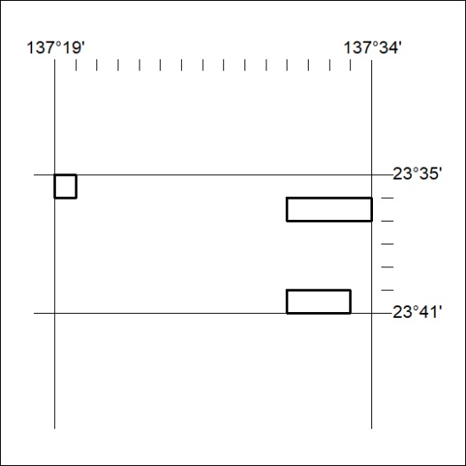

205/20

Corrigendum
Notice Number 178/20 appearing in MN46/20 on 7 May 2020 is hereby cancelled and replaced by the following:

Mineral Titles Act 2010
NOTICE OF LAND CEASING TO BE A MINERAL TITLE AREA
Title Type and Number: | Exploration Licence 27266
Area Ceased on: | 06 May 2020
Area: | 92 Blocks, 289.53 km²
Locality: | LAKE CAROLINE
Name of Applicant(s)/Holder(s): | 100% RED METAL LIMITED [ACN. 103 367 684]
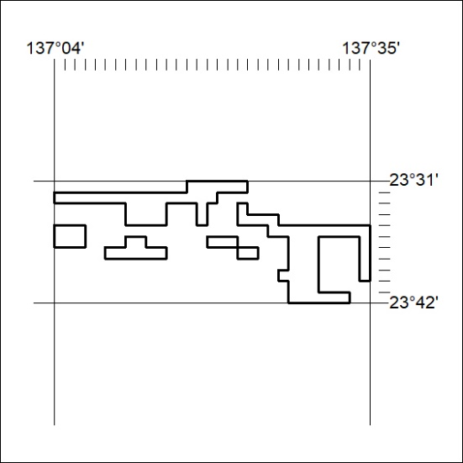
206/20

