Mineral Titles Act
NOTICE OF GRANT OF A MINERAL TITLE
Title Type and Number: | Mineral Lease 32277
Granted: | 27 July 2020, for a period of Years
Area: | 124.10 Hectares
Locality: | LUCY
Name of Holder/s: | 100% JINKA MINERALS LIMITED [ACN. 131 851 404]
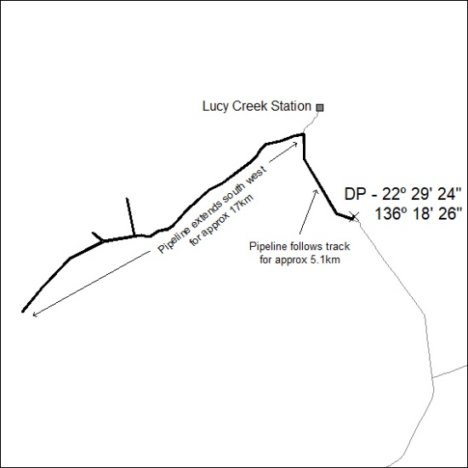

244/20

