Mineral Titles Act 2010
NOTICE OF LAND CEASING TO BE A MINERAL TITLE APPLICATION AREA
Title Type and Number: | Exploration Licence 28241
Area Ceased on: | 20 August 2020
Area: | 7 Blocks, 13.23 km²
Locality: | OENPELLI
Name of Applicant(s)/Holder(s): | 100% UXA RESOURCES LTD * [ACN. 112 714 397]
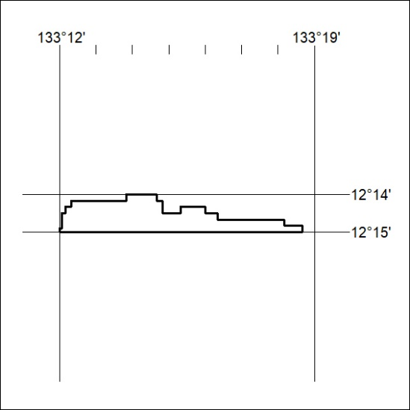

285/20

Mineral Titles Act 2010
NOTICE OF LAND CEASING TO BE A MINERAL TITLE APPLICATION AREA
Title Type and Number: | Exploration Licence 28242
Area Ceased on: | 20 August 2020
Area: | 8 Blocks, 12.31 km²
Locality: | OENPELLI
Name of Applicant(s)/Holder(s): | 100% UXA RESOURCES LTD * [ACN. 112 714 397]
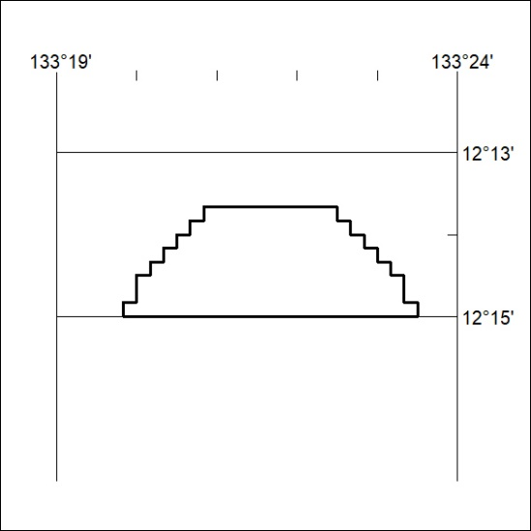

286/20
Mineral Titles Act 2010
NOTICE OF LAND CEASING TO BE A MINERAL TITLE AREA
Title Type and Number: | Exploration Licence 29689
Area Ceased on: | 14 August 2020
Area: | 47 Blocks, 147.69 km²
Locality: | RIDDOCH
Name of Applicant(s)/Holder(s): | 100% DBL BLUES PTY LTD [ACN. 140 024 442]
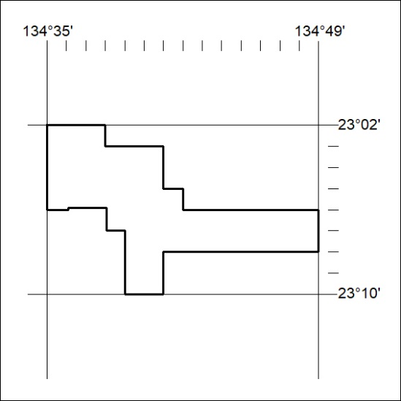

287/20

Mineral Titles Act 2010
NOTICE OF LAND CEASING TO BE A MINERAL TITLE AREA
Title Type and Number: | Exploration Licence 31574
Area Ceased on: | 30 August 2020
Area: | 30 Blocks, 99.49 km²
Locality: | MARANBOY
Name of Applicant(s)/Holder(s): | 100% FIDDLER'S CREEK MINING COMPANY PTY LTD * [ACN. 099 215 648]
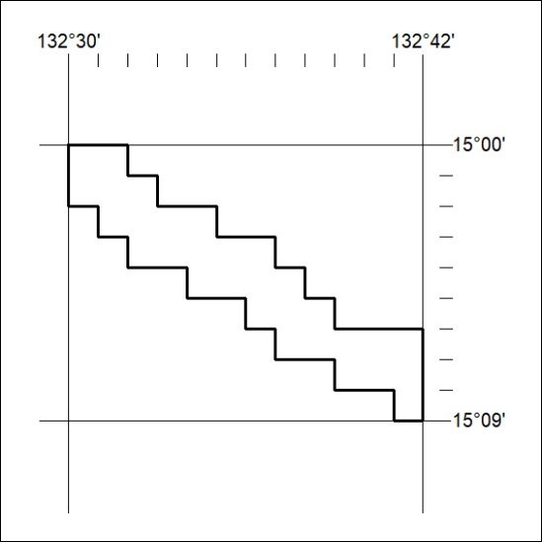

288/20
Mineral Titles Act 2010
NOTICE OF LAND CEASING TO BE A MINERAL TITLE AREA
Title Type and Number: | Exploration Licence 31575
Area Ceased on: | 30 August 2020
Area: | 31 Blocks, 102.51 km²
Locality: | ELSEY
Name of Applicant(s)/Holder(s): | 100% FIDDLER'S CREEK MINING COMPANY PTY LTD * [ACN. 099 215 648]
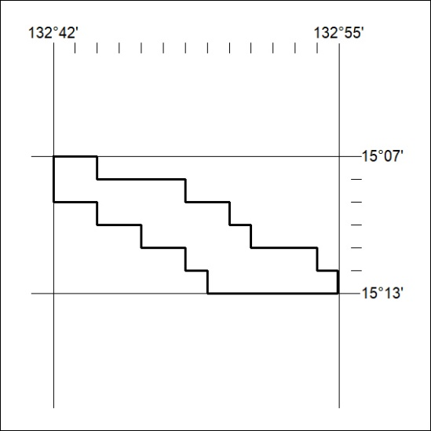

289/20

Mineral Titles Act 2010
NOTICE OF LAND CEASING TO BE A MINERAL TITLE AREA
Title Type and Number: | Extractive Mineral Lease 30972
Area ceased on: | 19 August 2020
Area: | 19.00 Hectare
Locality: | NOONAMAH
Name of Applicants(s)Holder(s): | 100% DARWIN RIVER QUARRIES PTY LTD [ACN. 167 335 882]
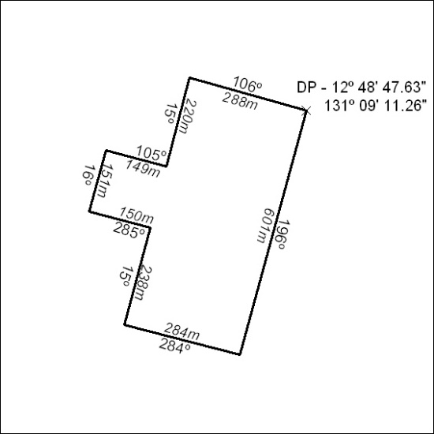

290/20

Mineral Titles Act 2010
NOTICE OF LAND CEASING TO BE A MINERAL TITLE AREA
Title Type and Number: | Extractive Mineral Permit 30287
Area ceased on: | 19 August 2020
Area: | 84.00 Hectare
Locality: | NOONAMAH
Name of Applicants(s)Holder(s): | 100% DARWIN RIVER QUARRIES PTY LTD [ACN. 167 335 882]
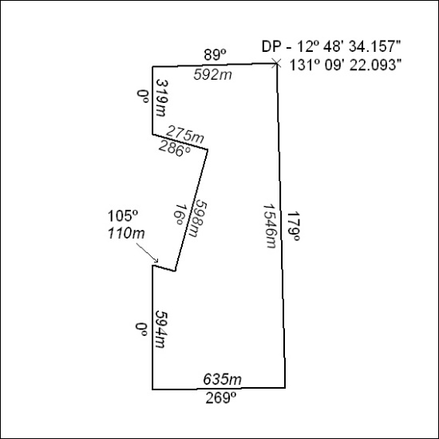

291/20

Mineral Titles Act 2010
NOTICE OF LAND CEASING TO BE A MINERAL TITLE AREA
Title Type and Number: | Extractive Mineral Permit 30289
Area ceased on: | 19 August 2020
Area: | 88.00 Hectare
Locality: | NOONAMAH
Name of Applicants(s)Holder(s): | 100% DARWIN RIVER QUARRIES PTY LTD [ACN. 167 335 882]
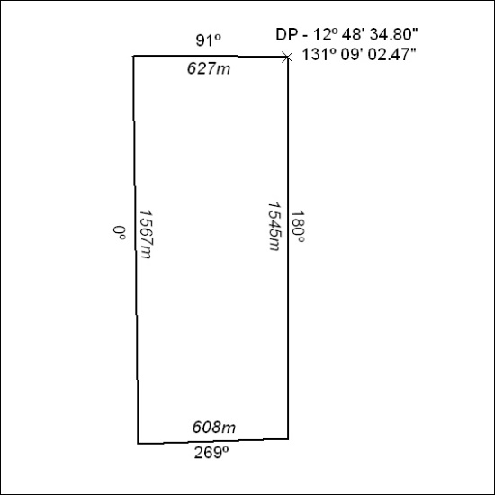

292/20

