Mineral Titles Act 2010
NOTICE OF LAND CEASING TO BE A MINERAL TITLE AREA
Title Type and Number: | Extractive Mineral Permit 30684
Area ceased on: | 19 August 2020
Area: | 11.00 Hectare
Locality: | NOONAMAH
Name of Applicants(s)Holder(s): | 100% OSTOJIC GROUP PTY LTD* [ACN. 009 629 805]
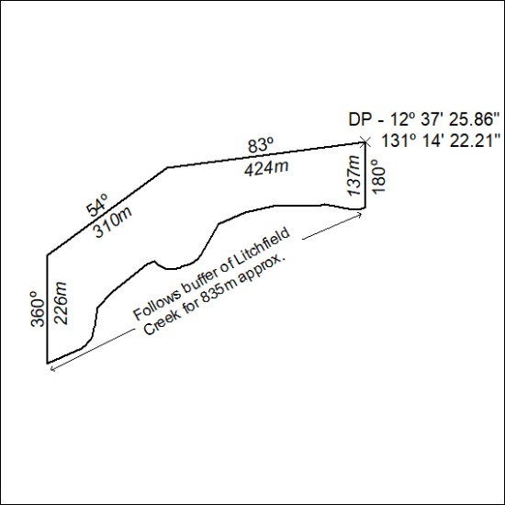

297/20

