Agnote

No: E67
August 2014

Perennial Sorghum
(Formerly titled "Silk Sorghum")
A. G. Cameron, Principal Pastures and Extension Agronomist, Darwin

INTRODUCTION
Silk perennial sorghum was first registered as a pasture plant cultivar in Australia in 1978. Since then it has become useful as a pioneer species in the Queensland Brigalow belt and as a short-lived perennial pasture in dry (500–700 mm rainfall) areas. In the Northern Territory, Silk sorghum has been grown successfully in the Douglas-Daly, Katherine and Tennant Creek regions.
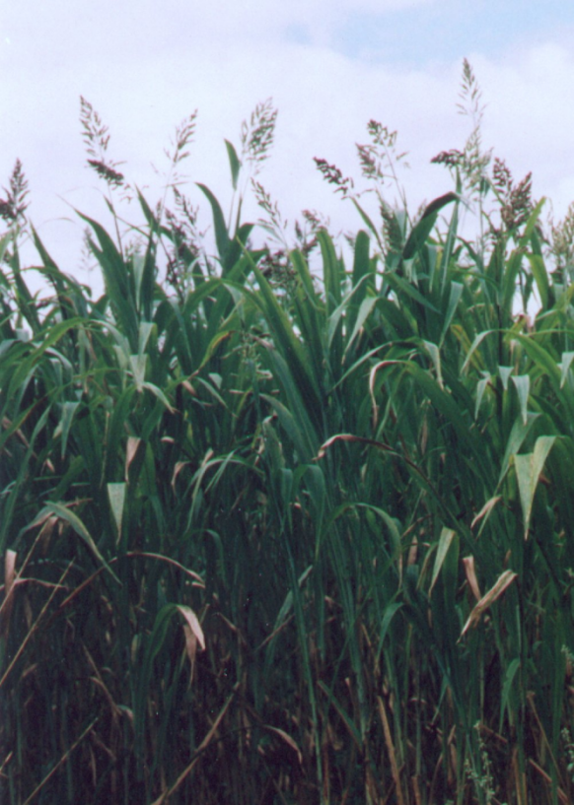
Silk sorghum is a hybrid between Krish hybrid sorghum (Sorghum halepense x S. roxburghii) and S. arundinaceum and was released in Queensland as a replacement for Sorghum almum.
A new variety of perennial sorghum called Jaffa has been bred from Silk sorghum in recent years. This variety is now available commercially.

DESCRIPTION
Perennial sorghums are erect tussocky short-lived perennial grasses which, under good conditions, grow to about 3.5 m in height at maturity. Tussocks of up to 30 cm in diameter produce 20 to 80 branched tillers with stems about 1 cm in diameter. Thick short rhizomes produce new stems usually 5 to 10 cm from the parent plant.
Seed heads are pyramid-shaped panicles containing yellowish brown seeds, each 2.5 to 4.0 mm long. There are approximately 148 000 seeds/kg.

CLIMATE AND SOILS
Perennial sorghums are best suited to deep, fertile heavy soils, but have grown well on Blain sandy red earths at Douglas Daly Research Farm (DDRF) and on Tippera clay loam in the Douglas Daly and Katherine Districts when adequately fertilised.
Perennial sorghums are more drought-tolerant than annual forage sorghums, but not as drought-tolerant as buffel grass. They have been grown on red soils in the Barkly District (350 mm annual rainfall) as a cover crop on ponded banks to revegetate degraded areas. In that environment, yields are variable. However, around 1 t/ ha of dry matter can be expected over the wet season.

USES
- As a forage crop in a pure stand fertilised with nitrogen (N) or following a legume rotation.
- In a short term pasture rotation following a legume crop or hay. Perennial sorghum is productive initially, but yields decline considerably after the first year as soil N is depleted.
- In a short term pasture mix with a twining legume such as Oolloo Centro or Milgarra blue pea.
- As a pioneer or weed control species. Sown thickly, Silk sorghum will overgrow most weeds and, by using available soil N, will also reduce the likelihood of a major competition from weeds in the following season.

MANAGEMENT
Sowing: Seed should be drilled into a well-prepared seedbed at a sowing rate of 4 to 6 kg/ha, followed by press-wheeling or rolling. If seed is broadcast, a higher sowing rate should be used. As seed is relatively inexpensive, sowing rates of up to 10 kg/ha can be used in high rainfall areas to obtain a thick stand of perennial sorghum to control weeds.
Fertiliser Requirements: In common with all forage sorghums, perennial sorghum is quite responsive to applied fertiliser. Specific fertiliser requirements will vary with soil type and location. However, to maintain high dry matter yields, annual maintenance dressings of phosphorus, sulphur (S) and potassium would be required in most areas if the crop is grown continuously.
Where perennial sorghum is not being grown to take advantage of a previous N build-up, or where it is not sown with a companion legume, it will respond to split applications of N four to six weeks apart during the wet season in areas with over 600 mm rainfall. Without adequate N, perennial sorghum will not persist.
Weed Control: If sown in a weed-free seedbed, the rapid growth rate of silk usually overcomes any weed problem.
If weed control is required in a pure perennial sorghum crop, atrazine can be applied post-planting, pre-emergent at 1.25–3 kg/ha active ingredient, depending on weed type. For broadleaf weeds, 2, 4-D can be used with care at the seedling stage when Silk sorghum is 7 to 15 cm high. Fluoxypyr may be used to control broadleaf weeds post-emergent when secondary roots have developed. These herbicides should not be used if a companion legume is sown.
High rates of herbicide should be avoided on sandy soils.
Yield: A Silk sorghum/Maldonado pasture at DDRF yielded 5.5 t/ha dry matter in its first wet season, comparing favourably with other sown pastures with similar management. Steers grazing this pasture at one animal/ha continuously for 12 months from June 1996 to June 1997 gained on average 197 kg/animal, equal to, or better than, weight gains on other sown pasture mixtures.
Grazing: Fertilised pastures based on perennial sorghum can support stocking rates up to one animal/ha with good weight gains during both wet season and dry season grazing in the Top End. Perennial sorghum can be grazed continuously at moderate stocking rates, or grazed intensively at high stocking rates for a short period before being allowed to regrow.
Young crops should not be grazed until secondary roots have developed and the crop is approximately 80 cm high. If regrowth is desired after intensive grazing, animals should be removed when it has been grazed down to no less than 15 cm. Regrowth can be grazed again when it is about 80 cm tall. To avoid the possibility of prussic acid poisoning, young regrowth should not be grazed, particularly if the regrowth is water stressed.
There is some evidence from Queensland that palatability of perennial sorghum may be reduced when soil fertility declines.
Perennial sorghum can cause problems when in seed during mustering as the sharp seeds, held at 2 m high, can pose a danger to the eyes of animals.
Precautions when grazing perennial sorghum:
All sorghums contain prussic acid, which in high doses, can cause poisoning. Prussic acid content is highest in new or stressed growth and problems are most likely when hungry animals gain access to such a crop.
- Feed hungry stock before putting them onto forage sorghum and introduce only a few animals at first.
- Wait until the crop or regrowth is 80 cm high before grazing.
- Note that adequate phosphorus application to the soil lowers the risk
- Provide animals with a sulphur (S) supplement, which detoxifies prussic acid. Forage sorghums tend to have a low S content and animals grazing sorghum as a sole fodder may become S deficient.
The treatment for prussic acid poisoning is to drench cattle with 55 g photographic hypo (sodium thiosulphate) in 600 mL water. The sodium thiosulphate can also be given intravenously or by intra-ruminal injection.
Hay: Perennial sorghum is suitable for haymaking. The hay will be of similar quality to early maturing forage sorghums. Little data is available on perennial forage quality from the NT. However, as a guide, expect crude protein at 4%, dry matter digestibility at around 50% and metabolisable energy at 15 to 17 MJ/kg in April in the Top End.

WEED POTENTIAL
Early fears in Queensland of perennial sorghum becoming a weed in cropping areas, similar to Johnson grass (S. halepense) have not been realised. Perennial sorghum pastures decline and eventually die when soil N is depleted. In the NT this may take only one to two years.
Perennial sorghum is easy to plough out when no longer required. Seedlings and young plants are easily killed with non-residual contact herbicides. Heavy grazing (over 2.5 animals/ha), particularly in the dry season, will also eradicate perennial sorghum.

WARNING
Pasture plants have the potential to become weeds in certain situations. To prevent that, ensure that pasture seeds and/or vegetative material is not inadvertently transferred to adjacent properties or road sides.

Please visit us at our website:
www.dpif.nt.gov.au

© Northern Territory Government
ISSN 0157-8243
Serial No. 784
Agdex No. 126/20

Disclaimer: While all care has been taken to ensure that information contained in this document is true and correct at the time of publication, the Northern Territory of Australia gives no warranty or assurance, and makes no representation as to the accuracy of any information or advice contained in this publication, or that it is suitable for your intended use. No serious, business or investment decisions should be made in reliance on this information without obtaining independent and/or professional advice in relation to your particular situation.

