Mineral Titles Act
NOTICE OF LAND CEASING TO BE A MINERAL TITLE AREA
Title Type and Number: | Exploration Licence 31554
Area Ceased on: | 21 February 2018
Area: | 70 Blocks, 196.98 km²
Locality: | MILLIK MONMIR
Name of Applicant(s)/Holder(s): | 100% DESERT MINERALS EXPLORATION PTY LTD [ACN. 165 710 887]
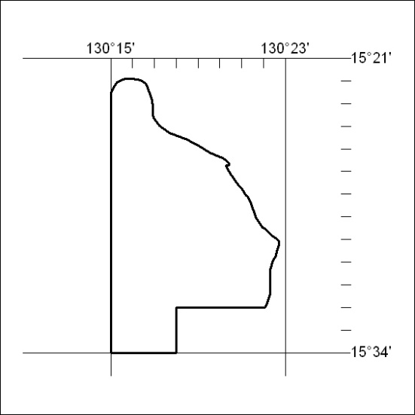

79/18

