Mineral Titles Act
NOTICE OF LAND CEASING TO BE A MINERAL TITLE
Title Type and Number: | Extractive Mineral Lease 24030
Area ceased on: | 17 April 2018
Area: | 14.00 Hectare
Locality: | MARY RIVER
Name of Applicants(s)Holder(s): | 100% TSIRBAS Georgios
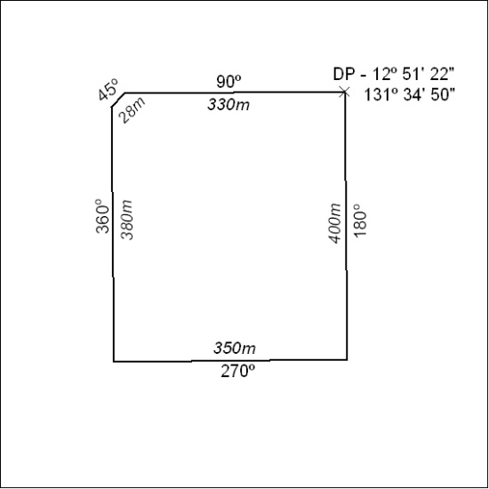

138/18

Mineral Titles Act
NOTICE OF LAND CEASING TO BE A MINERAL TITLE AREA
Title Type and Number: | Exploration Licence 29976
Area Ceased on: | 11 April 2018
Area: | 2 Blocks, 6.69 km²
Locality: | BATCHELOR
Name of Applicant(s)/Holder(s): | 100% NORTH QUEENSLAND MINING PTY LTD [ACN. 152 890 643]
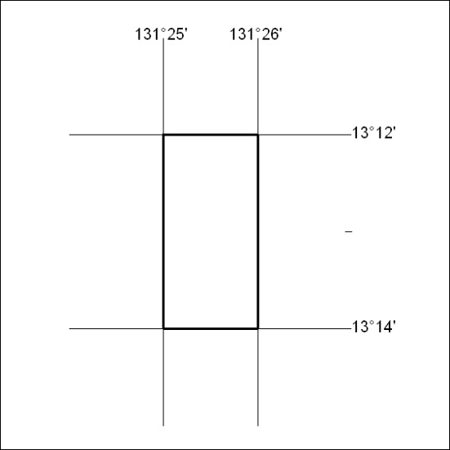

139/18

Mineral Titles Act
NOTICE OF GRANT OF A MINERAL TITLE
Title Type and Number: | Exploration Licence 31708
Granted: | 18 April 2018, for a period of 6 Years
Area: | 2 Blocks, 6.68 km²
Locality: | PINE CREEK
Name of Holder/s: | 100% ROCKWASH PTY LTD [ACN. 611 356 837]
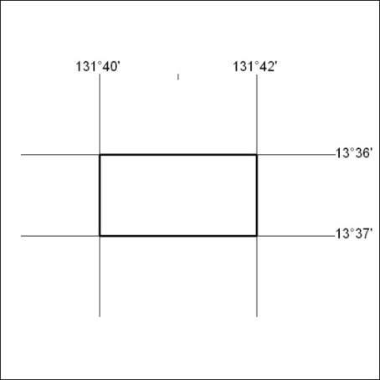
Area granted is indicated above. The titleholder is not permitted to exercise occupational rights on any land that is subject to a development title, or an application for a development title. Any land the subject of a Reserved Land gazettal under the Mineral Titles Act and all land vested in the Commonwealth of Australia is also excluded by description but not excised from the grant area.

140/18

