Overview
The rural industries and fisheries in the Northern Territory (NT) include cattle (interstate, abattoir and live export), other livestock (buffalo, crocodiles and horses), horticulture (fruit, vegetables, nursery and cut flowers) and mixed farming (fodder and forestry). The fisheries industry comprises harvesting of wild catch (including the Northern Prawn Fleet) and aquaculture. A substantial recreational fishing sector generates tourism activity and provides lifestyle amenity. The percentage contribution of each industry to the rural and fisheries total is illustrated in Figure 1, with the cattle, fisheries and horticulture industries being the major players.

Figure 1: Contribution of Industry to Sector Production Value, 2016-17
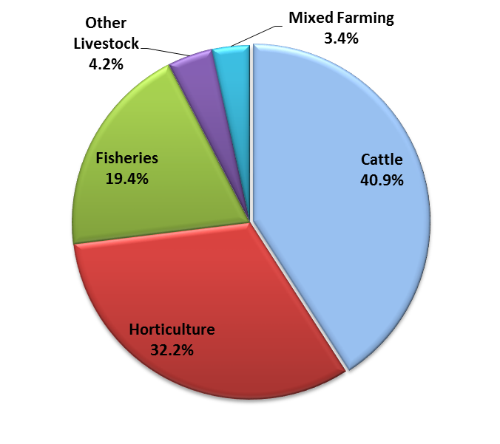
Source: Department of Primary Industry and Resources data collections

The rural industries and fisheries have significant links to other sectors of the Territory economy such as manufacturing, transport and storage, retail and wholesale trade. These industries are vital in regional areas, providing economic stimulus and employment for approximately 1,899 persons in 2016-17 (ABS). This labour force estimate is subject to high sampling variability. The sector also account for a significant proportion of the Territory's non-mineral export revenue, with the live cattle trade. Territory rural industries and fisheries accounted for 2.7% of Gross State Product (GSP) in 2016-17, just below the national proportion of 2.8% (Table 1). Exports of Territory rural and fisheries produce are dominated by live cattle exports (mainly to Indonesia and Vietnam), aquaculture, fishing, forestry and to a lesser extent agriculture services.
In 2016-17, the total estimated value of rural industries and fisheries production was $726.5 million, a decrease of 1.6% over the previous year, a result reflective of mixed production results and market conditions (see Figure 2). The decrease is primarily due to a 9.1% decrease in the value of cattle production to $297.1 million (due to falling exports and abattoir output while interstate movements increased marginally), 11.2% fall in other livestock production (mainly crocodile production) to $30.2 million and a 14.1% decrease in the value of mixed farming to $24.7 million (driven by Tiwi forestry shipments and hay production). These decreases were offset by a 4.1% growth in the value of horticultural production to $233.7 million, and a 13.3% increase in fisheries production to $140.8 million (driven by the wild stock catch and aquaculture).

Table 1: Agriculture, Forestry and Fisheries Contribution to GSP by State
2016-17 | % Contribution to GSP
Tasmania | 9.6%
South Australia | 5.9%
Queensland | 3.4%
Western Australia | 2.9%
Northern Territory | 2.7%
Victoria | 2.6%
NSW | 1.8%
Australian Capital Territory | 0.1%
Australia (% of GDP) | 2.8%
Source: ABS 5220.0

Figure 2: NT Rural Industries and Fisheries Production Value
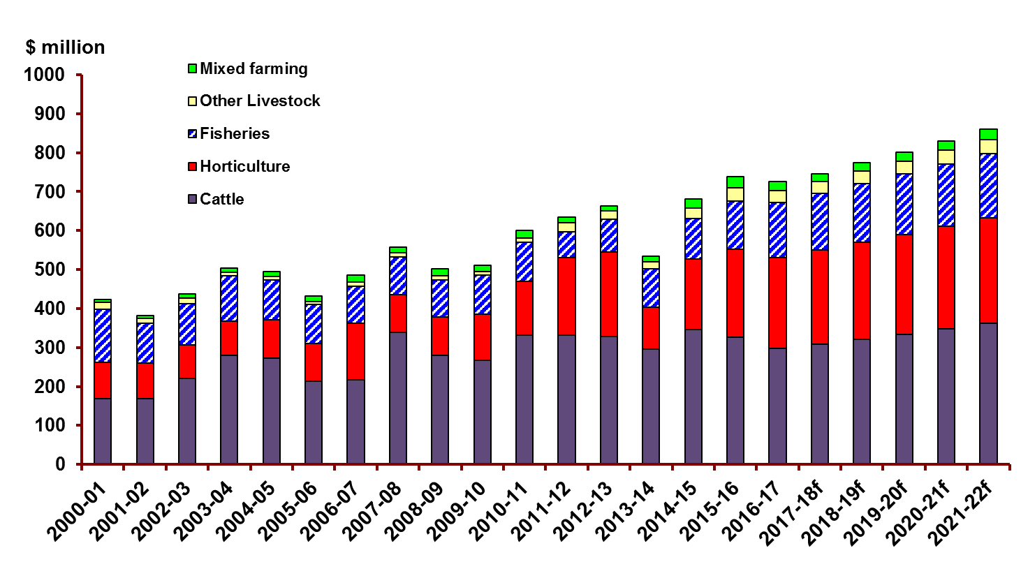
Source: Department of Primary Industry and Resources data collections
Table 2: Gross Value of Territory Rural Industries and Fisheries Production ($ million)
Value of horticultural production ($ million)
 | 2014-15 | 2015-16 | 2016-17 | 2017-18f | 2018-19f | 2019-20f
Mangoes | 95.5 | 88.5 | 88.3 | 90.9 | 93.7 | 96.5
Table Grapes | 0.8 | 8.0 | 8.0 | 8.2 | 8.5 | 8.7
Bananas | 0.0 | 0.0 | 0.0 | 0.0 | 0.0 | 0.0
Melons | 45.8 | 52.6 | 50.3 | 51.8 | 53.4 | 55.0
Other fruits | 4.7 | 8.0 | 17.7 | 18.2 | 18.8 | 19.3
Vegetables | 17.2 | 41.5 | 43.9 | 45.2 | 46.6 | 48.0
Nursery-Cut Flowers & Turf | 17.9 | 18.0 | 17.7 | 18.2 | 18.8 | 19.3
Local markets | 0.0 | 7.9 | 7.8 | 8.0 | 8.3 | 8.5
Total | 182.0 | 224.5 | 233.7 | 240.7 | 247.9 | 255.4
Value of fisheries production ($ million)
 | 2014-15 | 2015-16 | 2016-17 | 2017-18f | 2018-19f | 2019-20f
Fish | 26.2 | 31.6 | 37.3 | 38.4 | 39.5 | 40.7
Crustaceans | 4.6 | 3.0 | 5.9 | 6.1 | 6.3 | 6.5
Aquaculture | 24.5 | 24.5 | 34.4 | 35.5 | 36.5 | 37.6
Molluscs & Echinoderms | 0.2 | 0.3 | 0.6 | 0.7 | 0.7 | 0.7
Total NT Fisheries | 55.5 | 59.4 | 78.3 | 80.7 | 83.1 | 85.6
Crustaceans-NPF | 47.2 | 64.9 | 62.5 | 65.0 | 67.7 | 69.7
Total Fisheries | 102.8 | 124.3 | 140.8 | 145.7 | 150.7 | 155.3
Value of cattle, other livestock and mixed farming ($ million)
 | 2014-15 | 2015-16 | 2016-17 | 2017-18f | 2018-19f | 2019-20f
Cattle | 345.3 | 327.0 | 297.1 | 308.8 | 321.2 | 334.1
Other Livestock | 27.3 | 34.0 | 30.2 | 31.2 | 32.2 | 33.2
Field crops | 24.4 | 20.0 | 19.3 | 19.9 | 21.5 | 23.1
Poppy | 0.0 | 2.4 | 0.0 | 0.0 | 0.0 | 0.0
Forestry | 0.0 | 6.4 | 5.4 | 0.0 | 0.0 | 0.0
Total | 397.0 | 389.7 | 352.0 | 359.8 | 374.9 | 390.5
Total NT Rural Industries and Fisheries Production Value ($ million)
 | 2014-15 | 2015-16 | 2016-17f | 2017-18f | 2018-19f | 2019-20f
Horticulture | 182.0 | 224.5 | 233.7 | 240.7 | 247.9 | 255.4
Fisheries | 102.8 | 124.3 | 140.8 | 145.7 | 150.7 | 155.3
Cattle | 345.3 | 327.0 | 297.1 | 308.8 | 321.2 | 334.1
Other Livestock | 27.3 | 34.0 | 30.2 | 31.2 | 32.2 | 33.2
Mixed Farming | 24.4 | 28.8 | 24.7 | 19.9 | 21.5 | 23.1
Grand Total | 681.8 | 738.5 | 726.5 | 746.2 | 773.5 | 801.1
Source: Department of Primary Industry and Resources data collections, f = forecast. (1) Please note all figures here have been rounded respectively and may not tally to totals. (2) NPF = Northern Prawn Fleet (Commonwealth-managed fishery). (3) Cattle valuations are calculated using farm gate production values not market or whole of industry contribution values. (4) Local Markets value is derived from production sold at markets located mainly in Darwin plus production sold to supermarket chains.

Forecasting Notes
No data was collected for Bananas for 2016-17 therefore no forecasts were generated.
No forecasts were generated for Poppy as it is was one-off trial crop not ongoing production.
No forecasts were generated for Forestry as the $5.4m (2016-17) represents the second of two shipments of woodchips so a forecast is not generated beyond 2016-17.

Please use this data from 1 May 2018 to 30 June 2019 only
Table 3: Gross Value of Territory Rural Industries and Fisheries Production (Percentage changes)
 | 13-14 to 14-15 | 14-15 to 15-16 | 15-16 to 16-17
 | % | % | %
Mangoes | 172.6% | -7.3% | -0.2%
Table Grapes | 0.0% | 903.1% | 0.0%
Bananas | 0.0% | 0.0% | 0.0%
Melons | 34.7% | 14.7% | -4.4%
Other fruits | -14.1% | 70.2% | 121.3%
Vegetables | 6.7% | 142.0% | 5.7%
Nursery-Cut Flowers & Turf | 3.0% | 0.4% | -1.7%
Local markets | 0.0% | 0.0% | -0.8%
Total | 68.4% | 23.4% | 4.1%
 | 13-14 to 14-15 | 14-15 to 15-16 | 15-16 to 16-17
 | % | % | %
Fish | 1.0% | 20.5% | 17.9%
Crustaceans | 8.5% | -34.8% | 99.3%
Aquaculture | 61.1% | 0.2% | 40.5%
Molluscs & Echinoderms | 57.5% | 17.8% | 0.0%
Total NT Fisheries | 21.9% | 7.0% | 31.8%
Crustaceans - NPF | -11.6% | 37.5% | -3.7%
Total Fisheries | 3.8% | 21.0% | 13.3%
 | 13-14 to 14-15 | 14-15 to 15-16 | 15-16 to 16-17
 | % | % | %
Cattle | 17.0% | -5.3% | -9.1%
Other Livestock | 51.9% | 24.5% | -11.2%
Field crops | 84.0% | -18.1% | -3.5%
Poppy | 0.0% | 0.0% | -100.0%
Forestry | 0.0% | 0.0% | -14.9%
 | 13-14 to 14-15 | 14-15 to 15-16 | 15-16 to 16-17
 | % | % | %
Horticulture | 68.4% | 23.4% | 4.1%
Fisheries | 3.8% | 21.0% | 13.3%
Cattle | 17.0% | -5.3% | -9.1%
Other Livestock | 51.9% | 24.5% | -11.2%
Mixed Farming | 84.0% | 17.7% | -14.1%
Total | 27.8% | 8.3% | -1.6%
Source: Department of Primary Industry and Resources data collections
NPF = Northern Prawn Fleet (Commonwealth-managed fishery)

Please use this data from 1 May 2018 to 30 June 2019 only.

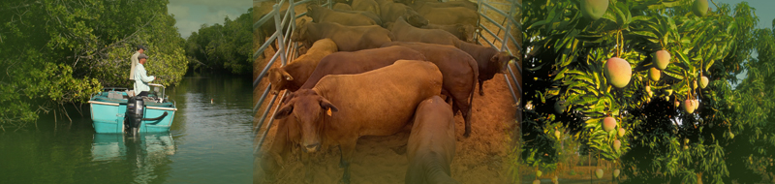
\

Acknowledgements
The important contributions made by staff of the Department of Primary Industry and Resources Crocodile Farmers Association of the Northern Territory, and NT Farmers Association are gratefully acknowledged.
The author would like to thank the following contributors:
Biosecurity and Product Integrity: Adele Kluth
NT Farmers Association
DPIR Fisheries Group: Murray Barton
Crocodile Farmers Association of the NT: Gae Mackay

Prepared by: Michael Jean

Contact Details
Michael Jean
Senior Economist
Department of Primary Industry and Resources
GPO Box 3000, DARWIN NT 0801 Australia

Telephone: +61 8 8999 2242
Email: michael.jean@nt.gov.au

Disclaimer
While all care has been taken to ensure that information contained in this document is true and correct at the time of publication, changes in circumstances after the time of publication may impact on the accuracy of its information.
The Northern Territory of Australia gives no warranty or assurance, and makes no representation as to the accuracy of any information or advice contained in this publication, or that it is suitable for your intended use.
You should not rely upon information in this publication for the purpose of making any serious, business or investment decisions without obtaining independent and/or professional advice in relation to your particular situation.
The NT of Australia disclaims any liability or responsibility or duty of care towards any person for loss or damage caused by any use of or reliance on the information contained in this publication.

