Mineral Titles Act
NOTICE OF LAND CEASING TO BE A MINERAL TITLE AREA
Title Type and Number: | Extractive Mineral Exploration Licence 31885
Area Ceased on: | 19 July 2018
Area: | 4 Blocks, 10.55 km²
Locality: | NOONAMAH
Name of Applicant(s)/Holder(s): | 100% A AND SF MADDALOZZO PTY. LIMITED [ACN. 009 624 015]
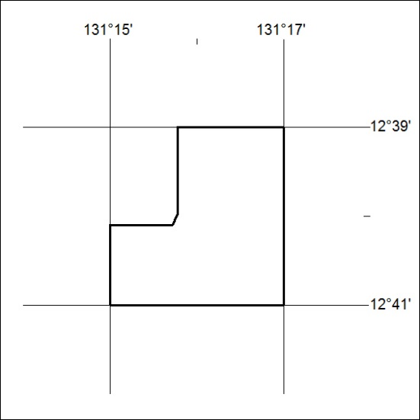

311/18

Mineral Titles Act
NOTICE OF LAND CEASING TO BE A MINERAL TITLE
Title Type and Number: | Mineral Lease 30910
Area ceased on: | 18 July 2018
Area: | 30.00 Hectare
Locality: | SHORT RANGE
Name of Applicants(s)Holder(s): | 100% SANTEXCO PTY LTD [ACN. 002 910 296]
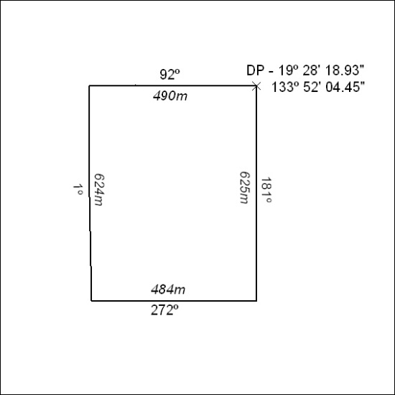

312/19

