Mineral Titles Act
NOTICE OF LAND CEASING TO BE A MINERAL TITLE AREA
Title Type and Number: | Exploration Licence 30603
Area Ceased on: | 30 July 2018
Area: | 22 Blocks, 71.80 km²
Locality: | BOWMAN
Name of Applicant(s)/Holder(s): | 100% TRACKER GEOSERVICES PTY LTD [ACN. 093 390 197]
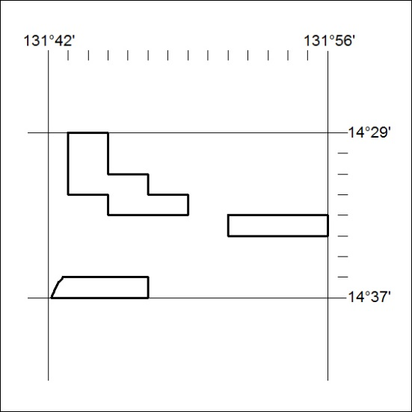

327/18

Mineral Titles Act
NOTICE OF LAND CEASING TO BE A MINERAL TITLE AREA
Title Type and Number: | Exploration Licence 30616
Area Ceased on: | 30 July 2018
Area: | 17 Blocks, 56.35 km²
Locality: | FERGUSSON RIVER
Name of Applicant(s)/Holder(s): | 100% TRACKER GEOSERVICES PTY LTD [ACN. 093 390 197]
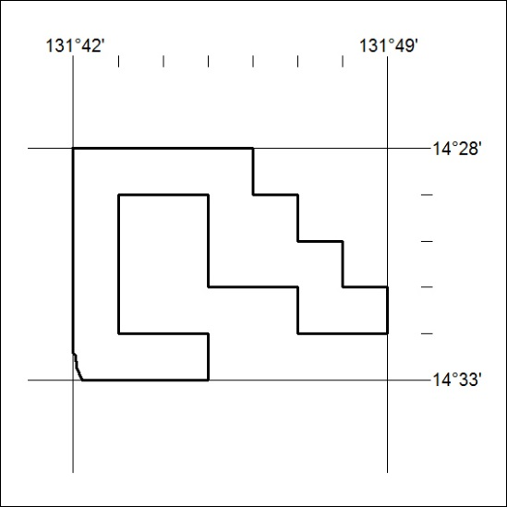

328/18

Mineral Titles Act
NOTICE OF LAND CEASING TO BE A MINERAL TITLE AREA
Title Type and Number: | Exploration Licence 31211
Area Ceased on: | 31 July 2018
Area: | 124 Blocks, 396.31 km²
Locality: | GEORGE CREEK
Name of Applicant(s)/Holder(s): | 100% PENINSULA RESOURCES LTD [ACN. 125 415 189]
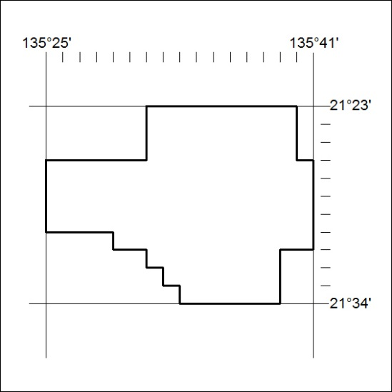

329/18

