Mineral Titles Act
NOTICE OF GRANT OF A MINERAL TITLE
Title Type and Number: | Extractive Mineral Exploration Licence 31837
Granted: | 10 September 2018, for a period of 2 Years
Area: | 4 Blocks, 12.54 km²
Locality: | KOOLPINYAH
Name of Holder/s: | 100% OSTOJIC GROUP PTY LTD* [ACN. 009 629 805]
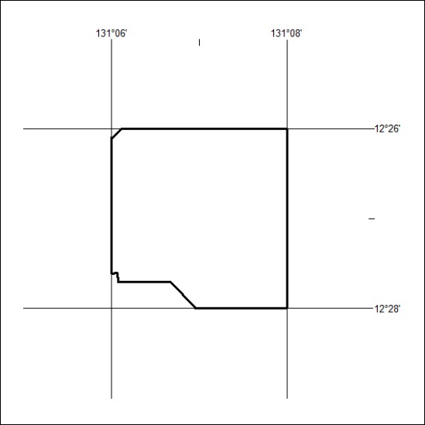
Area granted is indicated above. The titleholder is not permitted to exercise occupational rights on any land that is subject to a development title, or an application for a development title. Any land the subject of a Reserved Land gazettal under the Mineral Titles Act and all land vested in the Commonwealth of Australia is also excluded by description but not excised from the grant area.

398/18

Mineral Titles Act
NOTICE OF GRANT OF A MINERAL TITLE
Title Type and Number: | Extractive Mineral Exploration Licence 31844
Granted: | 10 September 2018, for a period of 2 Years
Area: | 3 Blocks, 4.24 km²
Locality: | KOOLPINYAH
Name of Holder/s: | 100% OSTOJIC GROUP PTY LTD* [ACN. 009 629 805]
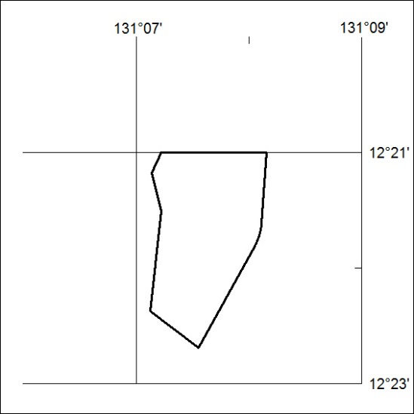
Area granted is indicated above. The titleholder is not permitted to exercise occupational rights on any land that is subject to a development title, or an application for a development title. Any land the subject of a Reserved Land gazettal under the Mineral Titles Act and all land vested in the Commonwealth of Australia is also excluded by description but not excised from the grant area.
399/18

Mineral Titles Act
NOTICE OF GRANT OF A MINERAL TITLE
Title Type and Number: | Extractive Mineral Exploration Licence 31845
Granted: | 10 September 2018, for a period of 2 Years
Area: | 4 Blocks, 2.75 km²
Locality: | KOOLPINYAH
Name of Holder/s: | 100% OSTOJIC GROUP PTY LTD* [ACN. 009 629 805]
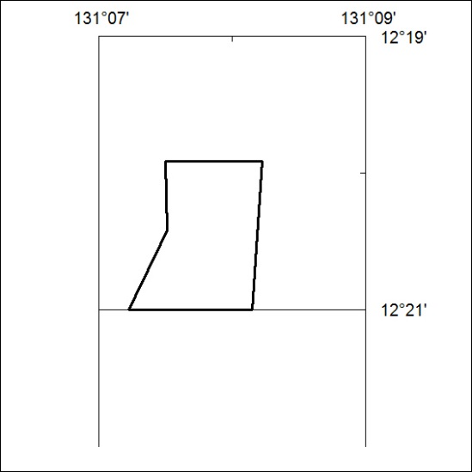
Area granted is indicated above. The titleholder is not permitted to exercise occupational rights on any land that is subject to a development title, or an application for a development title. Any land the subject of a Reserved Land gazettal under the Mineral Titles Act and all land vested in the Commonwealth of Australia is also excluded by description but not excised from the grant area.

400/18

