Northern Territory Pastoral Feed Outlook
September 2018
The purpose of this quarterly outlook is to summarise information relevant to the pastoral industry such as current feed supplies, seasonal conditions, the development of drought conditions in central Australia and fire risk.
You can see the entire document and all districts by continuing to scroll through this file. If you are interested in selected sections, you can click on the links below.
Summary of current situation & trends - all districts
Northern Territory Seasonal Outlook – as at September 2018
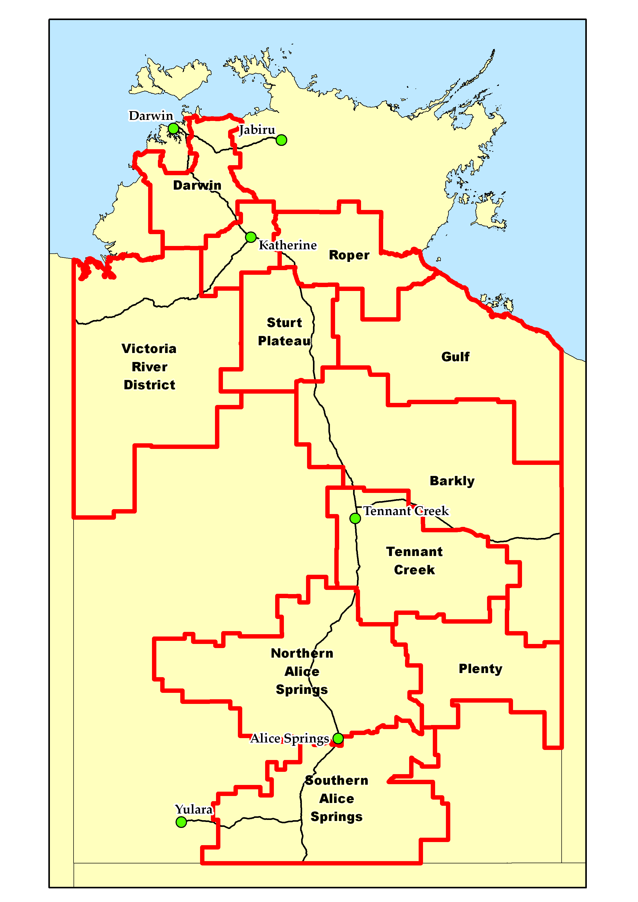
Individual District Summaries:
- Darwin District
- Katherine District
- Victoria River District
- Sturt Plateau District
- Roper District
- Gulf District
- Barkly District
- Tennant Creek District
- Northern Alice Springs District
- Plenty District
- Southern Alice Springs District

Summary of current situation & trends - all districts – September 2018
Pasture growth in 2017/18 was close to the long-term median across the majority of the NT. However, this pasture growth was considerably lower than that experienced in 2016/17 for the VRD, Barkly, Tennant Creek and Alice Springs regions. Hence, in regions where stock numbers have increased with the generally better-than-average seasons in the past couple of decades (e.g. VRD and Barkly), there is the potential for forage shortages if stock numbers are not adjusted to reflect the more typical growth conditions experienced this year. The far south-eastern part of the Barkly district has experienced low to extremely low pasture growth over the past 12 months (lowest 30% of years on record), and has very low standing dry matter levels. Minimal 2018 winter growth in the southern districts has resulted in areas of below to well-below average pasture growth (lowest 30% of years). There is a low chance of exceeding average rainfall in the coming months and a late onset to the northern wet season is likely.

KEY | Green = low risk | Orange = watch | Red = high risk

KEY | ↑ = increasing trend | ↓ = decreasing trend | ↔ = steady

 | Northern Territory Pastoral Districts
Indicator | Darwin | Katherine | VRD | Sturt Plateau | Roper | Gulf | Barkly | Tennant Creek | Northern Alice Springs | Plenty | Southern Alice Springs | Comments
Past 12 months  total pasture growth | ↔ | ↑ | ↔ | ↑ | ↔ | ↔ | ↔ | ↔ | ↓ | ↓ | ↓ | Arrows indicate trend compared to the long-term mean.
Current estimated standing biomass | ↓ | ↓ | ↓ | ↓ | ↓ | ↓ | ↓ | ↓ | ↓ | ↓ | ↓ | Arrows indicate trend since previous quarter.
Current fire risk | ↓ | ↓ | ↔ | ↔ | ↔ | ↑ | ↓ | ↔ | ↔ | ↓ | ↓ | Arrows indicate the trend since previous quarter.
Current seasonal outlook | ↓ | ↓ | ↓ | ↓ | ↓ | ↓ | ↓ | ↔ | ↑ | ↑ | ↓ | Arrows indicate the trend since previous quarter and taking into account the forecasted model predictions.

For further information about this Outlook, please contact Chris Materne on 08 8951 8135 or Dionne Walsh on 08 8999 2178

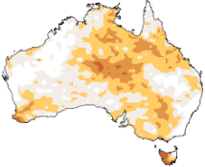
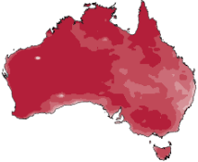
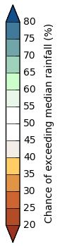
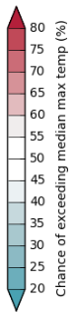
Northern Territory Seasonal Outlook
as at September 2018
Sourced from the Australian Bureau of Meteorology
http://www.bom.gov.au/climate/outlooks/
The national outlook for September to November 2018 indicates that:
- Drier than average conditions are more likely across much of the NT, especially across the central and southern districts.
- Warmer than average days and nights are more likely across the entire NT.
The El Niño-Southern Oscillation is currently neutral, but there is a 50% chance of El Niño forming in the coming months. Similarly, the Indian Ocean Dipole (IOD) is also neutral. However, outlooks suggest a brief positive IOD event may form during Spring.
Chance of exceeding the median max. temp.
October to December 2018

Chance of exceeding the median rainfall
October to December 2018

Sea surface temperatures continue to be cooler than average to Australia's northwest, which is acting to suppress rainfall over southern and central Australia.
In addition to the natural drivers such as the El Niño–Southern Oscillation and the IOD, Australian climate patterns are being influenced by the long-term increasing trend in global air and ocean temperatures.
Seasonal Indicators | Comments (sourced from the Australian Bureau of Meteorology)
El Niño Southern Oscillation (ENSO)  http://www.bom.gov.au/climate/enso/  Current outlook:  Neutral  ENSO status: Watch  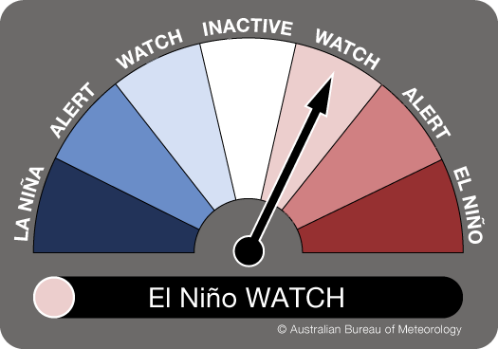 | El Niño–Southern Oscillation neutral, but El Niño tropical Pacific may warm to El Niño levels in Spring.  The El Niño–Southern Oscillation (ENSO) is currently neutral. However, current observations and model outlooks indicate El Niño remains possible in 2018. Therefore, the Bureau's ENSO Outlook remains at El Niño WATCH, meaning there is approximately a 50% chance of El Niño forming in the coming months; double the normal chance.  El Niño during Spring typically means below-average rainfall in eastern and northern Australia, including a later than average start to the northern wet season, while daytime temperatures are typically above average over the southern two-thirds of Australia. | 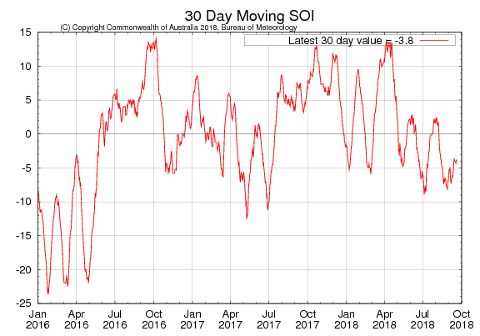  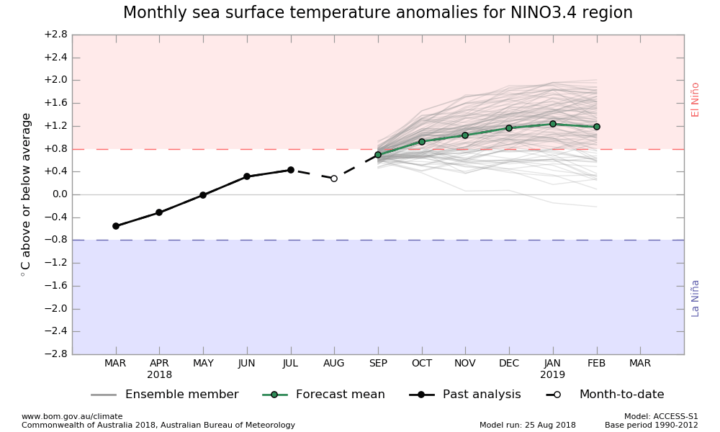
Indian Ocean Dipole (IOD)  http://www.bom.gov.au/climate/enso/#tabs=Indian-Ocean  Current outlook:  Neutral | IOD currently neutral  The Indian Ocean Dipole (IOD) is neutral. However, roughly half of international climate models suggest a short-lived positive IOD event may develop. A positive IOD during Spring typically reduces rainfall in central and southern Australia, and can exacerbate any El Niño-driven rainfall deficiencies. | 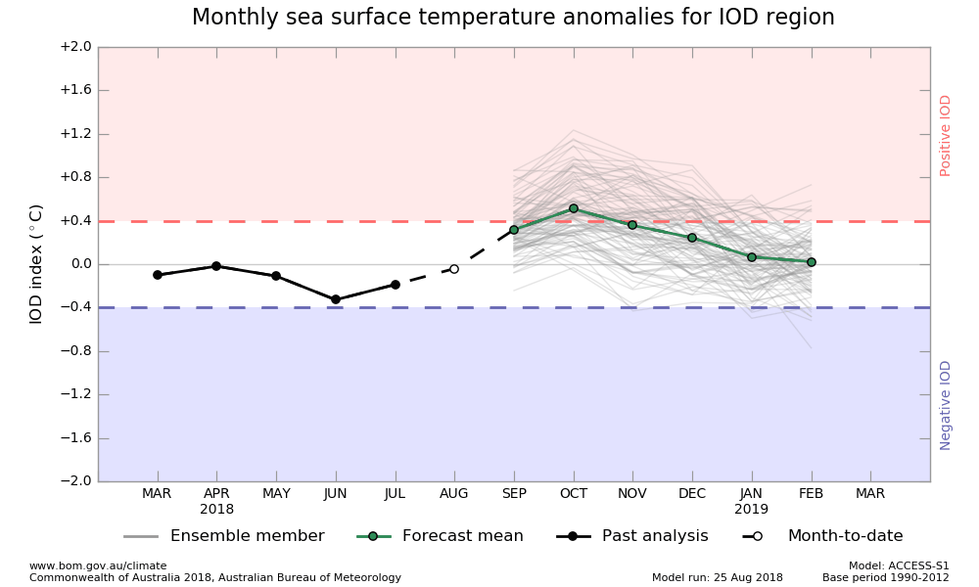  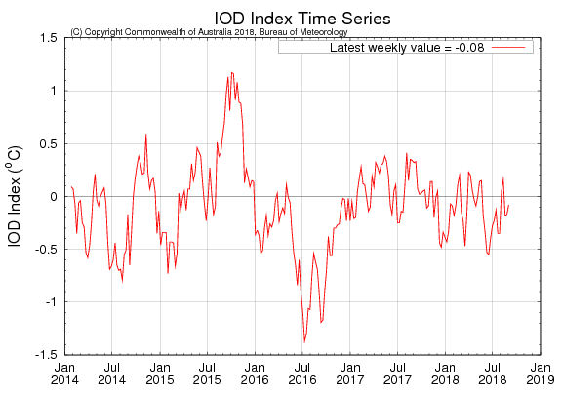

Darwin District
- The 2017/18 pasture growth was similar to the long-term median  - 41% of the district has been burnt since 1 July 2018  - 58% of the district had a high fire risk as at 1 September 2018 | Pasture Growth (Past 12 Months)  2,007kg/ha  as at 1 September 2018

In a typical wet season, pasture growth in the Darwin region tends to be limited by available soil nitrogen rather than soil moisture. Therefore, a poor wet season may not generally affect the total quantity of pasture grown on upland country.

As at 1 September 2018
(% of district) | <1,000kg/ha | 1,000 - 2,000kg/ha | 2,000 - 3,000kg/ha | >3,000kg/ha
2018/19  Pasture Growth | 100% | 0% | 0% | 0%
Total Standing Dry Matter | 65% | 29% | 5% | 1%

Median Pasture Growth (kg/ha)  (Running Total) | Current Estimated  Total Standing Dry Matter
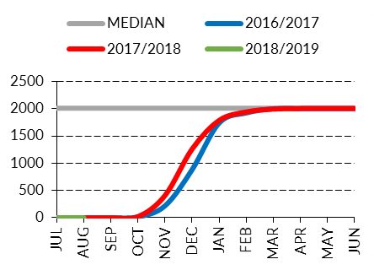 | 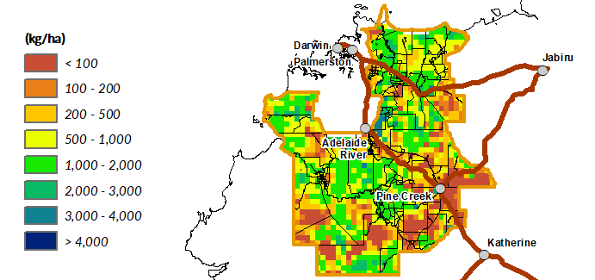

Growth Relative to Long Term  (September 2017 – September 2018) | Chance of Exceeding  Median Pasture Growth  (September 2018 – November 2018)
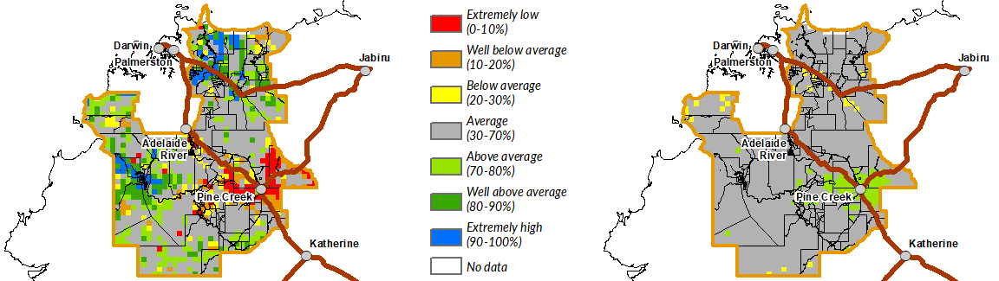

Katherine District
- The 2017/18 pasture growth was similar to the long-term median for the district as a whole, but some locations did get much better growth than others  - 20% of the district has been burnt since 1 July 2018  - 79% of the district had a high fire risk as at 1 September 2018 | Pasture Growth (Past 12 Months)  2,139kg/ha  as at 1 September 2018

As at 1 September 2018
(% of district) | <1,000kg/ha | 1,000 - 2,000kg/ha | 2,000 - 3,000kg/ha | >3,000kg/ha
2018/19  Pasture Growth | 100% | 0% | 0% | 0%
Total Standing Dry Matter | 34% | 49% | 16% | 1%

Median Pasture Growth (kg/ha)  (Running Total) | Current Estimated  Total Standing Dry Matter
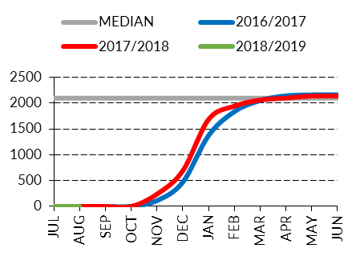 | 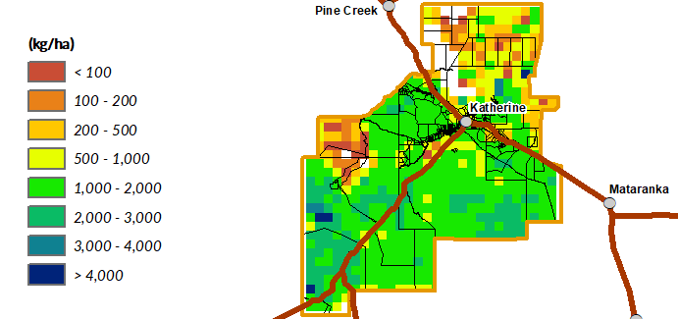

Growth Relative to Long Term  (September 2017 – September 2018) | Chance of Exceeding  Median Pasture Growth  (September 2018 – November 2018)
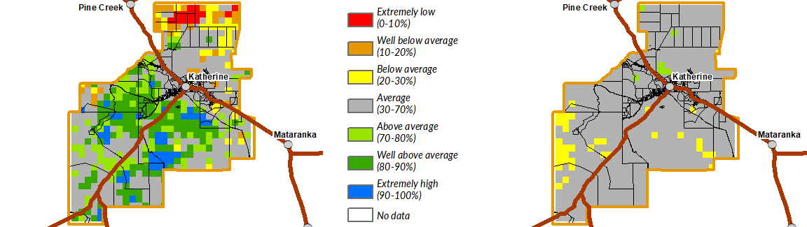

Victoria River District
- 2017/18 pasture growth was similar to the long-term median but quite a lot lower than 2016/17  - 95% of the district had a high fire risk as at 1 September 2018 | Pasture Growth (Past 12 Months)  1,820kg/ha  as at 1 September 2018

As at 1 September 2018
(% of district) | <1,000kg/ha | 1,000 - 2,000kg/ha | 2,000 - 3,000kg/ha | >3,000kg/ha
2018/19  Pasture Growth | 100% | 0% | 0% | 0%
Total Standing Dry Matter | 22% | 40% | 19% | 19%

Median Pasture Growth (kg/ha)  (Running Total) | Current Estimated  Total Standing Dry Matter
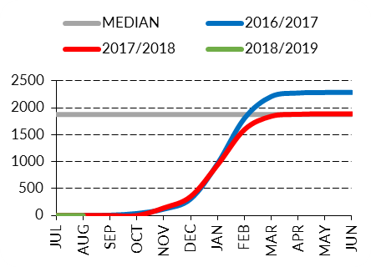 | 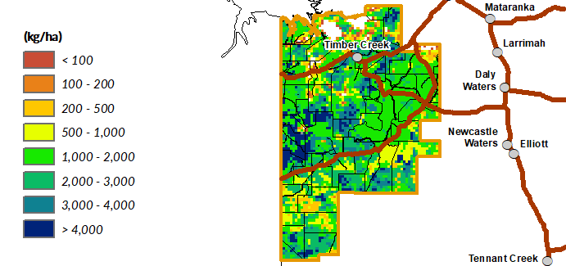

Growth Relative to Long Term  (September 2017 – September 2018) | Chance of Exceeding  Median Pasture Growth  (September 2018 – November 2018)
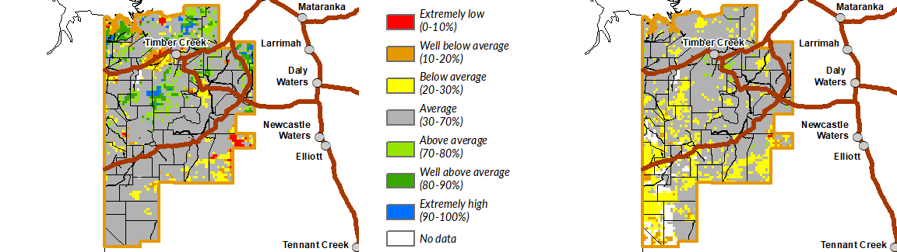

Sturt Plateau District
- 2017/18 pasture growth was slightly better than the long-term median and similar to 2016/17  - 100% of the district had a high fire risk as at 1 September 2018 | Pasture Growth (Past 12 Months)  2,104kg/ha  as at 1 September 2018

As at 1 September 2018
(% of district) | <1,000kg/ha | 1,000 - 2,000kg/ha | 2,000 - 3,000kg/ha | >3,000kg/ha
2018/19  Pasture Growth | 100% | 0% | 0% | 0%
Total Standing Dry Matter | 10% | 79% | 8% | 3%

Median Pasture Growth (kg/ha)  (Running Total) | Current Estimated  Total Standing Dry Matter
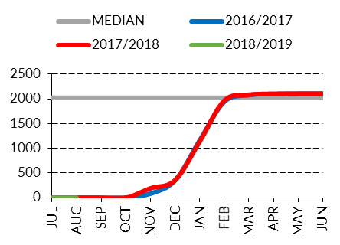 | 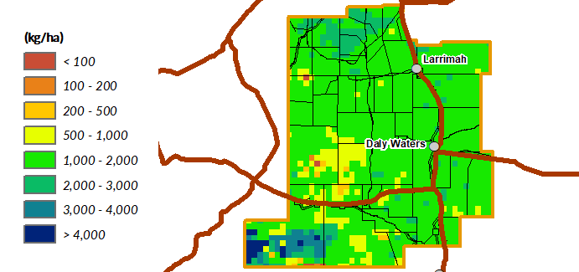

Growth Relative to Long Term  (September 2017 – September 2018) | Chance of Exceeding  Median Pasture Growth  (September 2018 – November 2018)
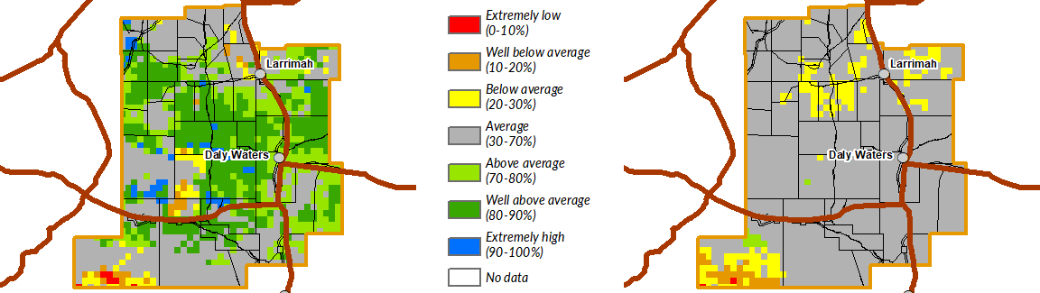

Roper District
- 2017/18 pasture growth was similar to the long-term median but lower than 2016/17  - 93% of the district had a high fire risk as at 1 September 2018 | Pasture Growth (Past 12 Months)  2,200kg/ha  as at 1 September 2018

As at 1 September 2018
(% of district) | <1,000kg/ha | 1,000 - 2,000kg/ha | 2,000 - 3,000kg/ha | >3,000kg/ha
2018/19  Pasture Growth | 100% | 0% | 0% | 0%
Total Standing Dry Matter | 20% | 43% | 27% | 10%

Median Pasture Growth (kg/ha)  (Running Total) | Current Estimated  Total Standing Dry Matter
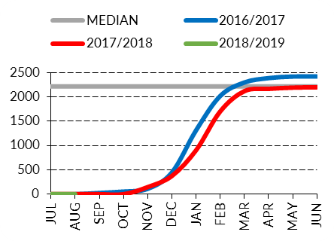 | 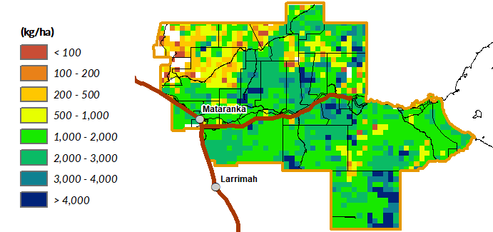

Growth Relative to Long Term  (September 2017 – September 2018) | Chance of Exceeding  Median Pasture Growth  (September 2018 – November 2018)
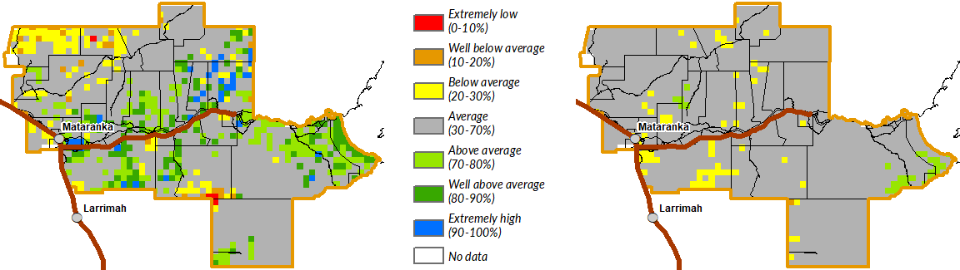

Gulf District
- 2017/18 pasture growth was similar to the long-term median but lower than 2016/17  - 100% of the district had a high fire risk as at 1 September 2018 | Pasture Growth (Past 12 Months)  2,145kg/ha  as at 1 September 2018

As at 1 September 2018
(% of district) | <1,000kg/ha | 1,000 - 2,000kg/ha | 2,000 - 3,000kg/ha | >3,000kg/ha
2018/19  Pasture Growth | 100% | 0% | 0% | 0%
Total Standing Dry Matter | 15% | 48% | 20% | 17%

Median Pasture Growth (kg/ha)  (Running Total) | Current Estimated  Total Standing Dry Matter
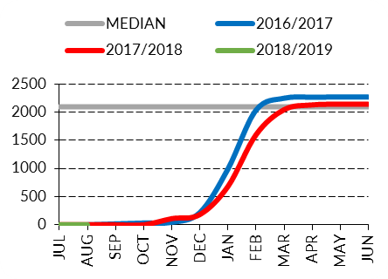 | 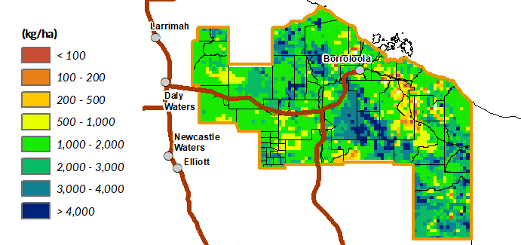

Growth Relative to Long Term  (September 2017 – September 2018) | Chance of Exceeding  Median Pasture Growth  (September 2018 – November 2018)
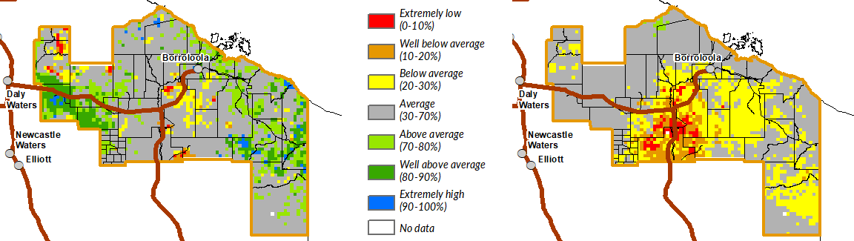

Barkly District
- 2017/18 pasture growth for the district as a whole was similar to the long-term median, however there was considerable variation depending on location  - The far south-eastern region has experienced low to extremely low pasture growth over the past 12 months (lowest 30% of years), and has very low standing dry matter levels  - Less than 1% of the district has been burnt since 1 July 2018  - 67% of the district had a high fire risk as at 1 September 2018 | Pasture Growth (Past 12 Months)  710kg/ha  as at 1 September 2018

As at 1 September 2018
(% of district) | <250kg/ha | 250 - 500kg/ha | 500 - 1,000kg/ha | >1,000kg/ha
2018/19  Pasture Growth | 100% | 0% | 0% | 0%
Total Standing Dry Matter | 11% | 22% | 32% | 35%

Median Pasture Growth (kg/ha)  (Running Total) | Current Estimated  Total Standing Dry Matter
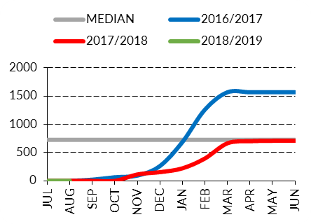 | 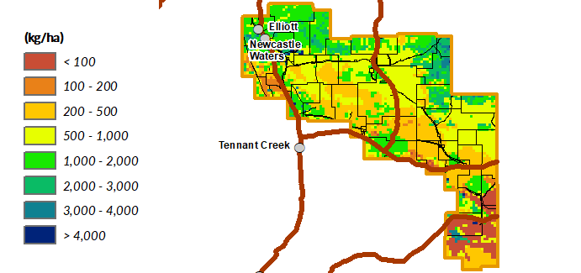

Growth Relative to Long Term  (September 2017 – September 2018) | Chance of Exceeding  Median Pasture Growth  (September 2018 – November 2018)
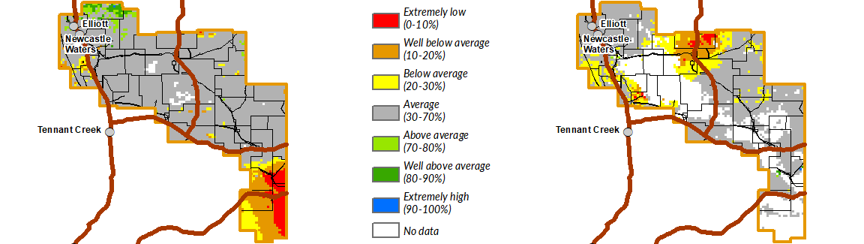

Tennant Creek District
- 2017/18 pasture growth was similar to the long-term median but much lower than 2016/17  - Very little winter pasture growth has occurred and the south-eastern area of the district is now starting to show below-average growth over the past 12 months (lowest 20-30% of years), which is dragging the arrow in the figure to the right lower  - Less than 1% of the district has been burnt since 1 July 2018  - 87% of the district had a high fire risk as at 1 September 2018 | Pasture Growth (Past 12 Months)  292kg/ha  as at 1 September 2018

As at 1 September 2018
(% of district) | <250kg/ha | 250 - 500kg/ha | 500 - 1,000kg/ha | >1,000kg/ha
2018/19  Pasture Growth | 100% | 0% | 0% | 0%
Total Standing Dry Matter | 8% | 8% | 16% | 68%

Median Pasture Growth (kg/ha)  (Running Total) | Current Estimated  Total Standing Dry Matter
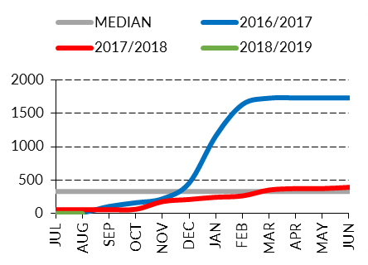 | 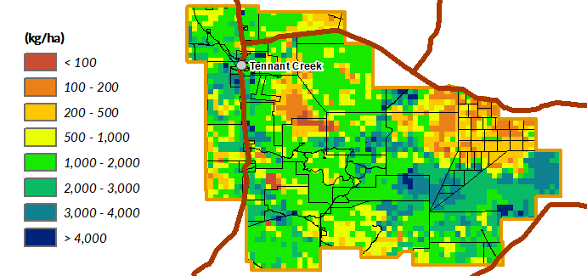

Growth Relative to Long Term  (September 2017 – September 2018) | Chance of Exceeding  Median Pasture Growth  (September 2018 – November 2018)
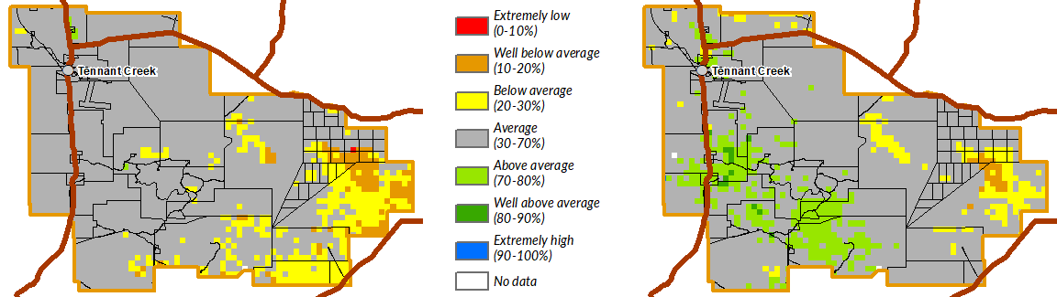

Northern Alice Springs District
 | - 2017/18 pasture growth was slightly lower than the long-term median and very much lower than 2016/17  - Very little winter pasture growth has occurred in the district and now there are areas that are showing below-average growth over the past 12 months (lowest 20-30% of years)  - Less than 1% of the district has been burnt since 1 July 2018  - 99% of the district had a high fire risk as at 1 September 2018 |  |  | Pasture Growth (Past 12 Months)  380kg/ha  as at 1 September 2018
As at 1 September 2018
(% of district) |  | <250kg/ha | 250 - 500kg/ha |  | 500 - 1,000kg/ha | >1,000kg/ha
2018/19  Pasture Growth |  | 100% | 0% |  | 0% | 0%
Total Standing Dry Matter |  | 2% | 6% |  | 36% | 56%

Median Pasture Growth (kg/ha)  (Running Total) | Current Estimated  Total Standing Dry Matter
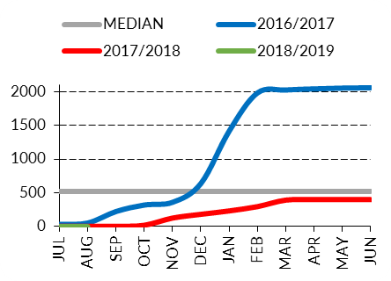 | 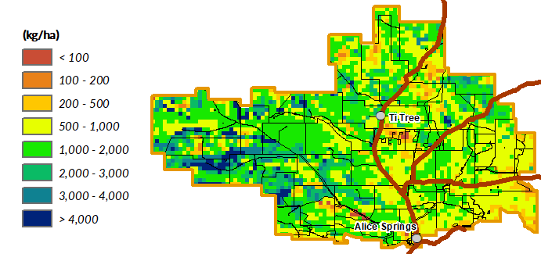

Growth Relative to Long Term  (September 2017 – September 2018) | Chance of Exceeding  Median Pasture Growth  (September 2018 – November 2018)
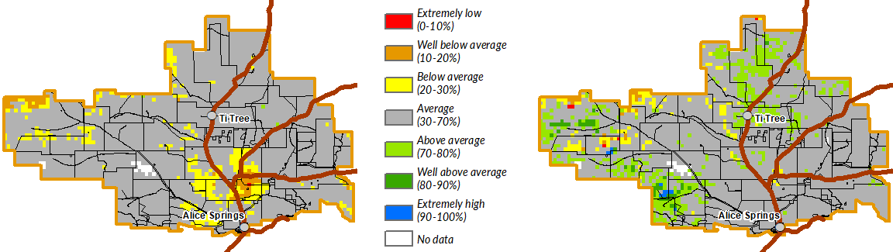

Plenty District
 | - 2017/18 pasture growth was similar to the long-term median across the district, however some central areas experienced below average pasture growth (in the lowest 30% of years)  - Very little winter pasture growth has occurred and now much of the district is showing below to well below-average growth over the past 12 months (lowest 10-30% of years) which is dragging the arrow in the figure to the right downwards  - 81% of the district had a high fire risk as at 1 September 2018 |  |  | Pasture Growth (Past 12 Months)  185kg/ha  as at 1 September 2018
As at 1 September 2018
(% of district) |  | <250kg/ha | 250 - 500kg/ha |  | 500 - 1,000kg/ha | >1,000kg/ha
2018/19  Pasture Growth |  | 100% | 0% |  | 0% | 0%
Total Standing Dry Matter |  | 4% | 23% |  | 44% | 29%

Median Pasture Growth (kg/ha)  (Running Total) | Current Estimated  Total Standing Dry Matter
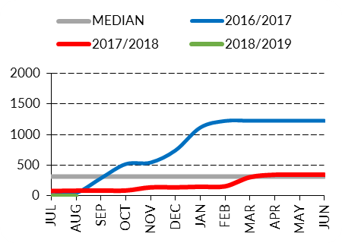 | 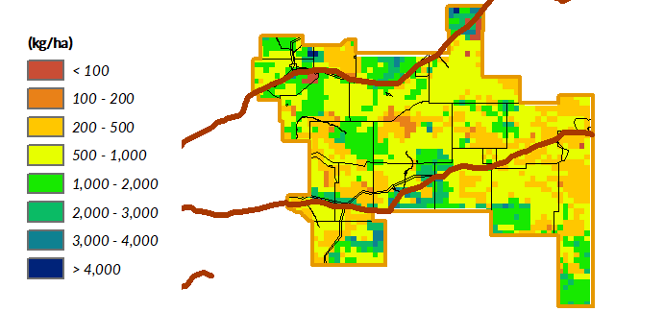

Growth Relative to Long Term  (September 2017 – September 2018) | Chance of Exceeding  Median Pasture Growth  (September 2018 – November 2018)
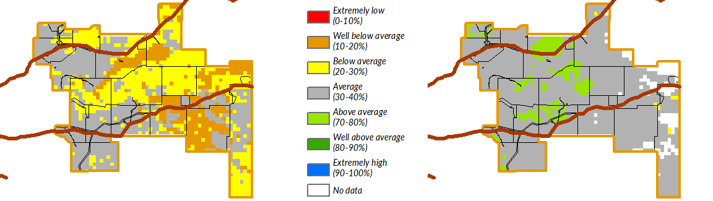

Southern Alice Springs District
- 2017/18 pasture growth was similar to the long-term median but much lower than 2016/17  - Very little winter pasture growth has occurred and a large area across the northern and eastern parts is now showing below-average to extremely low pasture growth (lowest 30% of years) over the past 12 months which is dragging the arrow in the figure to the right downwards  - Less than 1% of the district has been burnt since 1 July 2018  - 83% of the district had a high fire risk as at 1 September 2018 | Pasture Growth (Past 12 Months)  151kg/ha  as at 1 September 2018

As at 1 September 2018
(% of district) | <250kg/ha | 250 - 500kg/ha | 500 - 1,000kg/ha | >1,000kg/ha
2018/19  Pasture Growth | 100% | 0% | 0% | 0%
Total Standing Dry Matter | 7% | 19% | 36% | 38%

Median Pasture Growth (kg/ha)  (Running Total) | Current Estimated  Total Standing Dry Matter
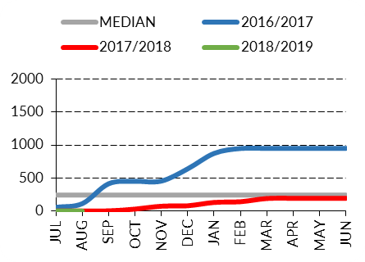 | 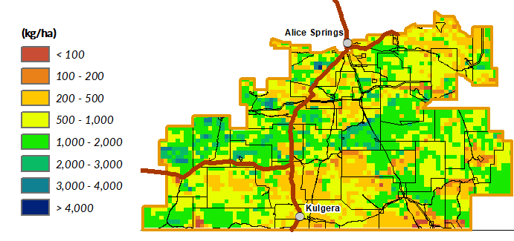

Growth Relative to Long Term  (September 2017 – September 2018) | Chance of Exceeding  Median Pasture Growth  (September 2018 – November 2018)
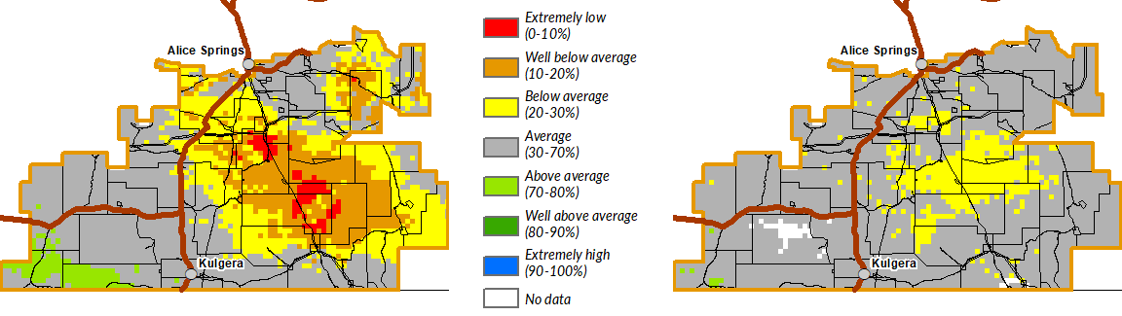

Pasture Information
The pasture and fire risk information in this document is derived from AussieGRASS. AussieGRASS is a model that simulates pasture growth and standing biomass using climate data, vegetation mapping, fire history and regional estimates of grazing pressure. The model can be used to track simulated pasture growth and total standing pasture biomass at the landscape scale.
Note that the model does not use stocking rate data for individual properties. Where stock numbers are significantly higher or lower than typical for a district, model estimates of total standing dry matter may be erroneous.

Disclaimer
While all care has been taken to ensure that information contained in this document is true and correct at the time of production, changes in circumstances after the time of distribution may affect the accuracy of its information. The Northern Territory of Australia gives no warranty or assurance, and makes no representation as to the accuracy of any information or advice contained herein, or that it is suitable for your intended use.
You should not rely solely upon information in this document for the purpose of making business or investment decisions in relation to your particular situation.
The Northern Territory of Australia disclaims any liability or responsibility or duty of care towards any person for loss of damage caused by any use of or reliance on this information.

