Mineral Titles Act
NOTICE OF LAND CEASING TO BE A MINERAL TITLE AREA
Title Type and Number: | Exploration Licence 23884
Area Ceased on: | 16 October 2018
Area: | 9 Blocks, 28.89 km²
Locality: | JARRAH JARRAH
Name of Applicant(s)/Holder(s): | 100% PRODIGY GOLD NL* [ACN. 009 127 020]
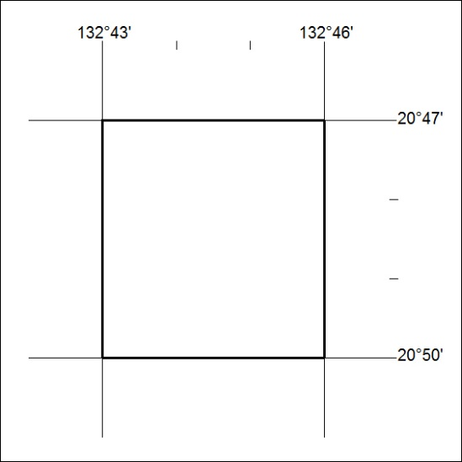

451/18

Mineral Titles Act
NOTICE OF LAND CEASING TO BE A MINERAL TITLE
Title Type and Number: | Mineral Lease (Northern) 326
Area ceased on: | 15 October 2018
Area: | 21.00 Hectare
Locality: | PINE CREEK
Name of Applicants(s)Holder(s): | 100% MCKINLAY RIVER MINING PTY. LTD [ACN. 059 869 224]
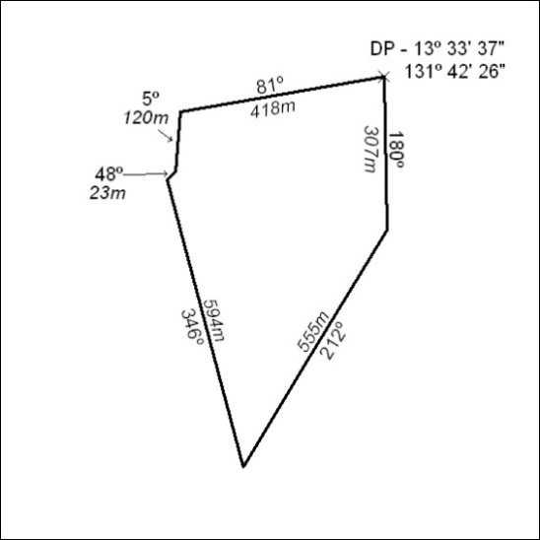
(Area now amalgamated into Mineral Lease 31973 under s102)

452/18

Mineral Titles Act
NOTICE OF LAND CEASING TO BE A MINERAL TITLE
Title Type and Number: | Mineral Lease (Northern) 574
Area ceased on: | 15 October 2018
Area: | 15.00 Hectare
Locality: | PINE CREEK
Name of Applicants(s)Holder(s): | 100% MCKINLAY RIVER MINING PTY. LTD [ACN. 059 869 224]
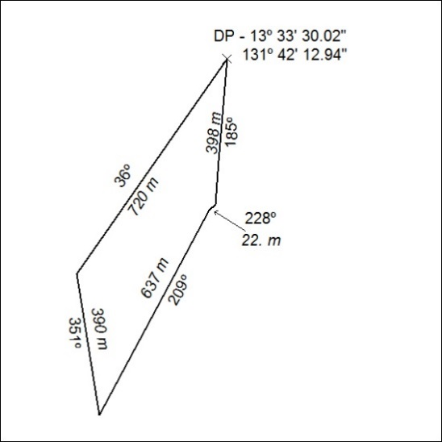
(Area now amalgamated into Mineral Lease 31973 under s102)

453/18

Corrigendum
Notice number 450/18 appearing in MN128/18 on 15 OCTOBER 2018 is hereby cancelled.

