Mineral Titles Act
NOTICE OF LAND CEASING TO BE A MINERAL TITLE AREA
Title Type and Number: | Exploration Licence 30817
Area Ceased on: | 22 October 2018
Area: | 5 Blocks, 15.29 km²
Locality: | HUMBERT
Name of Applicant(s)/Holder(s): | 100% RIPPLE RESOURCES PTY LTD [ACN. 127 220 768]
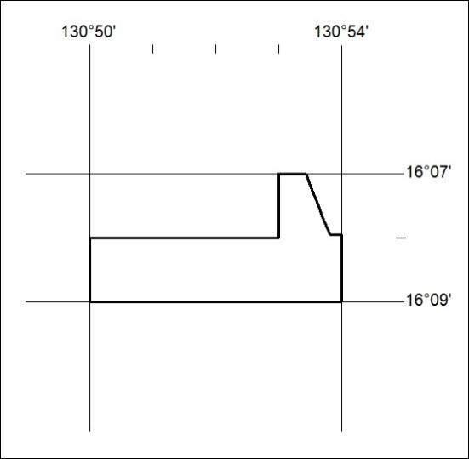

468/18

Mineral Titles Act
NOTICE OF LAND CEASING TO BE A MINERAL TITLE AREA
Title Type and Number: | Exploration Licence 30818
Area Ceased on: | 22 October 2018
Area: | 58 Blocks, 191.11 km²
Locality: | VICTORIA RIVER DOWNS
Name of Applicant(s)/Holder(s): | 100% RIPPLE RESOURCES PTY LTD [ACN. 127 220 768]
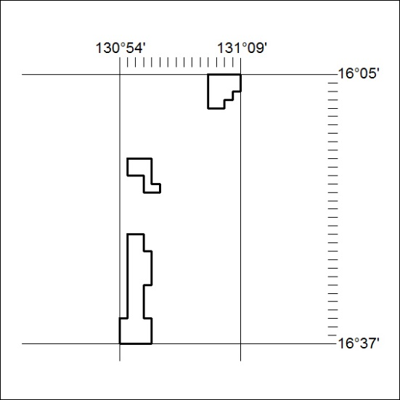

469/18

Mineral Titles Act
NOTICE OF LAND CEASING TO BE A MINERAL TITLE AREA
Title Type and Number: | Exploration Licence 30779
Area Ceased on: | 22 October 2018
Area: | 115 Blocks, 338.12 km²
Locality: | BUSHY PARK
Name of Applicant(s)/Holder(s): | 100% TERRITORY EXPLORATION PTY LTD [ACN. 123 338 376]
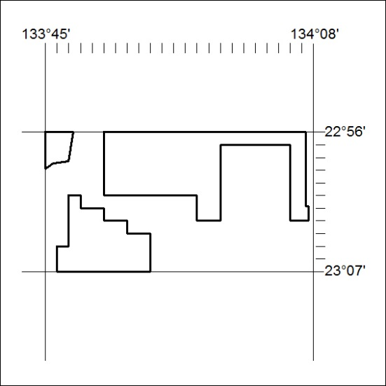

470/18

