Mineral Titles Act
NOTICE OF GRANT OF A MINERAL TITLE
Title Type and Number: | Exploration Licence 31618
Granted: | 26 October 2018, for a period of 6 Years
Area: | 226 Blocks, 664.45 km²
Locality: | TENNANT CREEK
Name of Holder/s: | 100% TREASURE CREEK PTY LTD [ACN. 619 057 644]
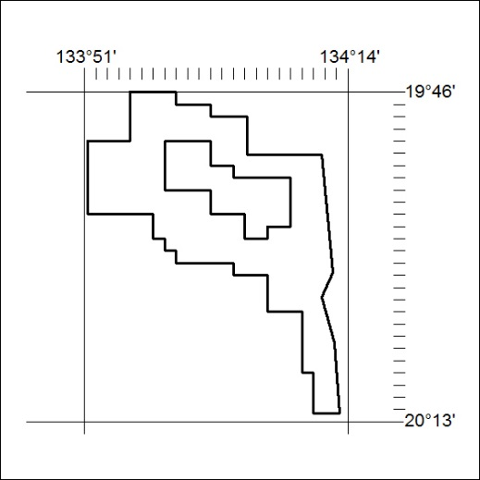
Area granted is indicated above. The titleholder is not permitted to exercise occupational rights on any land that is subject to a development title, or an application for a development title. Any land the subject of a Reserved Land gazettal under the Mineral Titles Act and all land vested in the Commonwealth of Australia is also excluded by description but not excised from the grant area.

485/18

Mineral Titles Act
NOTICE OF GRANT OF A MINERAL TITLE
Title Type and Number: | Exploration Licence 31842
Granted: | 25 October 2018, for a period of 6 Years
Area: | 250 Blocks, 787.09 km²
Locality: | ANNINGIE
Name of Holder/s: | 100% VANADIUM MINING PTY LTD [ACN. 621 703 991]
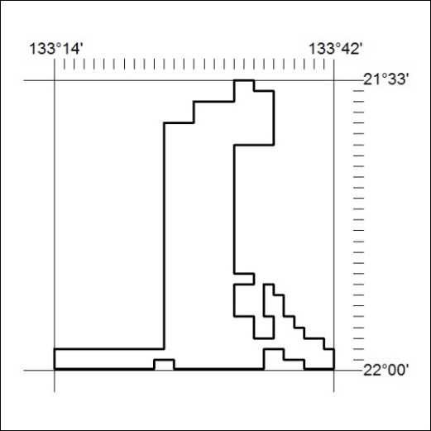
Area granted is indicated above. The titleholder is not permitted to exercise occupational rights on any land that is subject to a development title, or an application for a development title. Any land the subject of a Reserved Land gazettal under the Mineral Titles Act and all land vested in the Commonwealth of Australia is also excluded by description but not excised from the grant area.

486/18

Mineral Titles Act
NOTICE OF GRANT OF A MINERAL TITLE
Title Type and Number: | Exploration Licence 31841
Granted: | 25 October 2018, for a period of 6 Years
Area: | 250 Blocks, 799.51 km²
Locality: | CONICAL HILL
Name of Holder/s: | 100% VANADIUM MINING PTY LTD [ACN. 621 703 991]
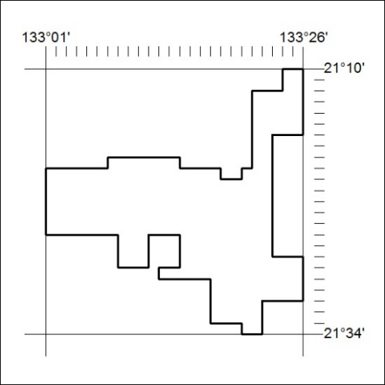
Area granted is indicated above. The titleholder is not permitted to exercise occupational rights on any land that is subject to a development title, or an application for a development title. Any land the subject of a Reserved Land gazettal under the Mineral Titles Act and all land vested in the Commonwealth of Australia is also excluded by description but not excised from the grant area.

487/18

Mineral Titles Act
NOTICE OF GRANT OF A MINERAL TITLE
Title Type and Number: | Exploration Licence 31842
Granted: | 25 October 2018, for a period of 6 Years
Area: | 250 Blocks, 787.09 km²
Locality: | ANNINGIE
Name of Holder/s: | 100% VANADIUM MINING PTY LTD [ACN. 621 703 991]
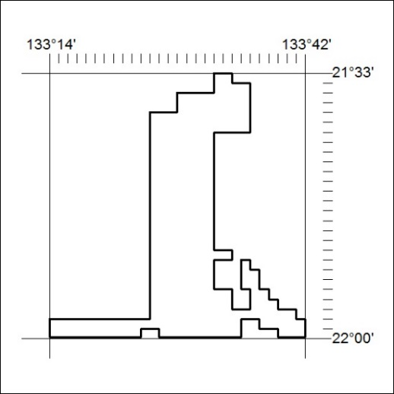
Area granted is indicated above. The titleholder is not permitted to exercise occupational rights on any land that is subject to a development title, or an application for a development title. Any land the subject of a Reserved Land gazettal under the Mineral Titles Act and all land vested in the Commonwealth of Australia is also excluded by description but not excised from the grant area.

488/18

